FREE Evening CPD
Course for Vets
University of Liverpool Small Animal Teaching Hospital Presents:
‘Let food by thy medicine and medicine be thy food’
An evening of CPD with the Liverpool Internal Medicine Team
Wednesday 30 March 2022
Lecture Theatre, Main Building, Leahurst Campus
Buffet & Registration: 7.00-7.30pm
Join us for an update from Andrea on the principles of supportive feeding for sick dogs and cats. After that, James will be sharing some recent interesting cases to discuss. Please bring your mobile phone to interact using the polling software.  Andrea Petrelli DVM MRCVS  James Barton BSc BVSC MRCVS  Daniel Batchelor BVSc PhD DSAM DipECVIM-CA SFHEA MRCVS |  |  |  |  | 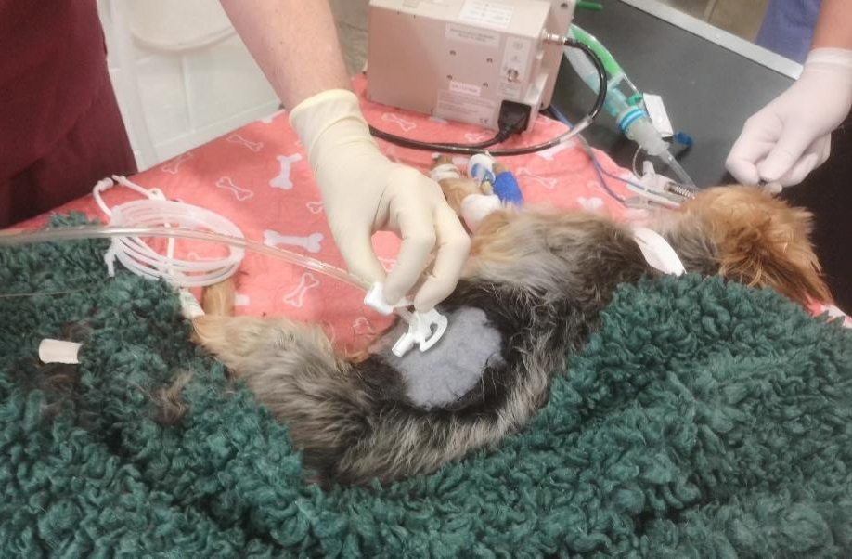
To book your place please complete and return this form via post or email, to the address below
(Admission only available to those pre-booking using this form)

I would like to attend the “Food is the best medicine” CPD evening on Wednesday 30 March 2022
Forename: |  |  | Surname:
Name of Practice:
Address of Practice:
Postcode: |  |  |  | Tel. No.:
Your place will be confirmed by email – Please PRINT your email address below
Email address:
Veterinary Postgraduate Unit,
University of Liverpool, School of Veterinary Science, Leahurst Campus, Neston, CH64 7TE
Tel: (0151) 794 6016 |  |  | Email: vpuoffice@liverpool.ac.uk

