Hi freshers!

Welcome to Vet Netball 🏐

Whether you are looking to play a high level of netball or haven’t played for ages and just want to have some fun we can’t recommend vet netball enough. It is a great way to stay active and interact with other girls on your course making some brilliant friends.

We are a fantastic club open to Vet and Biovet students that caters for all abilities with three competitive teams alongside social members. We train twice a week on a Monday and Wednesday with matches for each team on different days as well as having regular socials which include our End of Season meal, AU nights and lots of themed evenings.

We will be holding taster sessions and encourage everyone to come along and see what the club is about. More information including the dates and times will be released on our Instagram and Facebook so make sure that you are following using the QR codes.

For those players looking to play competitively, trials will be held after our taster sessions. (Dates for these will also be released on our social media). All players wanting to play fixtures will be placed on a team depending on their level of performance.

We can’t wait to meet you all. Please come and say hello and ask any questions that you may have during the Vet Freshers Fair or drop us a message on Instagram.

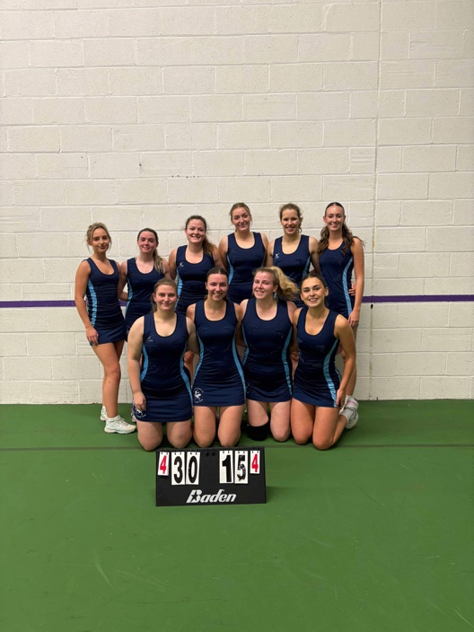

Your co-presidents,

Tosca and Talia xx

