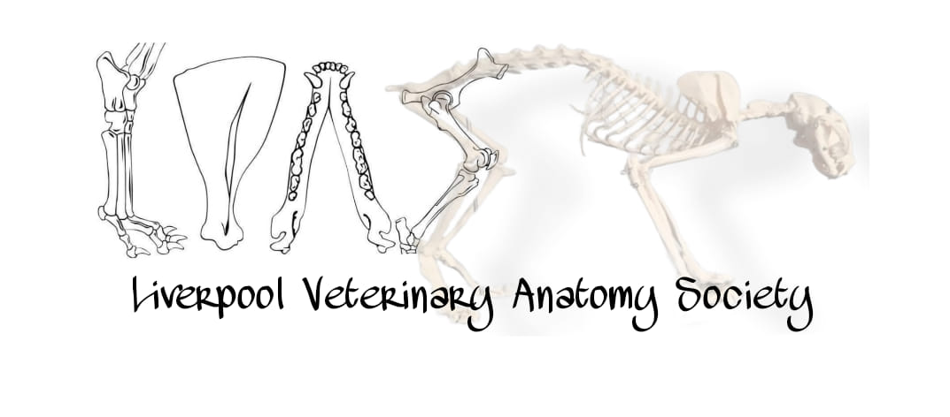
Liverpool Veterinary Anatomy Society 2023-24
Dear Freshers,
Congratulations on getting into the best vet school, I know how hard you have worked. I hope you are excited for the next 5 years which will be fun and challenging at the same time.
Our anatomy society is a relatively small one which is FREE to join which means we can tailor our activities to suit the needs of each cohort. The aim of the society is to make learning anatomy more enjoyable! It is a large part of the course, especially in the first year. Therefore, we want to ensure you have the best start to your time in vet school by creating numerous different ways to learn.
We have Anatomy themed games and models and colouring materials for you all to use. As you walk round the Vet School you will see glimpses of our work for example, Barry the horse and the mural on the Wall as you walk upstairs in the VTS. We will update the Facebook page where the models will be in due course as there have been some building changes this year.
We will be looking for committee members to join the team this year. Please come and join me in continuing the great work the society has done these last few years.
The roles that are available to apply for are: Vice president, Secretary, Treasurer and Social Secretary and project coordinator so if you think anatomy is something you will enjoy – or something you might need a bit more practice to get to grips with – then please look out for an email in the coming weeks and keep an eye on the main LUVS page for election details.
In the meantime, please find us on Facebook
(https://www.facebook.com/groups/liverpoolvetanatomy/ )
Enjoy moving into Liverpool, the city is a great place to be, even in the current climate and I hope this year is the start of a very exciting future for you all. Best Wishes,
Carol Louise Bell Email: lvanatomysociety@gmail.com
Current LVAS President 2023-2024

