Liverpool University Veterinary Sustainability Society

Hi all and well done on getting into Liverpool!

We hope you all have a wonderful time over your next few years here.

We are the student veterinary sustainability society for the University of Liverpool.

Our previous events have included:

* litterpicks- on campus, in residential areas and on local beaches. Do not worry if you have never done one before- most people haven’t either! All equipment is provided (including some really fetching hi-vis jackets).
* ‘crafternoons’- with the wellbeing representative and peer supporters
* plant workshops
* Bird surveys in conjunction with Ness Gardens
* Evening talks- on a range of topics, such as: a sustainable veterinary industry, how we can be sustainable as individuals and nature friendly farming

Our committee is composed of one president, a Leahurst rep, a Liverpool rep and a VetSustain representative. VetSustain helps and supports a drive towards sustainable change across the veterinary profession, from the curriculum, to out in practice as a vet. You can find out more about them here: <https://vetsustain.org/>

We are currently looking to fill the Liverpool and Leahurst representative roles, in addition to the VetSustain representative. If you are interested, please email the president Jennifer Ainger at [hljainge@liverpool.ac.uk](mailto:hljainge@liverpool.ac.uk).

Membership is free

# Social media

Facebook group: <https://www.facebook.com/groups/2845613969026744/>

Instagram: @l.u.v.s.s (Liverpool University Veterinary Sustainability Society)

Facebook formal clothing swap group: <https://www.facebook.com/groups/1306350259925159/>

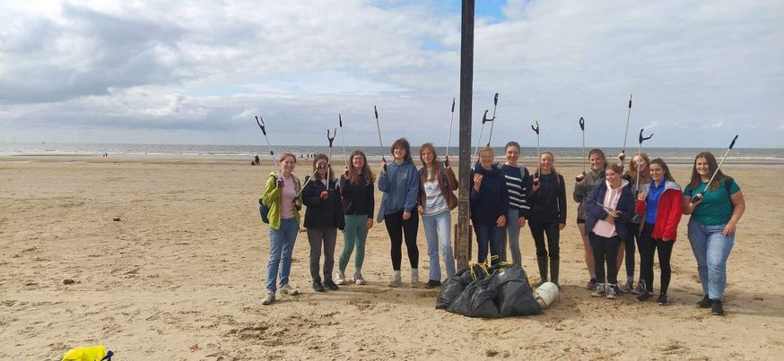

Formby beach litterpick