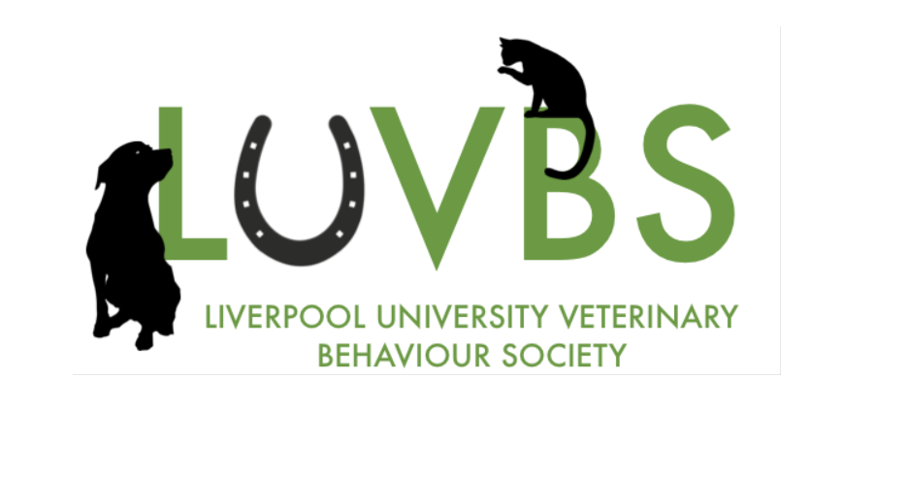

Hi and welcome to Liverpool!
Well done on earning your place.
We are the Liverpool University Veterinary Behaviour Society😊
Have you ever wondered what’s running through your cat’s mind as she purrs contentedly while you stroke her? Or why your doggo yelps and calls for you at the window whenever you drive away from the house? Or why your hamster chews all night on the bars of his cage, like he’s the lead in The Great Escape? Behavioural medicine - the link between emotional and physical health - is a fascinating and essential field for the veterinary student and our society is designed to develop awareness, understanding and practical skills.
We will running our annual Behaviour weekend event, which is the weekend of 25th/26th November this is at Leahurst with talks from a range of experts and animal handling sessions which are always fantastic fun. Hope to see some of you there
We are a relatively new society so would love to see more friendly faces to help us build into something bigger.
We are also excited to announce that there is an opportunity for students to join the team, we currently have roles available for first years for Liverpool Vice president and Treasurer. If you are interested in applying for this role and have some questions, please contact us via Facebook and keep an eye out on the LUVS main page for election details.
You can also stay up to date with events and updates on our Facebook page: Liverpool University Veterinary Behaviour Society: https://www.facebook.com/groups/159204108839932

Thanks, and hope to see you soon!

Carol Louise Bell Email: hlcbell7@Liverpool.ac.uk
Secretary - Currently acting president till re-election of committee)

