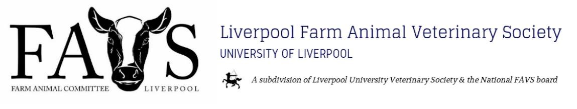
Hello 2023 Freshers!
Massive congratulations on earning a place here at Liverpool! In our unbiased opinion, you’ve made the smart choice by choosing Liverpool. We hope you’re looking forward to joining our FAVS family.
All the vet societies here at Liverpool are committed to making it the best experience possible for you. We at Liverpool Farm Animal Veterinary Society (LFAVS) have lots of great plans for you over the year and hope you’ll join us in making this year one of the society’s best.
At FAVS we’re passionate about all areas of farm animal production and practice. We run a wide range of talks, practicals, farm walks and lab tours to ensure students from a range of backgrounds all have the best possible understanding of farm medicine and the farming industry as a whole, whether you definitely want to go into farm, mixed, or even just considering it. This past year we have organised both online and in-person talks, including top tips as a new graduate farm vet and sustainability in the veterinary profession. We also held a species practical day at the Leahurst campus, which we plan to do again twice this next year.
Unlike many other sub-societies of LUVS, we also have a national student body - National
FAVS. Becoming a member of LFAVS automatically grants you membership of National FAVS, who we work closely with to bring you the best possible experience.
Annually, there is a National FAVS congress, which is basically a weekend of practicals, lectures, and partying. Those who went last year thoroughly enjoyed. Congress provides a brilliant opportunity to make contacts with vet students from other unis and network with vet practices, hopefully leading to excellent friendships, placements and beyond.
This year, membership of LFAVS is £15. This covers the duration of your time studying at Liverpool. The fee allows us to cover the cost of events and practical sessions (which as a member are free to attend). As a national FAVS member, included within this fee, you gain access to their EMS database, job listings and, of course, congress! Upon confirmation of membership you will be added to our private Facebook group. You can follow our public Facebook page and Instagram for more information about the society.
Congratulations once again on joining us here at Liverpool. I hope you are excited for September, hopefully I’ll meet some of you at VetFreshers!
To join please email hlthugh3@liverpool.ac.uk (Tom Hughes, President), or find me on Facebook.
If you have any further questions, please also feel free to contact me - I hope your time at Liverpool is the best it can be, push yourself out of your comfort zone and have fun!
Tom Hughes (LFAVS President)
Instagram: @LiverpoolFAVS Facebook page: Facebook.com/LFAVS Email: FAVSLiverpool@gmail.com

