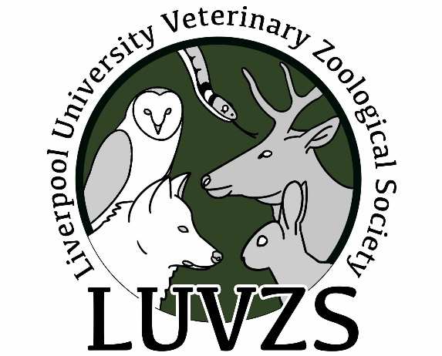

Hi all 2025 Freshers!
Congratulations on your place at the University of Liverpool, and I hope you have a great time here!
Here is a bit of information about Liverpool University Veterinary Zoological Society (LUVZS). We are a sub-society for anyone interested in wildlife, exotic species or conservation, but we also support those who don’t feel as confident when faced with a snake, bird or other strange creature.
We will be running some practical sessions alongside a range of online and in person talks by experts in everything from guinea pig anaesthesia to whale conservation.
In addition, we run our famous LUVZS Day, which is a combination of talks and practicals with lunch and some freebies.

Some sessions from previous years include:
- A day trip to Chester Zoo
- LUVZS Day which included a small mammal dissection practical, and talks about sharks, haemostasis and exotics emergency medicine by Dr Molly Varga.
- Invertebrate cases with Dr Benjamin Kennedy.
- Common conditions of guinea pigs with Dr Agata Witkowska.
- An introduction to amphibian medicine with Dr Filipe Martinho from the University of Liverpool Small Animal Veterinary Practice.
- Multiple in person talks about zoological EMS placements.
- Improving the welfare of companion parrots with Dr Amy Zhao from the Budgie Academy.
- Talks from the Reptile academy, Elephant welfare project and

You can join LUVZS by visiting us at the LUVS’s Freshers’ Fair or if you have any questions about becoming a member then please feel free to contact us and we will be happy to help.

We look forward to you joining LUVZS and seeing you at our talks and events!

Izzy Day LUVZS President 2025-2026

Contact Details
Email: LUVZS@Liverpool.ac.uk
Instagram: @luvzssociety
Facebook: Facebook · Liverpool University Veterinary Zoological Society - LUVZS3.6K+ followersLiverpool University Veterinary Zoological Society - LUVZS
Website: https://luvzs.square.site

