**Welcome to LSAVS!**

Hi Freshers! Congratulations and Welcome to LSAVS! We are an active, welcoming society passionate about all things small animal!

We are focused on small animal medicine, surgery, health and welfare, but we are always exploring new, relevant topics & taking requests from our lovely members!

We run many exciting talks and events throughout the year and are most proud of our Suturing Practicals, where we get students involved in learning and mastering their suturing techniques on real cadaver material!

Hopefully we will see you soon at our upcoming events!

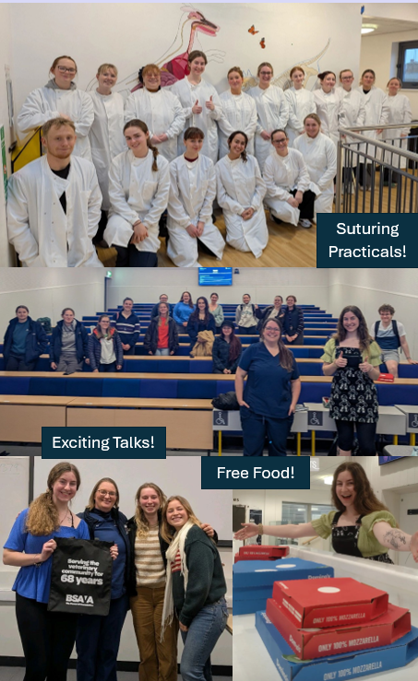

Highlights from last year include…

* Understanding ECGs with expert veterinary cardiologist Rachel James, sponsored by the BSAVA
* LSAVS Suturing Practicals with our lecturers - Dr Rosie MacDiarmid, Alison Reid, Marisol Collins and Kristen Hawkins
* ECC; Top 10 Emergencies and How to deal with them with Dr Jenny Bowen-Smith
* The Dangers of Raw Feeding and Antimicrobial Resistance with Dr Genever Morgan
* When Cases go Badly with Dr Dan Bachelor
* Hill's Nutrition Clinical Cases Talk and Quiz with Heidi Miner

We have had some requests regarding Post-Mortems and Whelping, too, so you might be seeing these talks being advertised soon!

Follow our Facebook (LSAVS- Liverpool Small Animal Veterinary Society) and Instagram (**@liverpoolsavs**) pages to keep up to date on the events we are running. If you are interested in becoming a member of LSAVS, or have any questions or requests for us, then please message our Instagram page, or email our co-president Robyn at **hlrlind@liverpool.ac.uk**. Memberships will be £5 per year or £15 for all 5 years! The benefits of memberships include free or discounted entry to all events, free food and priority over non-members for sold out events.

**All the best & We hope to see you soon! -LSAVS Committee 😊**