**Liverpool Farm Animal Veterinary Society**

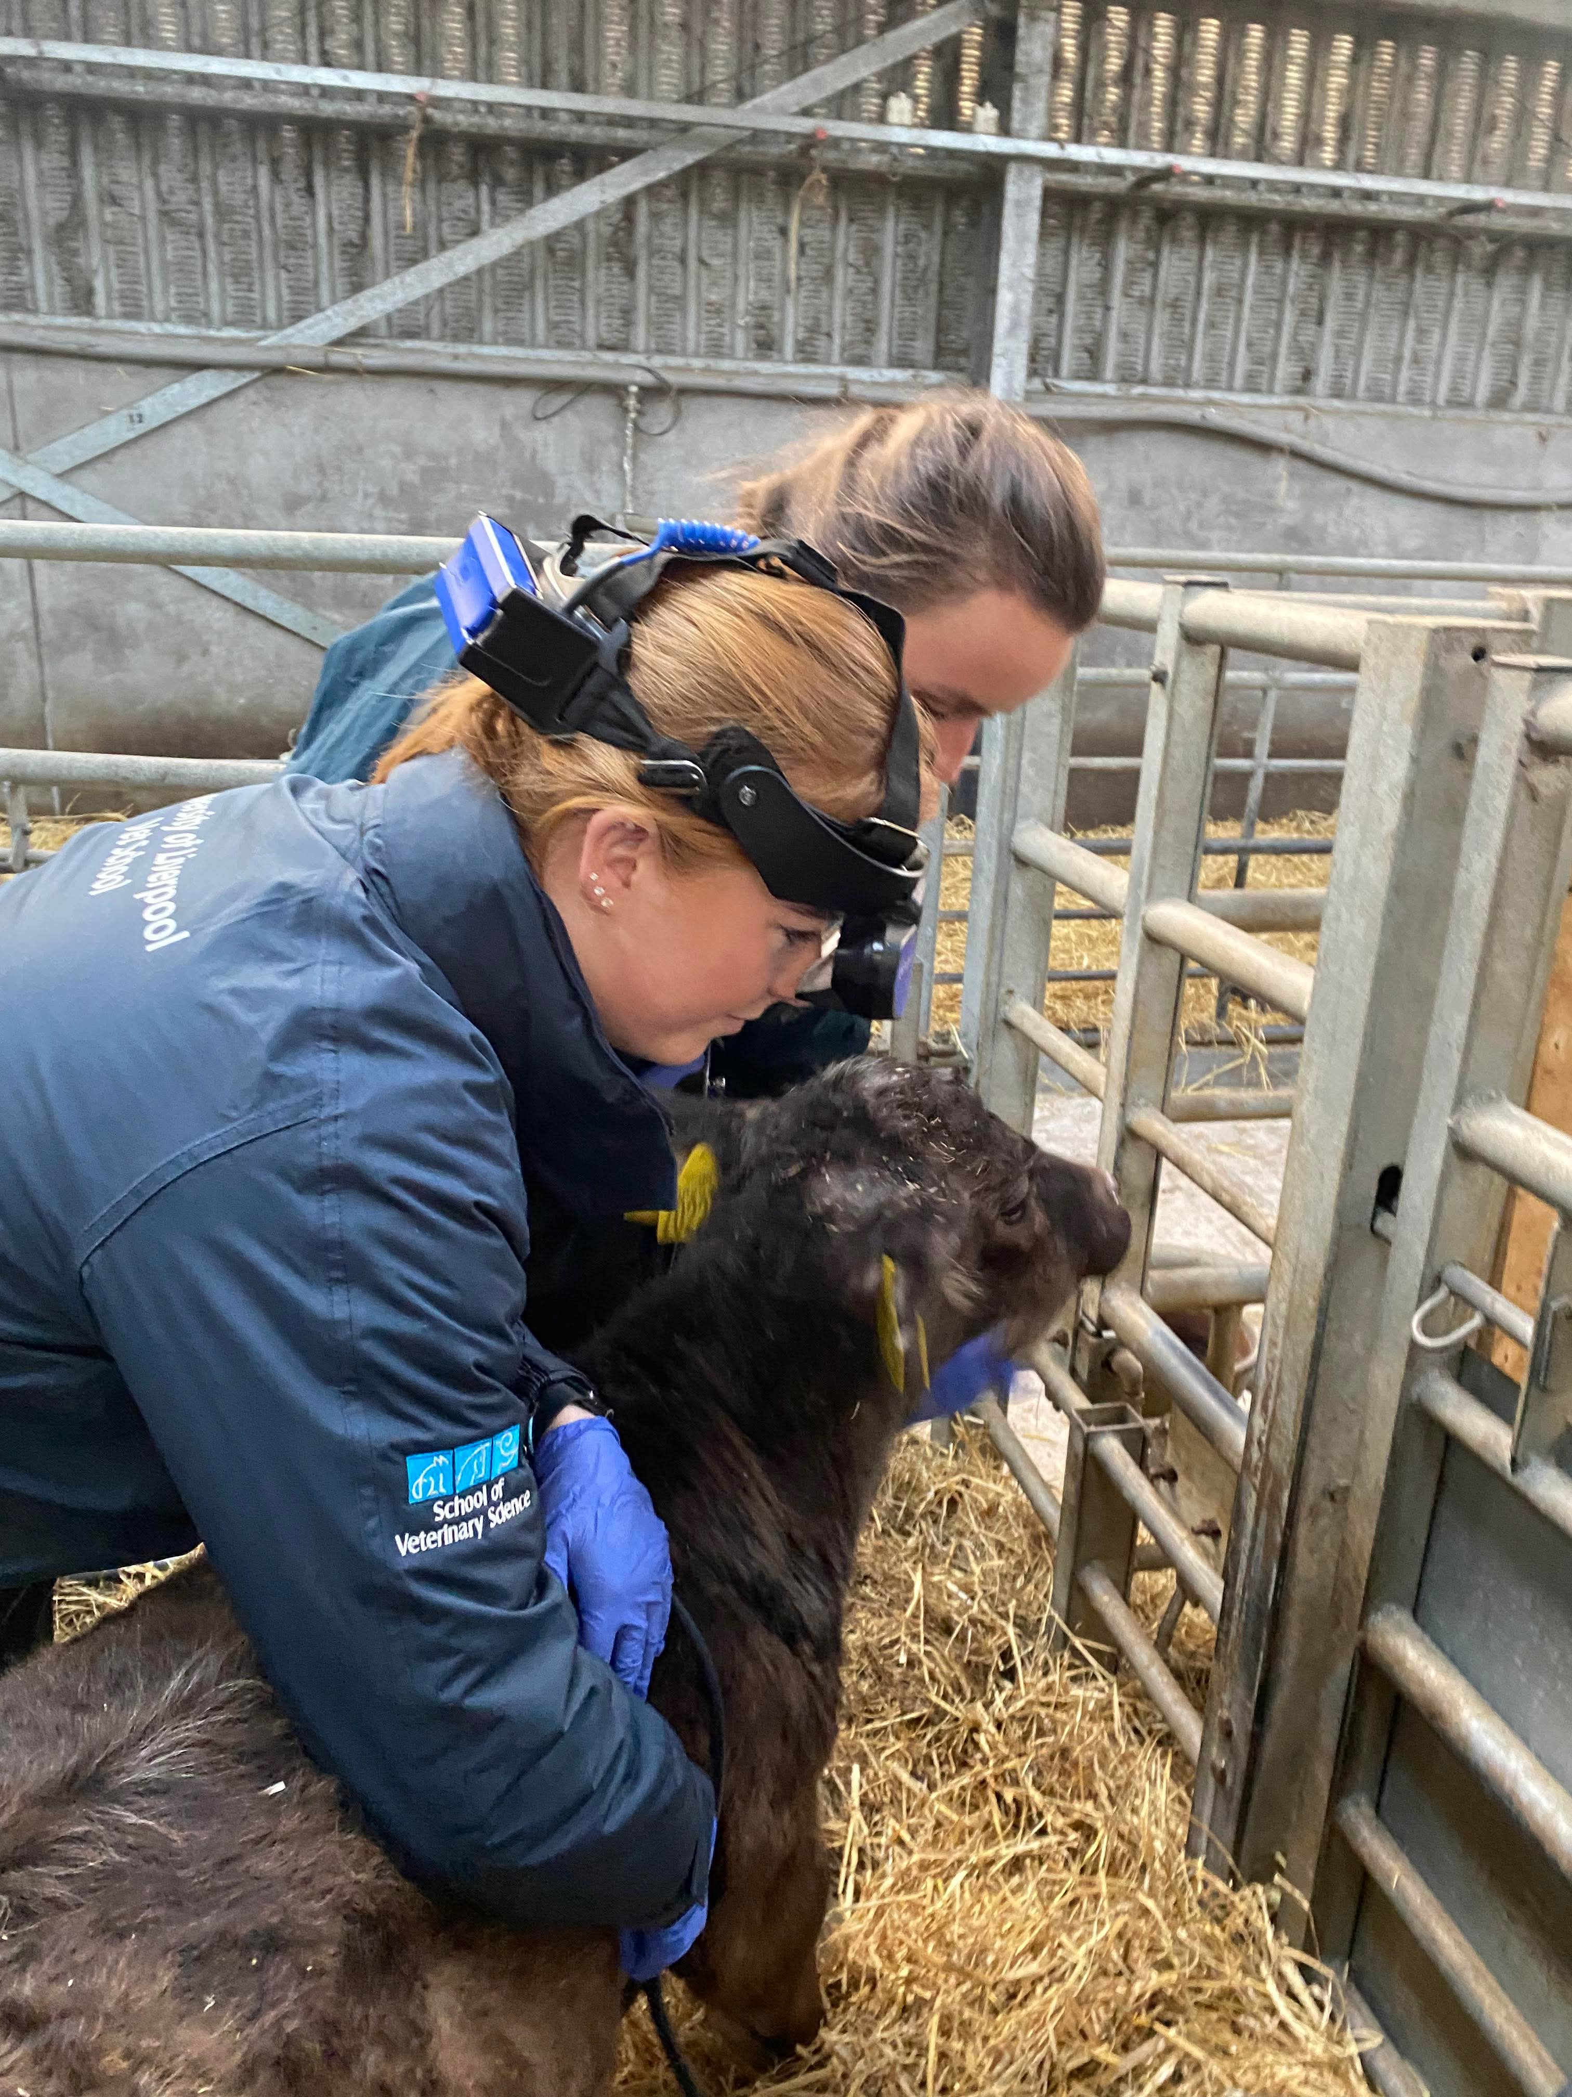Hello, and welcome to Liverpool Vet School! Congratulations on gaining your place and beginning your career.

We are LFAVS, the Farm Animal Veterinary Society here in Liverpool and Leahurst, and we welcome members from every year group. It does not matter if you’ve already decided that a farm career might be for you, or whether you are looking to broaden your horizons and learn more.

Our committee and members come from a variety of backgrounds, but we all share a keen interest in farm animal medicine.

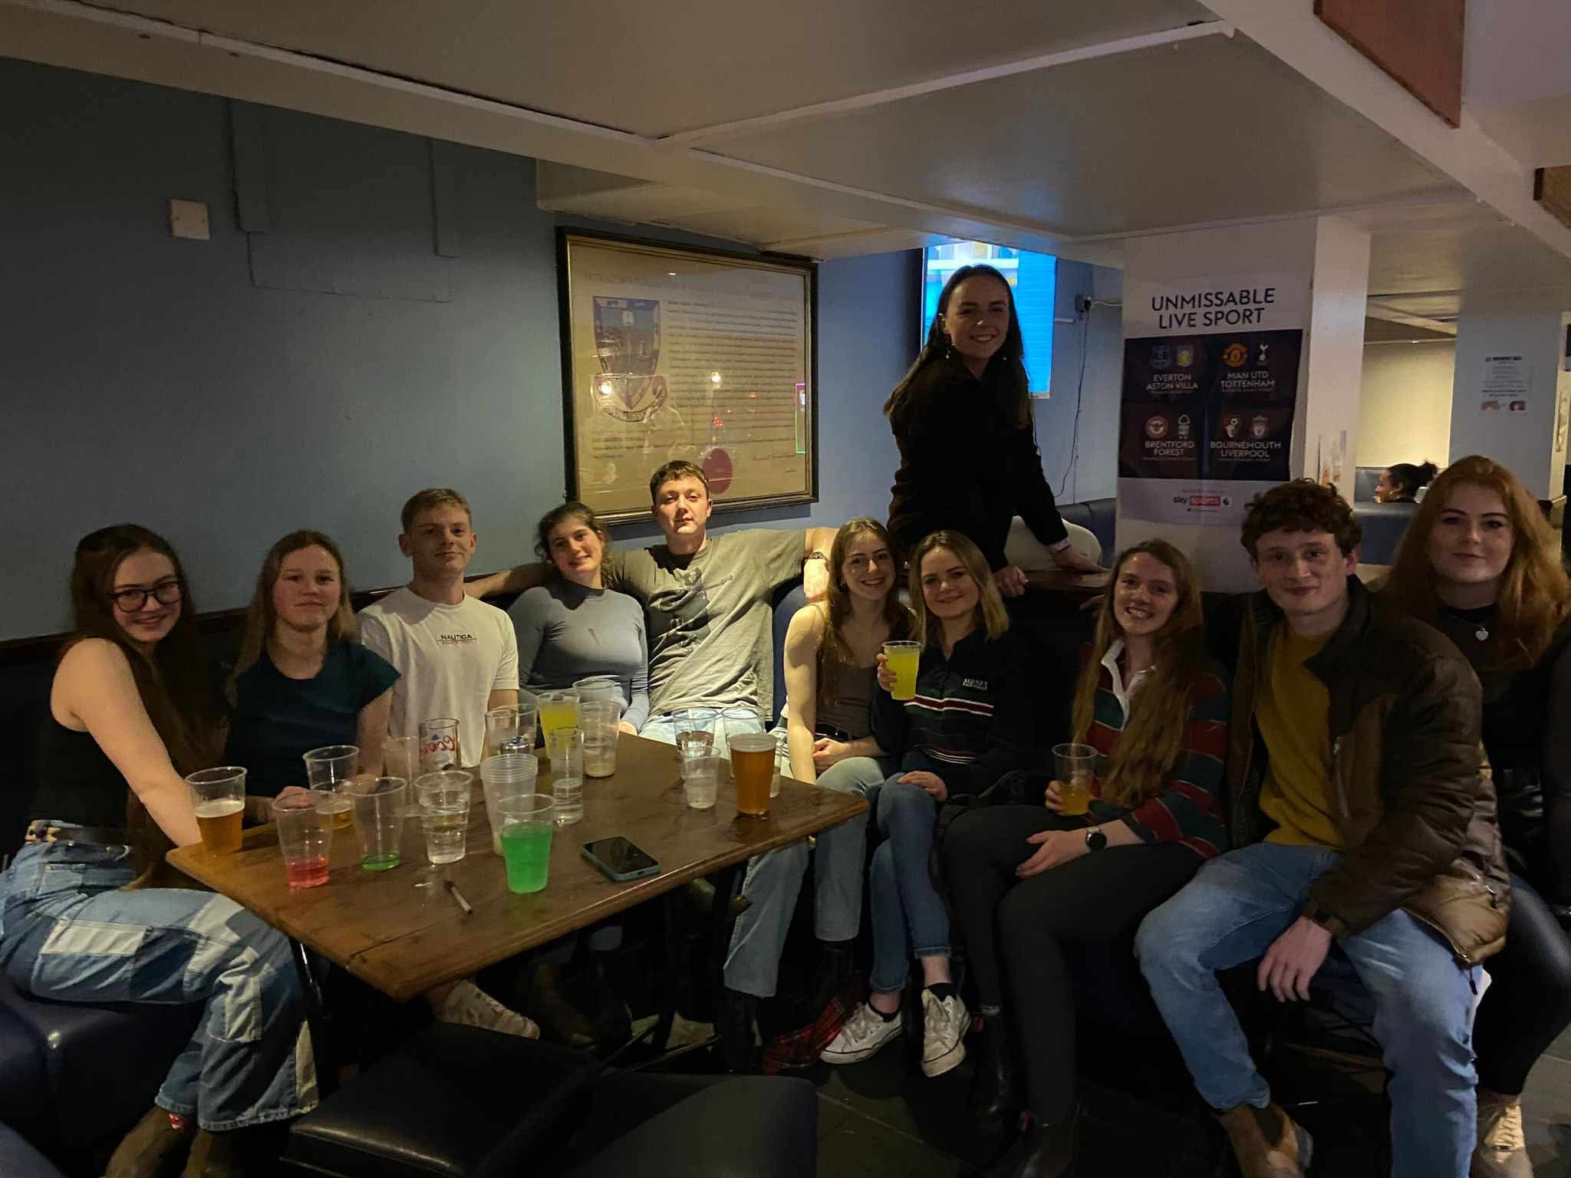We do a variety of events and talks throughout the year, both in Liverpool and Leahurst (often with pizza!). These range from ‘Avian Influenza & Poultry Vetting’ to ‘A Year in the Life of a Dairy Cow’. Some of our presenters are also alumni of Liverpool, and are always willing to give a helping hand to passionate students.

Through your membership, you are also a part of the wider FAVS, which allows you to attend congress which is held at a different vet school every year, Bristol in 2026! This is a weekend full of learning, as well as socialising. It is a great experience with lots of practical classes, as well as the opportunity to meet other veterinary students from around the UK.

We hold our annual ‘Species Day’, which is organised by our fantastic Species Day Co-ordinators. This is an opportunity to practice your clinical skills and attend some very interesting talks on Leahurst campus.

LFAVS will not only build on your farm animal teaching, but also allow you to meet like-minded peers in years below and above. For further information, please visit us at the Freshers Fair, on Instagram (@liverpoolfavs), or send either of us an email, and we will get back to you as soon as possible.

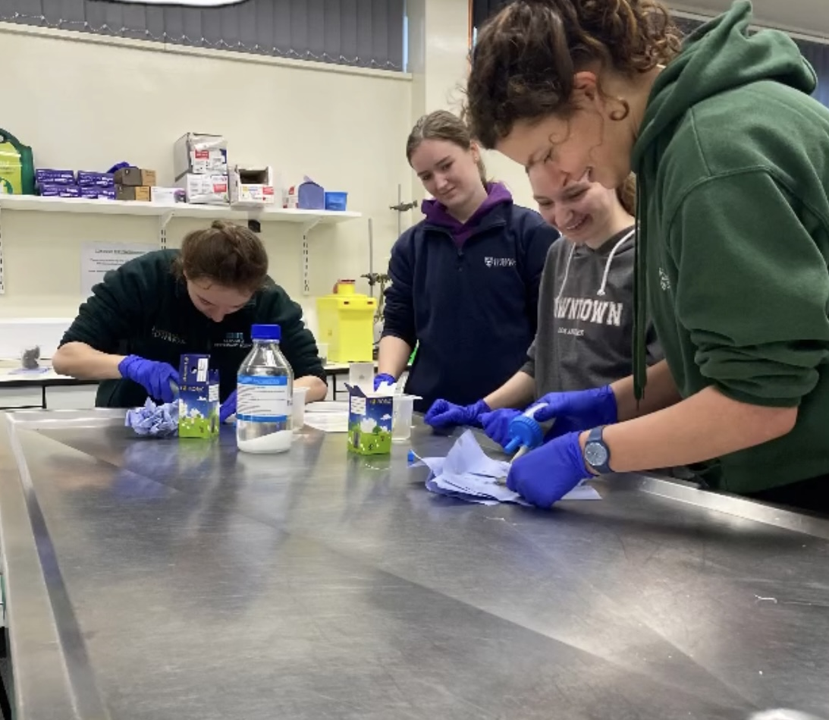We are looking forward to meeting you all!

Trudie & Connie

LFAVS Co-Presidents 2025-2026

Hltmarsh@liverpool.ac.uk / Hlcraff3@liverpool.ac.uk