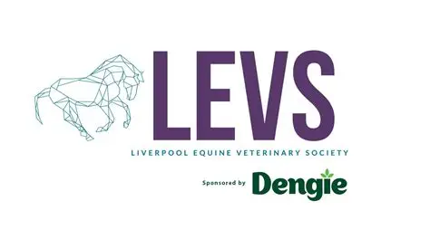

Hi 2025 Freshers! We are Liverpool Equine Veterinary Society (better known as LEVS), a group dedicated to sharing our passion for horses and all things horsey medicine.

If you’re not an overtly horsey person – fear not! We’re dedicated to showing people how versatile a career in equine vet med is, and while horsey jargon can take some time to pick up if you haven’t grown up around it. We are here to support you by continuing our ‘Help I’m not Horsey’ series to prepare you for husbandry and clinical placements (think dummy’s guide to handling horses).

We have some practical sessions and days we run every year, like our lunging/trot up practical at Thompson House Equine Vets to improve your handling skills. This year we hope to introduce some trips (hopefully to a horse trials/endurance competition to speak to the vets there and have a fun day out!), as well as some socials so you can meet other like-minded people.

Talks from current equine vets, paraprofessionals (vet physios, farriers, equine dental technicians) will also crop up throughout the year so keep an eye out for those too! We will make sure to spread the word on our social media outlets so make sure you’re following us on Facebook and Instagram!

**@liverpoolequinevetsoc** (insta)

**Liverpool Equine Veterinary Society** (facebook)

Looking forward to seeing you all at Fresher’s Fair where you can pick our brains about why this society is worth a join (it’s the best!).

Best wishes and see you soon,

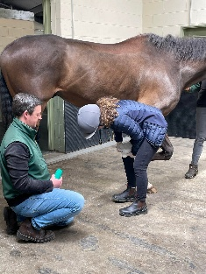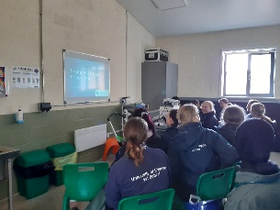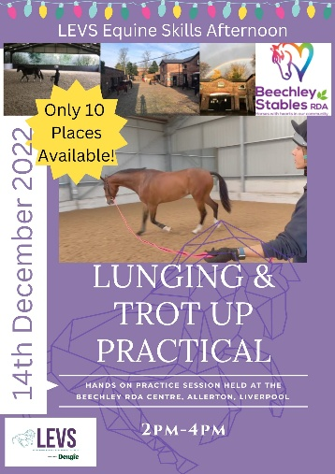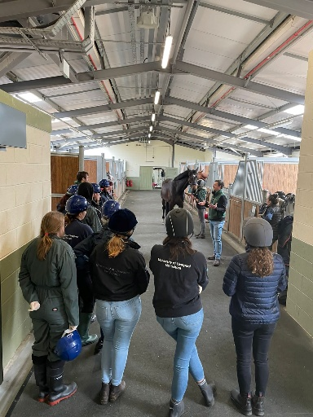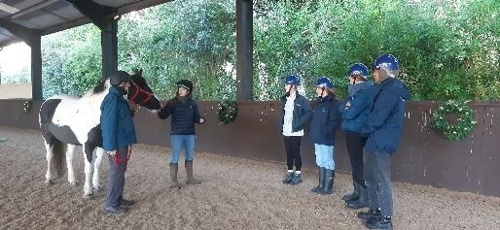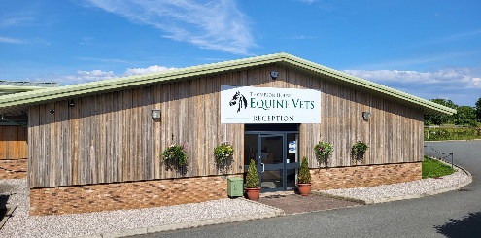Louisa Moll (LEVS President) and the rest of the LEVS committee x