Cycling to Leahurst Campus
Why do it? Basically, it’s good for you, better for your wallet and great for the world…
- It saves on the cost of fuel and associated pollution
- It’s great exercise, so it’s good for your body and your mind
- It eases the shortage of carparking at Leahurst
- It allows easy use of trains to and from Hooton or Neston
- You’ll beat the queue at the exit (as you can use the Damhead Lane exit)
- Because cycling changes you as person, you become more at one with your environment, you experience the smells, the previously unseen sights, the sound of your tyres being fuelled by your own muscles, the wildlife, the breeze…. It brings on a clarity, a sense of fulfilment and a feeling of being present that cannot be explained but must be experienced.
Need any more reasons? Here’s 21 great ones from Cycling UK

What do I need?
- A bike, of any type. Some are easier (and safer) than others to ride on certain surfaces and it helps if the bike fits you well. Narrow tyres are great on the road but may be slippery on off-road paths.
- A helmet. Whilst some still argue against them, the evidence that they significantly improve the outcome of an is overwhelming. Again the helmet should fit and have a chin strap to keep it place. (rule 59 of the highway code).
- Some lights, front and rear. Many experienced cyclists use lights even in broad daylight to increase their visibility to drivers. It is likely you’ll also need them on darker mornings and evenings (a legal requirement in the dark, plus a rear red reflector and amber pedal reflectors, rule 60) and in bad weather too. Lights come in two types, ones that are designed to make you more visible and ones that are bright enough to also light up your path. Think about your route and when you’ll most likely be riding. Consider if traditional batteries vs. rechargeable (often via USB) best suit your needs.
- Suitable clothing based on the weather, not likely to tangle in your chain and preferably with an element of high-visibility colouring (rule 59). The sleek all-black riding attire can look great, but think about improving your chances of being seen by drivers.
More information on cycling safety can be found here on the government cycle safety webpage and in more detail within the cycling section of the highway code The Highway Code - Rules for cyclists (59 to 82) - Guidance - GOV.UK (www.gov.uk)

How do I get to Leahurst?
Leahurst has two entrances, the main one off the A540 dual carriageway and one to the East of the campus on Damhead Lane. The A540 is a busy dual carriageway with a 60mph speed limit and variety of vehicles including HGVs. It is strongly recommended that you utilise the Damhead Lane as both your entrance and exit. Cyclists and pedestrians can use Damhead Lane access as both an entrance and exit. Vehicles may only exit here.
(WW= Wirral Way, a multi user path stretching from Hooton in Cheshire, 12 miles to West Kirby in Wirral)
Leahurst Campus has a 10mph speed limit and this also applies to cyclists.
If you ride an E-bike please pay particular attention to the speed limit. Note that charging facilities are not currently available at the campus and e-bike batteries must not be charged indoors.
Ness Heath Farm can be accessed from Mill Lane and both Wood Park Farm and Ness Heath Farm can be accessed directly from the WW
From Neston Little Neston and Ness
Option | Distance | Elevation | Surface types | Considerations | Directions
From Neston, Partially Traffic Free  In red on the map below | 1.6 miles | +75ft | 1.2 miles hardpack gravel path.  0.4 mile road (private) | WW can get dark early on this section.  Beware of farm traffic on the campus private Lane | Where Bushell Road meets the top of Station Road, there is an access point for the WW. Proceed along the WW until you approach the A540 underpass. Proceed through it then keep right to access the private Lane onto campus.
From Neston Cross by road  In Blue on the map below | 2.55 miles | +175ft | 100% Road | Roads can get busy at peak times | From the cross, head downhill along the High street then left at the traffic lights onto Hinderton Road. Follow this gradual climb to the traffic lights at the Hinderton Arms pub, then go straight across onto Quarry Road (cars cannot pass this way but cyclists can). Follow Quarry road until it finishes Hanns-Hall Lane, then head left/straight-on. Turn right after 500m onto Damhead Lane, then after 400m turn right onto the campus.
From Little Neston or Ness, by road, option 1 via Mill Lane  In Purple on the map below | 2.3 miles | +125ft | 100% Road | Mill Lane is narrow in parts with passing places. | From anywhere in the far end Little Neston, climb or converge on the top of Marshlands Road. Head up the hill on Burton Road towards Ness Gardens. After 800m or ½ mile (after passing the Wheatsheaf pub) turn left onto Mill Lane. Carefully proceed using the passing places to the end of the Lane and then straight ahead at the traffic lights onto Damhead Lane. Go over the hump-back bridge and then turn left onto campus.
From Little Neston or Ness, by road, option 2, avoiding narrow lanes  In orange on the map below | 2.1 miles | +125ft | 0.7miles, hardpack gravel path  1.3 miles, road (0.4 private) | Beware of farm traffic on the campus private Lane | From anywhere in the far end Little Neston, climb or converge on the top of Marshlands Road. Climb Bull Hill and turn left at the top, pass the shops and then turn right opposite the Royal Oak pub onto Lees Lane. Close to the top of Lees Lane (after 1.2km or ¾ mile) turn right on to the WW carpark and onto the WW itself. Proceed along the WW until you approach the A540 underpass. Proceed through it then keep right to access the private Lane onto campus.
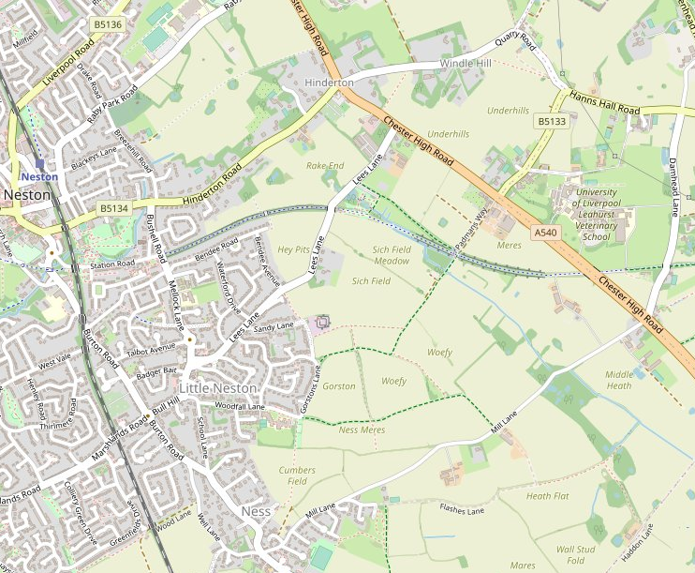
From Hooton Station or Willaston
Option | Distance | Elevation | Surface types | Considerations | Directions
From Hooton, traffic free (95%)  In red on the map below | 3.0 miles | +100ft | 2.4 miles hardpack gravel path,  0.6 miles road (0.4 private) | Short steep section at very start of WW,  Care needed when crossing Hadlow Road  Beware of farm traffic on private campus Lane | Turn left out of the station and climb the road up over the bridge. Just after the top, turn left through the opening onto the WW. Continue on WW, carefully crossing Hadlow Road after the restored train station. Continue on the WW until you reach the Leahurst access Lane (just before the A540 underpass. Double back left onto the lane and onto campus.
From Hooton by road  In Blue in the map below | 2.5 miles | +100ft | 100% Road | Other road users | Turn left out of the station (B5133) and climb the road up over the bridge. Continue a mile towards and through the village of Willaston. 300m after leaving the Village, turn left at the cross-roads onto Damhead Lane. After 400m turn right onto the campus.
From Willaston, partially traffic free  In red on the map below (including dotted line) | 1.5 miles | +50ft | 0.8 miles hardpack gravel path  0.7 miles road (0.4 private) | Other road and path users  Beware of farm traffic on private campus Lane | Starting from the green in the centre of the Village, proceed along Hadlow road for 450m until you reach with WW, marked by some restored level crossing gates at the station. Turn right onto WW and continue until you reach the Leahurst access Lane (just before the A540 underpass. Double back left onto the lane and onto campus.
From Willaston by road  In Blue in the map below | 1.1 miles | +50ft | 100% road | Other road users | Starting from the green in the centre of the Village, continue towards Neston along the B5133. 300m after leaving the Village, turn left at the cross-roads onto Damhead Lane. After 400m turn right onto the campus.

OpenStreetMap® is open data, licensed under the Open Data Commons Open Database License (ODbL) by the OpenStreetMap Foundation (OSMF).

Cycle Storage and Facilities at Leahurst Campus
Leahurst Campus has five designated locations where cycles can be stored. All of the areas have robust metal loops and will require a lock to secure your bike to them. Locations are:
- To the rear of Leahurst House
- To the side of the Education and Support Hub
- On the main driveway
- Between the carpark and Henry Edwards Learning Center
- The side of the Small Animal Teaching Hospital
Location 5
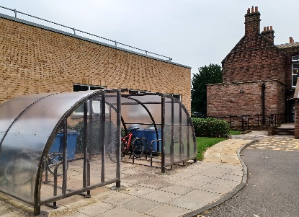
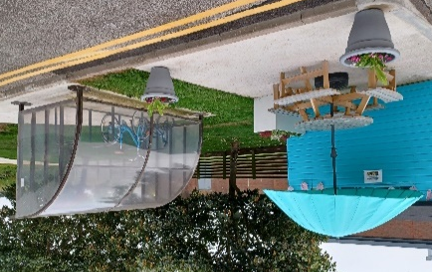
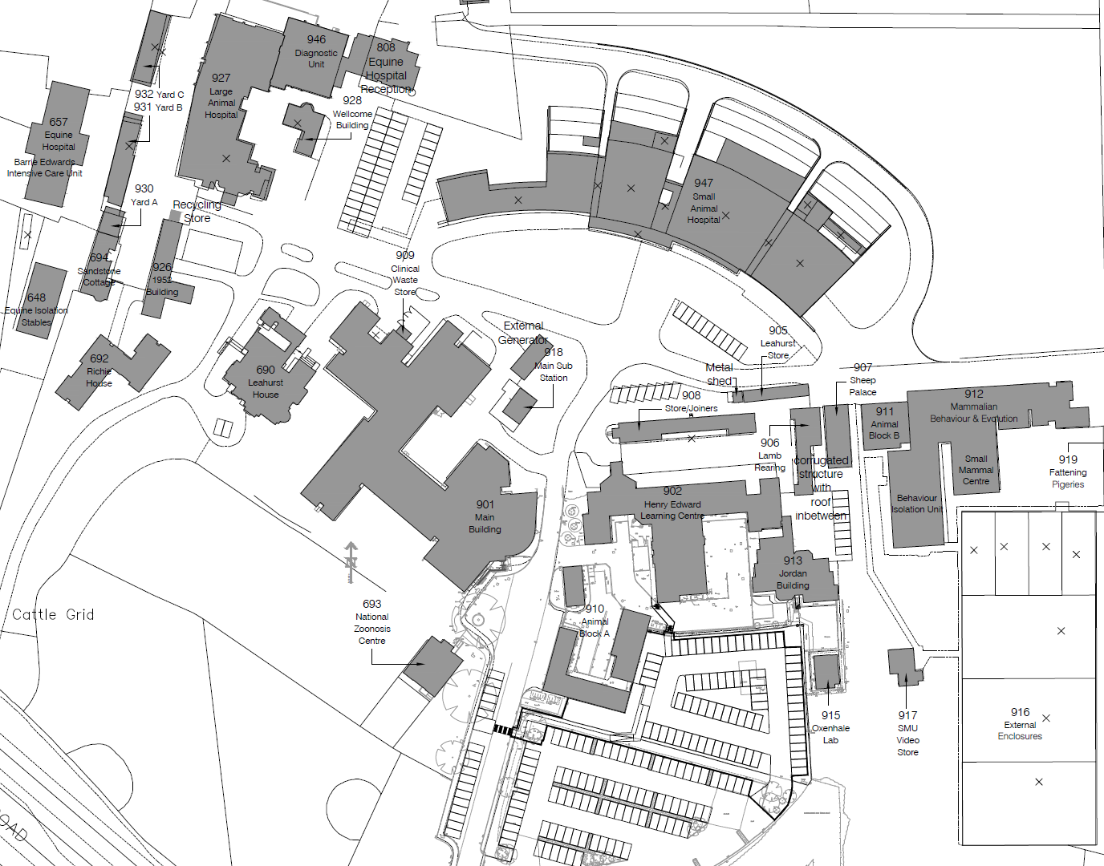
Location 4
Location 3
Location 2
Location 1

Not all bike locks are made equal and it can be confusing knowing what to choose, however an independent testing organisation called Sold-Secure has classified most of the locks available in the UK, starting at Bronze for more basic protection thought to Silver, Gold and Diamond with increasingly high levels of protection. Lower levels of protection will deter an opportunist whilst the higher levels can withstand prolonged attacks from determined thieves.
Shower facilities are available at:
- Henry Edwards Learning Centre, 1 x gender neutral (G/039) (side room off the farm practice changing room)
- Richie House (G/004) - 1 x gender neutral - Access restricted to Richie staff but available upon request.
- Education and Support hub, first floor (1/007) – 1 x gender neutral
- SATH – 1 x female changing (G/018), 1 x male changing (G/017) 1 x disabled shower (G/026) – accessible to SATH staff and students only.
- Leahurst House 2 x women (G/019) / 2 x Men (G/021)
Need a bit of help?
If you haven’t cycled for while or are inexperienced, it can be a little daunting setting out on the roads. The routes above try to make use of safer, slower roads and traffic free sections, but traffic, the major cause of anxiety for some cyclists cannot always be avoided. There is a whole host of great information to help you feel more at ease and confident on the road. Cycling UK is a great resource for things like Lane Positioning and how to help drivers see you better. Keep checking our newsletters such as Vets-News and our social calendars for cycling events too such as those run by University partners Peleton.
If your bike has a flat tyre, is making a strange noise or just isn’t running quite right then it is worth getting it checked over. The closest local bike shops (not endorsed by or affiliated with the University) can be found at:
Just Riding Along, 22 Bridge Street, Neston, CH649UJ,
call: 0151 353 1272 or visit the website

Wheel Worx Wirral
Platts Cottage, The Parade, Parkgate, CH64 6RW
0151 336 5098, wheelworxwirral@gmail.com

…however, there are many others available in Liverpool, Wirral, Cheshire and North Wales.
Leahurst also has many of its own keen cyclists, who are always happy to discuss any aspect of cycling, including where to find some local rides, clubs and even offer informal advice on conducting repairs and maintenance. If you’re interested to find out more contact Dan Dawson Daniel.Dawson@liverpool.ac.uk or Fernando Malalana-Martinez fernmala@liverpool.ac.uk

Additional Staff Benefits:
Cycle to Work Scheme. The University offers employees the opportunity to make huge tax and national insurance savings on the cost of a new bike and safety accessories to the value of between £100 and £2,500. These savings are achieved via salary sacrifice which lets you spread the cost over 12 months to make payments more convenient.
Cycle to work scheme - Staff Intranet - University of Liverpool

Merseytravel cycle discount scheme
For those staff who wish to purchase a bicycle without going through the cycle to work scheme, the University can get a discount at several independent cycle stores through its membership of Merseytravel’s Employers Networks.
University employees can take advantage of the cycle discount provided by numerous cycle providers, on the production of your staff ID and quoting the Merseytravel Employers’ Network scheme. Find out the participating providers here.

Based in Liverpool?
See our Liverpool cycling information here Cycling - Sustainability - University of Liverpool

