Recording off the job hours in Bud

Login to Bud, you should have received an invite to Bud via email.
Login | Bud

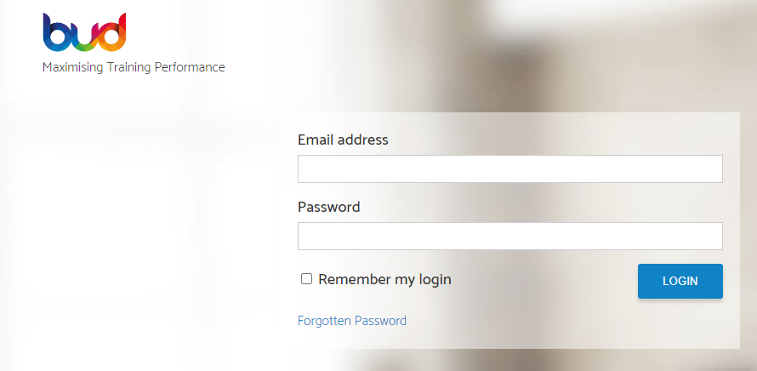

Once logged in, you will see the screen below. Click on continue learning to access your learning plan.

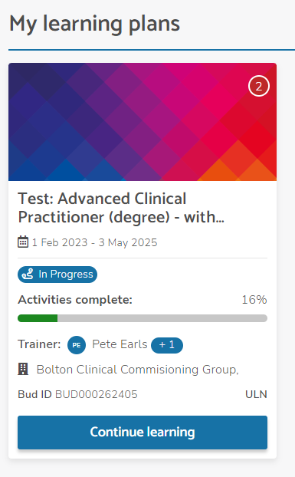
You will then see your learning plan screen, as below. You will see you can filter your activities. If you filter by Set activities, you will see activities each month for Monthly timesheet to capture Off the Job Hours.

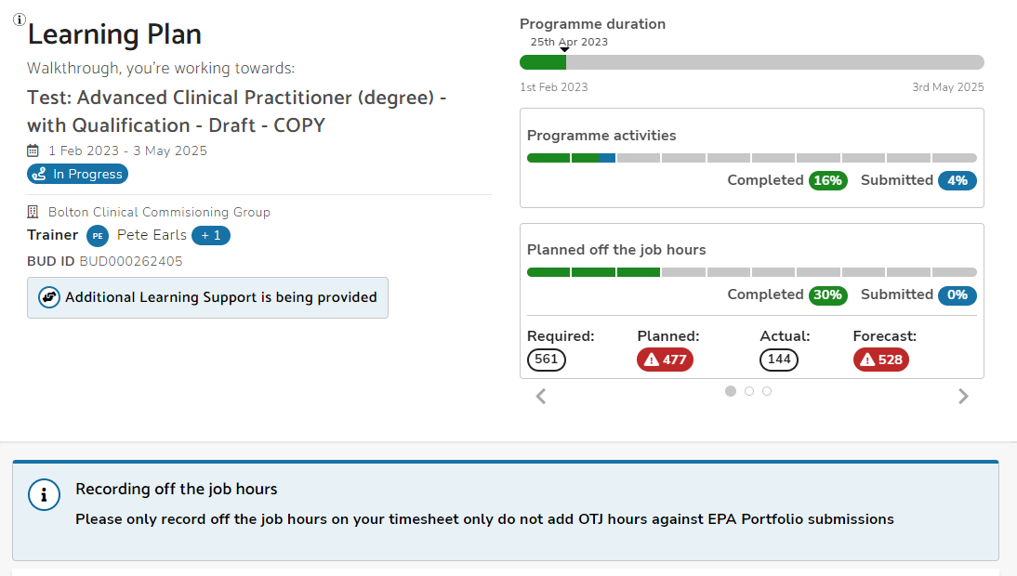

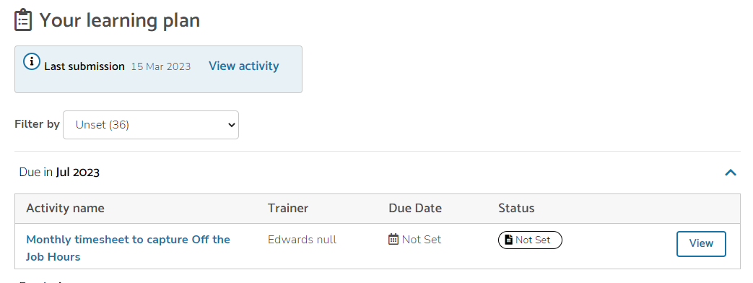

Click on view.
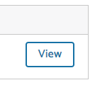
You will see Activity Details, then two other tabs for Submissions & Messages and Off the Job Hours.

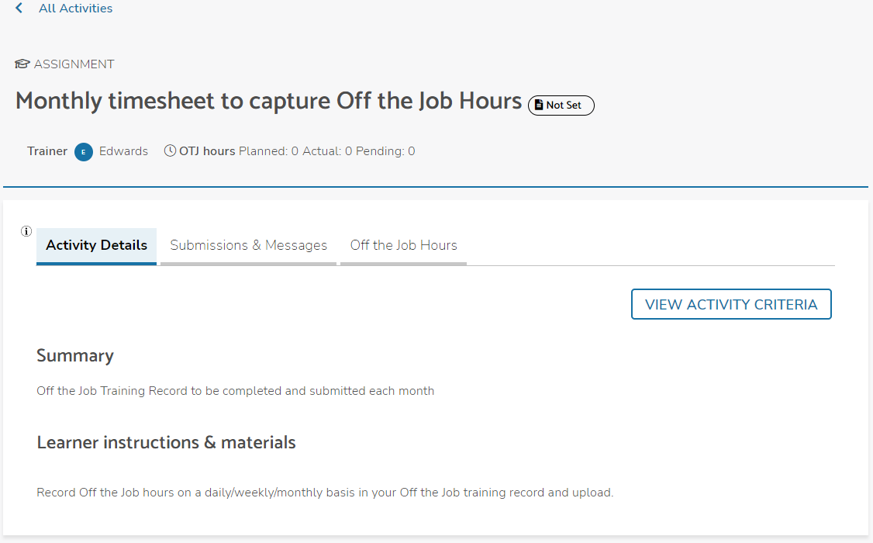

Click on the Submission & Messages tab, then the Make a Submission tab.

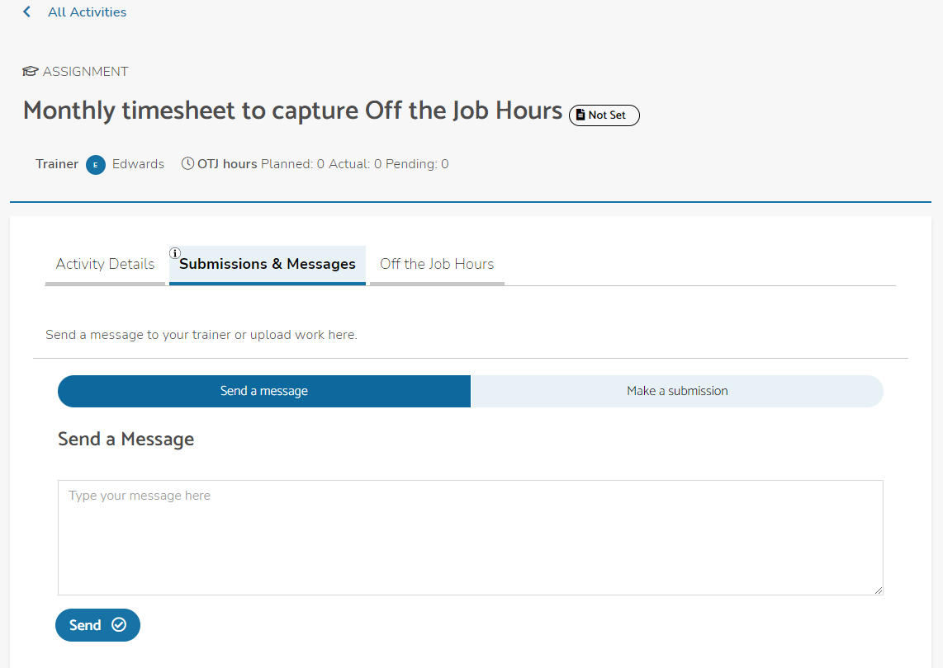

You will need to complete the Off the Job Training Record spreadsheet with the Off the Jobs hours completed for each corresponding month. This should include any off the job hours completed in work hours and on your university day.
Please ensure that the number of hours at the end of the month add up to a whole number as .25, .5, .75 etc. cannot be entered into the Bud system or be reported into the government funding return each month.

Upload the completed spreadsheet by dragging the file into the uploaded files section in the Make a Submission tab, as per below.

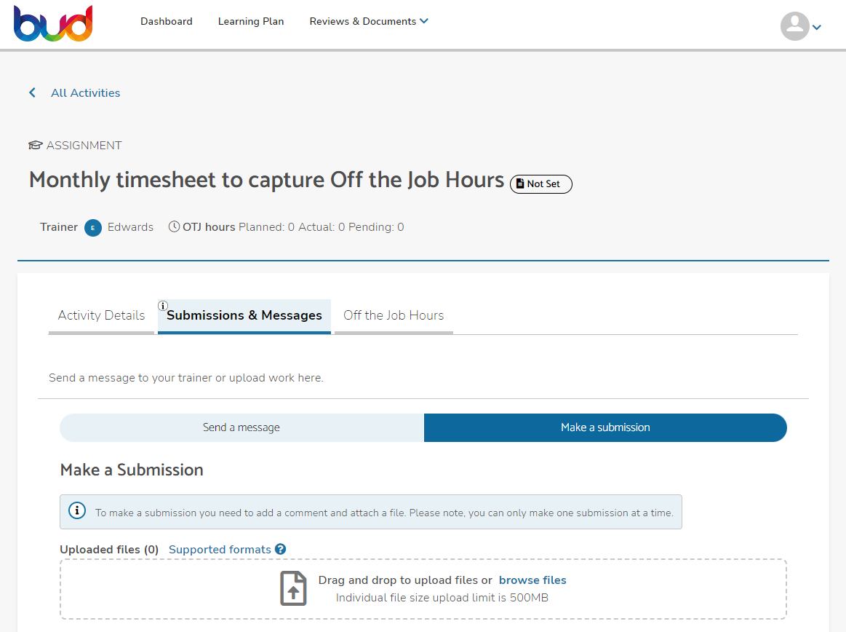

Then add a comment, such as ‘Completed April OtJ Record’ in the Add a Comment section and type in the number of hours in the Add the Off the job Hours ‘Hours’ box, as per below.
Click on Submit.
