LEAF User Guide
Getting Started
- Go to the LEAF login portal to start (https://app.ucl.ac.uk/leaf/leaf_external).
- Click “Register” (Fig.1 - see button above Login). Your username must be your institutional email. Validate via the email sent to your inbox. Once registered and validated, you should be able to login to LEAF.
Figure 1. LEAF Login Page
- Login to LEAF. You need to join an existing lab, or request to setup a new lab if your lab is not listed yet. When choosing the name for a new lab profile, make sure it is easy to recognize by other users.
- If joining an existing lab, then this can be approved either by someone already in the lab, or the institutional administrator. If you’ve requested to create a new lab profile, this can be approved only by your institutional administrator.
- Currently you may only join one lab. If you require access to multiple labs, you may request institutional admin rights from your institutional administrator.
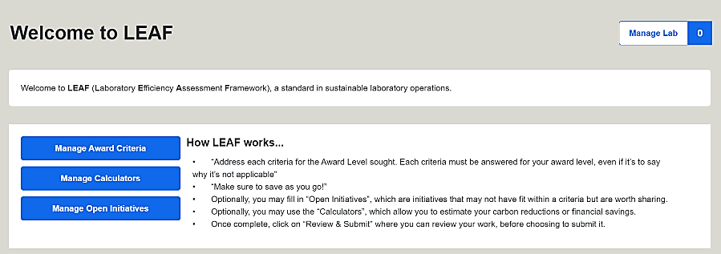
Figure 2. LEAF User Landing Page
Managing Your Lab
Figure 2 shows the landing page of your lab. You can manage the lab’s profile via the manage lab button at the top right of the landing page. The manage lab functions are outlined below.

- Lab Details: Here you can update the lab name, as well as provide context on your lab.
Note that the name chosen here will be printed on your accreditation certificate, but can be changed at any point.
- Lab Members: Here you can manage who is in your lab. You can add new members who have registered to the LEAF platform.
- New Lab Member Requests: Here you can approve new lab members to your lab.
- View Institution Structure: Here you can view how your lab is mapped within your institution amongst the other labs using LEAF. This will be set by your administrator.
- View Submission History: Here you will be able to see any approved, rejected, or pending LEAF submissions from your lab.
Figure 3. Manage Lab page
Completing LEAF
- To complete a LEAF submission, you must address the relevant criteria. You can access them via the Manage Award Criteria button from the LEAF landing page.
- To achieve an award level, all criteria must be addressed within that level. If you feel a criteria is not applicable, explain why. Your text will be automatically saved as you input it, but you can still click “Save answers” for assurance.
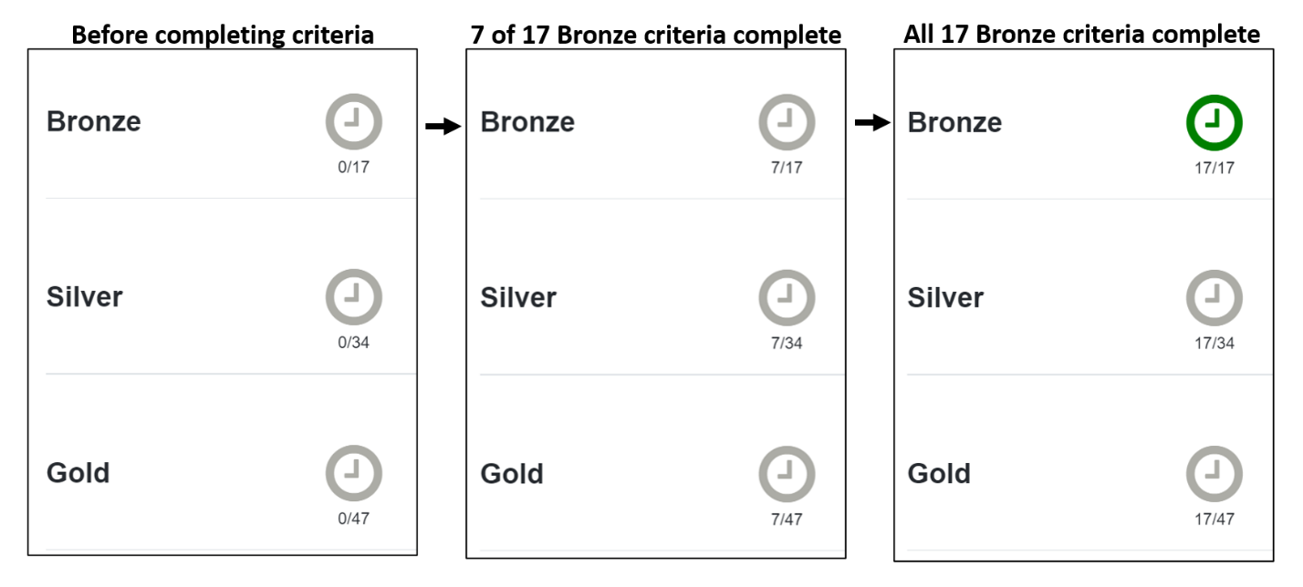
- LEAF Progress – You can track you progress on the LEAF landing page. The number of criteria completed for each award level will be shown as in (Fig.4). Icons (such as the clocks below) and the associated colours are outlined in the Submitting LEAF section below.
Figure 4. Series showing progress of completed Bronze award criteria.

- The LEAF Calculators and Open Initiatives are optional, but are recommended. Calculators allow you to estimate the carbon reduction and financial saving of actions you have completed. Open Initiatives can be used to share any sustainability progress in areas that are not covered by the LEAF criteria. Both can be accessed using the buttons that are on the LEAF landing page.

Calculators – these are intended to capture approximate trends and provide estimates as opposed to exact measurements. To use the calculators, please follow the below steps:
  - Click the Manage Calculators button from the LEAF landing page
  - Scroll down the page to see the available calculators displayed as below (Fig.5)
Figure 5. LEAF Calculators

  - Click on the calculator that you wish to use - Focus on the calculators that relate to areas where you expect to make an impact, as opposed to trying to complete them all.
  - Fill in the relevant Baseline Calculators. e.g., complete the ULT Freezers calculator baseline if you expect to change your ULT freezers operating temperature. If you are uncertain on any definitions or how to find the information needed, scroll down at the bottom of the calculator to find the “Top Tips” and “Relevant Terms” for assistance.
  - Calculators automatically save your input and there is no need to save as you go. After filling in your data, the calculator should provide the carbon and financial cost of your items at the bottom of the page.
  - Once the Baseline Calculator has been completed, once ready you may click on the Savings Calculator for that same item. Input your data reflecting on the actions you have taken that resulted in a change. e.g., you are using the Savings Calculator for Waste, as you now are recycling more items that would previously been disposed of as general or clinical waste. At the bottom of the page, you will find the financial and carbon cost, as well as the difference between your baseline and savings calculator. If your savings total is a positive number, you have obtained savings. If the savings figure is negative, you have increased your costs since the baseline.

Open Initiatives - These should be initiatives which have not been captured by the criteria or calculators, but contribute to the sustainability of your lab. To use the Open Initiatives, please follow the below steps:
- Click the Manage Open Initiatives
- Use the button on the top right of the screen to create an initiative.
- Provide a brief description of the initiative. You may estimate savings associated with your initiative (or simply put ‘0’ if there were no savings).
- Click the Save button at the bottom of the screen. This will return you to the Open Initiatives page and the initiative created should be visible.
Once you have completed all relevant criteria, filled in any Calculators and Open Initiatives, you can submit your LEAF Award for review.

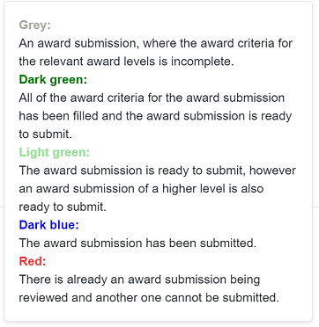
Submitting LEAF
Figure 6. Icon colour key
- On the LEAF landing page click the icon next to the award level you would like to submit.
Note: The icons are colour coded based on progress (see Fig.6). Once you have completed all the criteria for the award level you intend to submit the icon should turn dark green.
- You will be taken to the Review and Submit page which gives you the opportunity to review all that you have completed. You will be able to attach any calculator you have completed that you would like to submit simply by click “Attach” next to the relevant calculator.
- Once you have reviewed all of the information and attached any completed calculators, click on “Submit Sustainability Assessment” at the bottom of the page.
Note: It is important to submit for the highest award you are intending to achieve at this stage. e.g. do not submit for Bronze if you are seeking a Silver award.
- After you have submitted your LEAF Award the icons on the landing page will change colour accordingly.
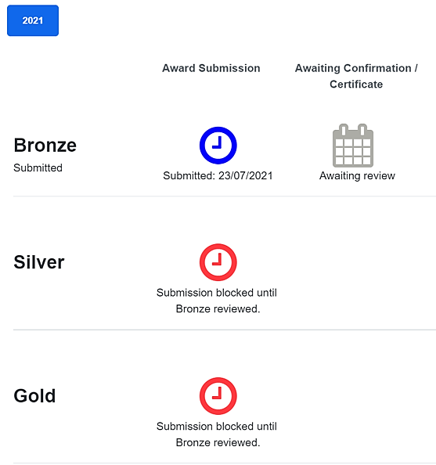
- Your submission will be reviewed by your Institutional Administrator and you should receive an email notifying you of the outcome.
Figure 7. Award submitted
- If you award is approved, the awaiting review icon will be replaced with a LEAF Award logo. Clicking on the logo will allow you to download your Award Certificate. Print your certificate, or share on social media!
- All criteria competed are retained in the award criteria making it easy for you to review this in future and edit as appropriate. They are time-stamped though, so review and ensure they are up-to-date each year.
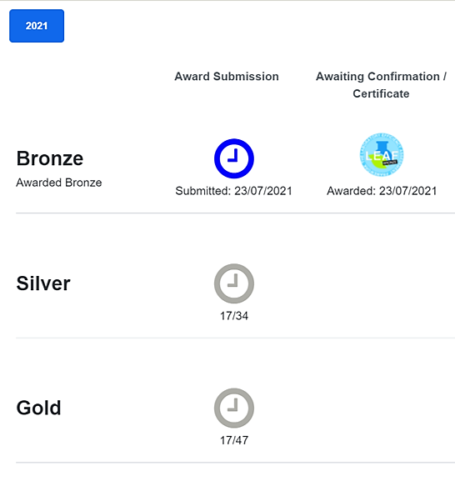
- As you progress, the award section on the LEAF landing page (Fig.7) will be have additional year tabs. Each year can be selected via the buttons in the top left corner.

