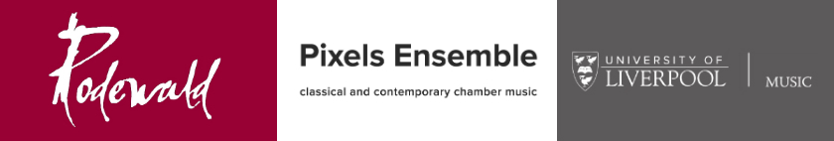

EXPRESSION OF INTEREST IN RODEWALD AWARD FOR YOUNG COMPOSERS
Please complete the form below by Monday 28 November 2016 and return to Dr Helen Thomas:

email: helen.thomas@liverpool.ac.uk
post: Department of Music, 80-82 Bedford Street South, Liverpool, L69 7WW

NAME OF SCHOOL: __________________________________________________________________

CONTACT NAME (individual student or teacher): __________________________________________

CONTACT EMAIL: ___________________________________________________________________

IF REPLYING ON BEHALF OF SCHOOL, NUMBER OF STUDENTS EXPECTED TO SUBMIT WORKS: ______

SIGNATURE _____________________________________________________DATE _____________

