Aurora Project Reflection

The Aurora x Vibe project was a great opportunity to gain some valuable industry experience. I was able to put my creative skills into practice by creating content for several social media channels to implement a successful campaign.

When conducting a research report prior to the campaign launch, it was really interesting to be allocated time to immerse ourselves in Vibe’s industry so that we could fully understand their intentions and competitive landscape. Although I knew it is always important to gain commercial awareness, this task allowed me to put that into practice within a real time project which I thought was especially valuable.

The initial campaign activation plan was set out between the three of us, identifying the objective, message, channels, content, CTA, initiatives and KPIs we intended to implement throughout the campaign. Within this process I learnt a lot about how the agency side of marketing operates and how thorough campaign plans can be. My favourite part of these initial ideas was meeting with Aibhe and brainstorming all of our creative ideas, as this allowed me to not only challenge myself creatively but also have the opportunity to bounce off someone else and expand on each other's ideas.

Some examples of our posts-
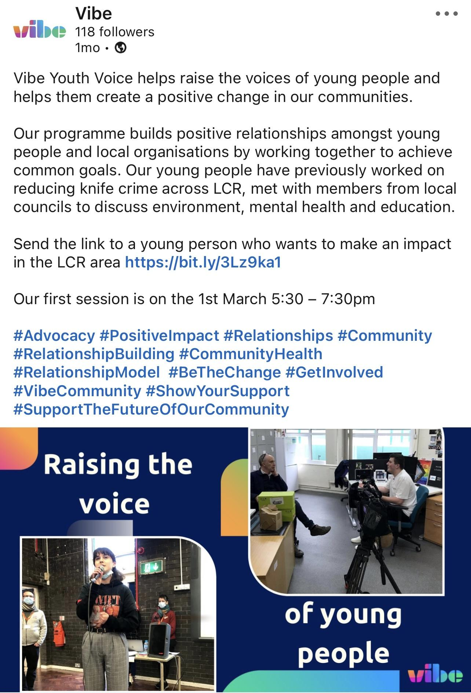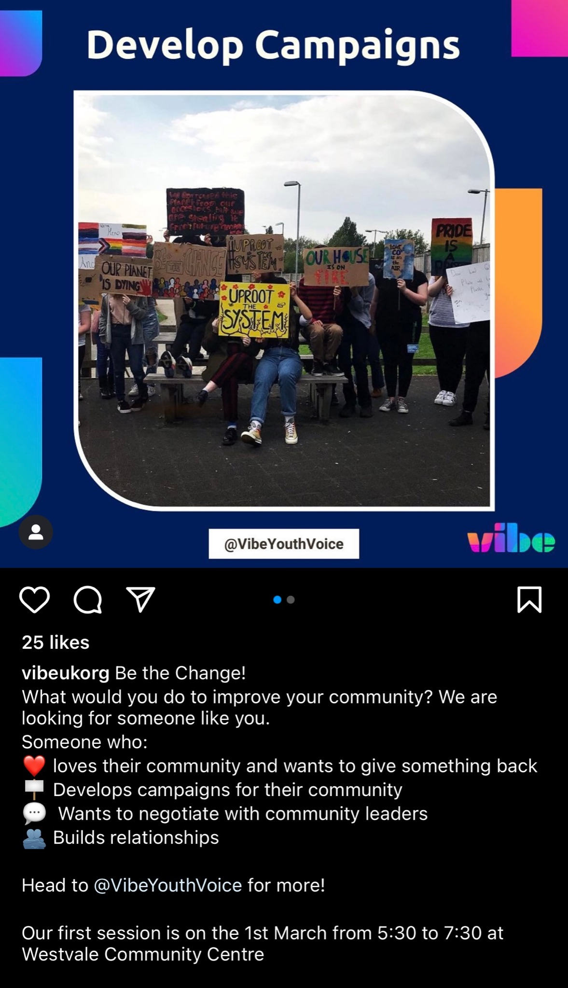

I was really happy with what we came up with and feel that we captured the brief well, making sure that we stuck with Vibe’s branding and carried this through the posts we created. We also sent more creative suggestions to Vibe to potentially implement in the future, which I felt was a good way to round off the project - this was influenced by our reflection on the analytics gathered from the campaign.

