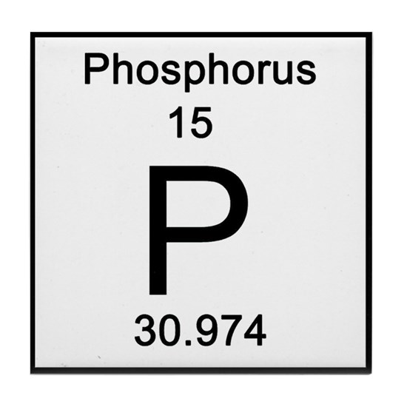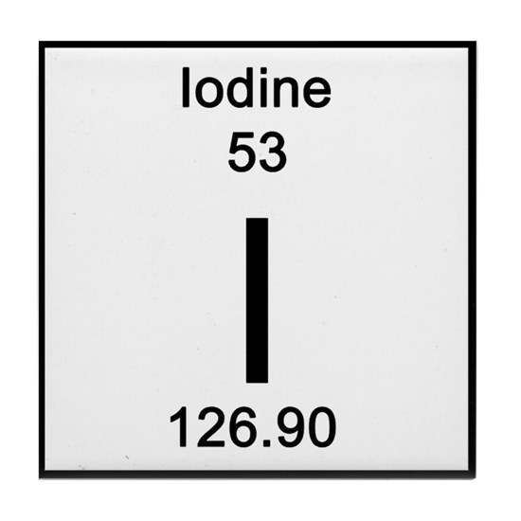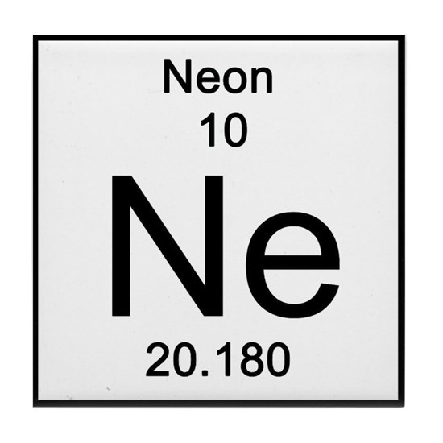
Name:

Contact:

Institution:

Dietary requirements:

Would you like to present? If Yes, please indicate if you wish an Oral or Poster Presentation

Abstract:

Please email the completed form to Dr Glyn Cobourne at g.cobourne@liverpool.ac.uk
Registration is Free of Charge. Deadline for Oral/Poster Presentations is 30th August 2019.

12th and 13th September 2019

