RSS Feed Guide
You can use your Outlook (email) account to set up an RSS feed, simply follow the steps below:
- In Outlook, right-click the RSS Feeds folder which can be found on the left hand menu under ‘Outbox’ and choose Add a New RSS Feed.
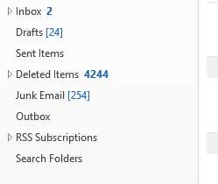
- In the New RSS Feed dialog box, enter the URL provided for the Researcher Blog: https://www.liverpool.ac.uk/researcher/blog/RSS/index.xml.
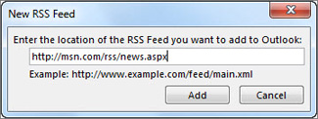
- Choose Add > OK.
- You will now receive a notification each time a new blog post is added.

