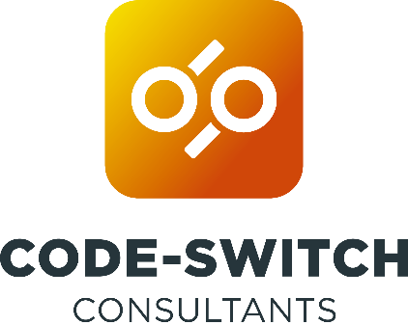

Code-Switching: the phenomenon in which speakers of more than one language switch between languages within the same conversation.
Code-switch between academia and research consultancy with the CSC consultancy method
SET YOURSELF UP FOR SUCCESS
- Engage clients & stakeholders from the outset - nail down the problem & the client's requirements
- Be outcome & product-oriented, as opposed to task-oriented
- Take time to plan robustly & realistically - the devil is in the detail Consider risks & mitigations - prevent avoidable issues
- Formally record what you agree to deliver - avoid disputes later on
MONITOR & CONTROL PROGRESS
- Spend time each week monitoring & managing the plan & risks
- Engage clients & stakeholders - ensure fit-for-purpose products Communicate progress regularly -avoid nasty surprises
- Ensure the right people get the right information at the right time to make the decisions required to progress
- Assess the impact of changes, e.g. delays, costs, incorrect assumptions, scope creep - be upfront & renegotiate if required
CODE-SWITCH!
- Understand your audience(s), what is important to them & their information needs when creating presentations & reports
- Ask about expectations, house style guidelines & templates
- Write in a business style - be concise, communicate key messages Lose the jargon - use online readability tools to help simplify writing
- Don't be put off by red pen - there is a process of review & revision before achieving sign-off
REFLECT, LEARN & IMPROVE
- Reflect on every consultancy engagement
- Engage clients & stakeholders in evaluation - different perspectives
- Facilitate open & honest discussions about what went well & what could have been better
- Identify key lessons for future initiatives - what should you & others stop, start, or continue to do
- Share with clients & stakeholders so you can all learn & improve

JOIN OUR PANEL DISCUSSION TO:
- MEET THE CODE-SWITCH TEAM
- HEAR FROM CODE-SWITCH POSTDOCS
- LEARN ABOUT THE CSC METHOD

#NPDC21
www.codeswitchconsultants.com

