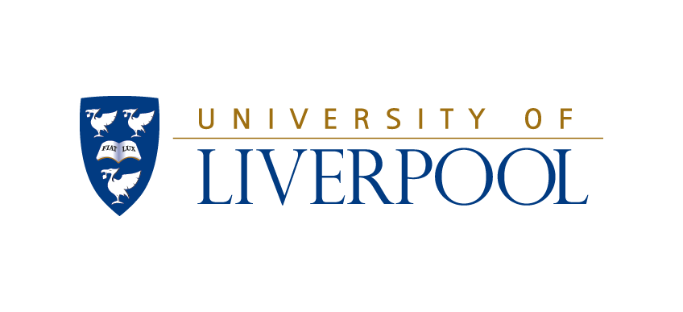
Images of Research Competition 2022: NPAW 2022
Authorisation of use
I confirm that I am the sole and exclusive owner of the submitted image or have written permission from the copyright owner to enable the University of Liverpool to use the image. I hereby grant the University of Liverpool and its affiliates and subsidiaries permission to use photograph and accompanying text provided by me as part of ‘Images of Research Competition’ for use in educational and promotional activities for the following:
- University print communications
- University website publishing
- University promotion/advertising
I also hereby unconditionally and irrevocably waive any interest in the copyright in the material, to the extent that such rights are capable of being waived. I understand that my photograph, audio or video recording may remain in use for up to 10 years from the date below. If I wish to withdraw consent for the future use of such material, I may do so by emailing researcher@liverpool.ac.uk however this withdrawal of consent will not apply retrospectively to material already in circulation.

(Scanned/Digital) Signature: Date (DD/MM/YY):

Name and mailing address (please print)

Name:

Email:

Phone:

Office use only:

