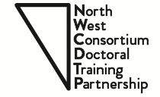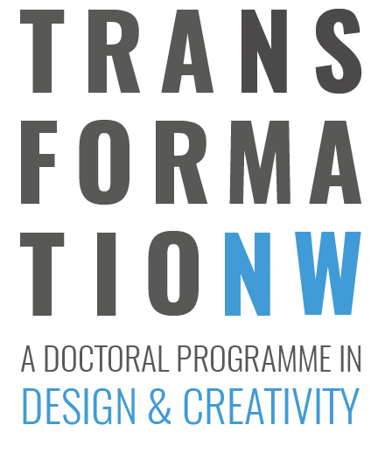

NPIF 2
STUDENTSHIP COMPETITION
(September 2018 entry)

1. Name of Primary Supervisor and applicant (if a student is named in the project)

2. Institutions at which the studentship will be held

Lancaster University University of Liverpool University of Manchester
Manchester Metropolitan University Keele University University of Salford
Royal Northern College of Music

Pathway:

3. Supervisory team

Please provide details of the supervisory team, their experience and prior experience of supervising PhD students

4. Project details:

Project title:

5. Project details

Please describe the proposed research using up to 1,500 words. Include a word count. In particular, explain how this aligns to the Industrial Strategy and to the themes of the call (Artificial Intelligence and Data-Driven Research).

7. Project partners

Please provide information on industry engagement or project partner. In case of partners, please describe their role on the proposed project. Please also provide details of their contribution to the project and indicate whether this will be a Collaborative Doctoral Award (CDA)

8. Recruitment

Please describe the process through which the student will be recruited and how you will ensure that this is an open and transparent process.

9. Acknowledgement

Signature of applicant:

(Type Name if submitted electronically)

Date:

