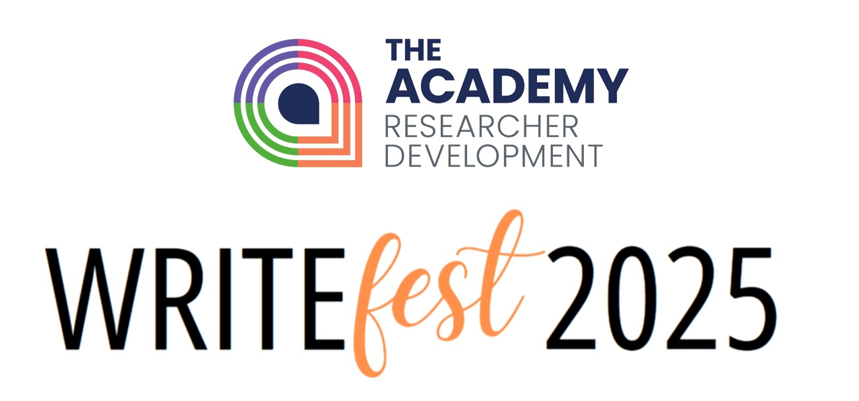

Welcome to WriteFest 2025
WriteFest is our annual celebration of academic writing, held every November to support researchers in developing their writing practice. Through workshops, webinars, writing retreats, and on-demand resources, WriteFest helps researchers reflect on the writing process, enhance their writing practices, and connect with a community of fellow writers across the University of Liverpool.

03 NOVEMBER | 10:00-11:00
Copyright and your Thesis
Learn about the issues to consider when including material created by other people in your PhD thesis.

Register here
Online Session | Webinar

03 NOVEMBER | 13:00-14:00
AI Tools for Research
Explore some of the Generative Artificial Intelligence tools that could be useful for research purposes.

Register here
Register here
Online Session | Webinar

03 NOVEMBER | 14:00-15:30
CV Masterclass
Learn how to write and tailor CVs for both academia and industry.

Register here
Register here
In-Person Session | Masterclass

04 NOVEMBER | 09:30-17:00
PGR Writing Retreat
Make progress with your writing in a focused, supportive, distraction-free environment.

Register here
Register here
In-Person Session | Practical application of skills

04 NOVEMBER | Recording
Fellowship Quest: Navigating the journey from pre-application to success
This recording of an RSA Lunch & Learn provides an introduction to applying for a fellowship.
Recording
Register here
On-demand resource | Recording

05 NOVEMBER | 10:00-12:00
Shut Up and Write
Online writing retreat giving participants two hours of protected time to focus on their writing projects.

Teams Channel
Register here
Hybrid Session | Practical application of skills

05 NOVEMBER | 10:00-12:00
The mechanics of academic writing
Explore the building blocks of strong academic writing.

Register here
Register here
In-Person Session | Practical application of skills

05 NOVEMBER | 14:00-15:00
Best practice for Research Data Management
An introduction to Research Data Management.

Register here
Register here
Online Session | Webinar

06 NOVEMBER | 10:00-11:00
Mastering your abstracts for publication and REF
Master the essentials of writing effective STEM abstracts that capture editors’, reviewers’, and REF panelists’ attention – including practical tips, examples, and common pitfalls to avoid.
Register here
Register here
Online Session | Interactive workshop

07 NOVEMBER | 10:00-12:00
Shut Up and Write
Online writing retreat giving participants two hours of protected time to focus on their writing projects.

Teams Channel
Register here
Online Session | Practical application of skills

10 NOVEMBER | Recording
The power of writing for just one hour
Unleash the power of writing for just one hour.
Recording
Register here
On-demand resource | Recording

11 NOVEMBER | 11:00-12:00
Research Data Management: FAIR Principles and Open Data
This session will introduce you to the FAIR Principles and how you can apply them to your research data.

Register here
Register here
Online Session | Webinar

11 NOVEMBER | 10:00-12:00
Thesis writing bootcamp for late-stage PGRS
Explore the practicalities of thesis writing, including planning techniques, appropriate writing style, and writing to completion.

Register here
Register here
Online Session | Interactive workshop

11 NOVEMBER | 13:00-14:00
RSA Lunch & Learn: Write on: Strategies to start, shape and sharpen your writing
Join us to discover creative ways to get the words flowing, ignite your imagination and turn a first draft into a final draft.

Register here
Register here
In-Person Session | Interactive workshop

12 NOVEMBER | 10:00-12:00
Shut Up and Write
Online writing retreat giving participants two hours of protected time to focus on their writing projects.

Teams Channel
Register here
Hybrid Session | Practical application of skills

12 NOVEMBER | 14:00-16:00
Fellows! Develop your publication strategy to strengthen your outputs and career
This workshop will help Research Fellows to create publication strategies, navigate REF, write 3*/4* publications & embrace Open Research.

Register here
Register here
In-Person Session | Interactive workshop

13 NOVEMBER | 10:00-12:00
Academic writing for mid-stage PGRs
Deepen your understanding of academic writing and develop good writing practices.

Register here
Register here
Online Session | Interactive workshop

14 NOVEMBER | 10:00-12:00
Shut Up and Write
Online writing retreat giving participants two hours of protected time to focus on their writing projects.

Teams Channel
Register here
Hybrid Session | Practical application of skills

18 NOVEMBER | 10:00-11:30
Academic cover letters
Consider how to craft a cover letter for various academic positions.

Register here
Register here
Online Session | Interactive workshop

19 NOVEMBER | 10:00-12:00
Shut Up and Write
Online writing retreat giving participants two hours of protected time to focus on their writing projects.

Teams Channel
Register here
Hybrid Session | Practical application of skills

19 NOVEMBER | 12:00-13:00
Developing PGRs as academic writers
This session for supervisors will discuss the challenges PGRs face with academic writing and our role as supervisors in developing skills and practice for successful academic writing and successful thesis completion.
Register here
Register here
Hybrid Session | Interactive workshop

19 NOVEMBER | 13:00-16:00
Academic reading for academic writing
This online session is designed to help participants develop skills and strategies for academic reading which feed into their academic and research writing.

Register here
Register here
Online Session | Interactive workshop

19 NOVEMBER | 09:30-16:30
RSA Writing Retreat
Protected time and space to achieve your writing goals supported by other researchers, with time for setting goals and sharing writing tips.

Register here
Register here
In-Person Session | Practical application of skills

20 NOVEMBER | 10:00-11:30
Writing policy briefings
Provides a guide for researchers interested in writing targeted policy briefings with potential to generate genuine impact.

Register here
Register here
Online Session | Webinar

20 NOVEMBER | 10:00-11:00
Best practice for Research Data Management
An introduction to Research Data Management.

Register here
Register here
Online Session | Webinar

21 NOVEMBER | 10:00-12:00
Shut Up and Write
Online writing retreat giving participants two hours of protected time to focus on their writing projects.

Teams Channel
Register here
Online Session | Practical application of skills

24 NOVEMBER | 12:00-12:45
Advanced EndNote Desktop
Learn more about using this referencing tool.

Register here
Register here
Online Session | Webinar

24 NOVEMBER | 14:00-15:00
Research Data Management: FAIR Principles and Open Data
This session will introduce you to the FAIR principles and how you can apply them to your research data.

Register here
Register here
Online Session | Webinar

25 NOVEMBER | 13:00-14:00
Thinking critically about Data
This webinar will cover the basics of collecting and analysing data, including critiquing methodology used by others.

Register here
Register here
Online Session | Webinar

25 NOVEMBER | 14:00-16:00
Overcoming writer’s block
Learn the common roadblocks for writing and how to combat them.

Register here
Register here
Online Session | Interactive workshop

26 NOVEMBER | 14:00-15:00
Creating a Data Management Plan using DMPonline
Discuss how to use DMPonline for writing your data management plans.

Register here
Register here
Online Session | Webinar

26 NOVEMBER | 10:00-12:00
Shut Up and Write
Online writing retreat giving participants two hours of protected time to focus on their writing projects.

Teams Channel
Register here
Hybrid Session | Practical application of skills

27 NOVEMBER | 10:00-12:00
Narrative CV Clinics
Get one-to-one feedback on your narrative CV for an external funding application.

Register here
Register here
Online Session | Interactive workshop

27 NOVEMBER | 10:00-12:00
Developing effective writing habits
Build effective writing habits to support your research.

Register here
Register here
In-Person Session | Practical application of skills

28 NOVEMBER | 10:00-12:00
Shut Up and Write
Online writing retreat giving participants two hours of protected time to focus on their writing projects.

Teams Channel
Register here
Online Session | Practical application of skills

