MANAGEMENT AND HANDLING OF RADIOACTIVE WASTE WITHIN THE UNIVERSITY OF LIVERPOOL

Version 10 – October 2014

CHANGE |  | DATE
Introduction of 30 L Bins for organic solvent waste |  | June 2010
Limits of activity per bin |  | October 2010
RSA93 to EPR2010 |  | April 2010
Bin Labelling |  | November 2010
Disposal company contacts | July 2010
Change of Polkacrest to SITA | January 2011
Addition of bin issue procedure | January 2011
Addition of wipe test for waste bins | June 2012
Amendment of bin limits | September 2012
Rearrangement of documents and some minor edits | November 2012
Change of SITA Permit Number | June 2013
Change of Authorisation to Permit | Feb 2014
Change of Waste Database | March 2014
Radioactive waste intro copied from LR1 Feb 2014 V2 | March 2014

RADIOACTIVE WASTE (CAMPUS, LEAHURST and LSTM)

Permitted Disposal Limits
The University’s maximum disposal activity for each type of waste is shown in each Permit (formerly known as the Certificate of Authorisation). The permitted limit given therein for each disposal route is the maximum total disposal activity for all Academic Units covered by each Permit (e.g. the whole main campus). It is NOT the permitted limit for each Academic Unit.

50% Rule
In order to avoid potential breaches of the limits contained in the University’s Permits, the departmental RPS must give prior notification to the Radiation Protection Office (RPO) if there are plans to increase the amount of waste their department usually disposes of (by any route) by more than 50% of their departmental baseline (Ref: Baselines document available from the Radiation Protection Office).

Gaseous
Gaseous waste is generally not produced in any significant amounts. Nevertheless, for highly volatile radioactive materials, such as tritiated water or certain radio-iodine compounds, every effort must be made to estimate and record discharges via fume hood vents.

Aqueous Liquid
Aqueous liquid waste may be disposed of down designated sinks only. The tap should be turned on sufficient to give a gentle (i.e. non-splashing) flow of water. The aqueous waste may then be slowly poured into the flow, care being taken to avoid splashing which could contaminate areas surrounding the sink. The flow of water from the tap should be allowed to continue after the waste has been poured in order to flush the waste away. The date, isotope and activity must be recorded on the appropriate waste log sheet in the department.

Non-Aqueous Liquid
Non-aqueous waste, being organic scintillant contained in plastic scintillation counting vials, may be accumulated in a designated yellow 30 litre ‘Medi-Bin’ in a designated area with a maximum of 40 MBq per ‘Medi-Bin’.

Non-aqueous waste, other than in scintillation counting vials, should be collected in a Winchester set aside for the purpose. A maximum of 10 litres of such waste having a maximum activity of 40 MBq may be decanted into a designated yellow 60 litre ‘Medi-Bin’ containing sawdust.

Non-aqueous liquid waste must not contain any alpha-emitting radionuclides.

A Waste Container Declaration Form (Appendix 1) must be completed for each bin giving details of its contents (details required are date, radioisotope and activity of each radioisotope) and confirming that the outside of the bin has been checked for contamination. The RPO will collect such waste for disposal upon notice that the waste is awaiting collection.

Solid
- Very Low Level Waste
Solid waste of activity less than 40kBq per item (400 kBq per item for waste containing carbon-14 or tritium) may be disposed of in waste containers emptied by Local Authority contractors provided that the total activity does not exceed 400kBq/0.1m³ (4 MBq / 0.1 m³) for waste containing carbon-14 or tritium). This is known as ‘Very Low Level Waste’ (VLLW). Waste containing alpha-emitting radionuclides CAN be disposed of via this route.

There must be no indication of radioactivity in this type of waste when it is disposed of – all warning labels, tape etc. showing the word ‘radioactive’ or the trefoil symbol must be removed or completely defaced.

A record must be kept of all waste disposed of in this way and the details included in the monthly return to RPO.

Radionuclide | Single item limit (kBq) | Total activity limit per 0.1 m³ (kBq)
Carbon-14, tritium | 400 | 4000
All others | 40 | 400

- Decay storage
Solid waste containing short-lived radionuclides (having a half-life less than 30 days) may be stored for decay until the activity has fallen below the VLLW levels given above. Such waste must not contain any alpha-emitting radionuclides and must not be stored for longer than the periods shown in the following table:

Location | Radionuclide | Maximum storage period
Main campus / LSTM | All with half-life < 30 days | 3 months
Leahurst | Technetium-99m | 7 days
 | Iridium-192 | 34 months
 | All others with half-life < 30 days | 3 months

- Solid waste for incineration
Other solid waste, excluding waste containing alpha-emitting radionuclides, may be accumulated in designated yellow 60 litre ‘Medibin’ containers for disposal. On disposal from the University the maximum activity per Medibin is 40 MBq (see the note on LIMITS below).

A Waste Container Declaration Form (Appendix 1) must be completed for each bin giving details of its contents (details required are date, radioisotope and activity of each radioisotope) and confirming that the outside of the bin has been checked for contamination. The RPO will collect such waste for disposal upon notice that the waste is awaiting collection.

- Other solid waste
Solid waste which does not fit into any of the above categories should be kept separate from other waste. The departmental RPS should be informed and will arrange collection by RPO for disposal. This category of waste can only be disposed of via authorised disposal service contractor and there will be a significant charge for waste of this category.

Limits

The activity declared on the Waste Container Declaration Form (Appendix 1) must be the activity at the time of collection by the RPO. However solid radioactive waste may be accumulated by the University for up to twelve months and therefore the activity on disposal will not necessarily be the activity on collection from Departments.
The maximum activity permitted per solid waste container is 40 MBq on collection from the department, including H-3, C-14 and other radionuclides BUT no alpha emitters.

RADIOACTIVE WASTE (RLBUHT)
NOTE: Radioactive waste disposal on the RLBUHT site is subject to the RLBUHT Open Permit NOT the University of Liverpool Open Permit.

Aqueous Liquid
Aqueous liquid waste may be disposed of down designated sinks as detailed above.
The date, isotope and activity must be recorded on the appropriate departmental log sheet.

Non-Aqueous Liquid
Non-aqueous waste, being organic scintillant contained in plastic scintillation counting vials, may be accumulated in small (2 – 3 litre) plastic bags in a designated area. A note must be attached to each bag giving details of its contents (details required are date, approximate number of vials, radioisotope and activity of each radioisotope). Arrangements should be made with the Department of Nuclear Medicine of the RLBUHT in the Duncan Building to transfer the waste to them for disposal.
Non-aqueous waste, other than in scintillation counting vials, should be collected in a Winchester set aside for the purpose. The details of the radioisotope and its activity should be entered on a Log sheet relating to the Winchester. When the Winchester is full the RPS should be informed. The RPS will collate the data from the Log sheet then make arrangements with the Department of Nuclear Medicine of the RLBUHT in the Duncan Building to transfer the waste to them for disposal.

Solid
Solid waste of activity less than 40 kBq per single item may be disposed of in waste containers emptied by Local Authority contractors provided that the total activity does not exceed 400 kBq/0.1m³.

Solid waste, being waste containing no radioisotopes with half-life exceeding 1 year with the exception of C14 or H3, may be accumulated in designated containers for disposal. Details of date, radioisotope and activity must be entered on the Log sheet relating to the container. When the container is full the RPS should be informed.
The RPS will collate the data from the Log sheet then make arrangements with the Department of Nuclear Medicine of the RLBUHT in the Duncan Building to transfer the waste to them for disposal.

Solid waste other than above should be kept separate from other waste. The departmental RPS should be informed and will arrange collection by the Department of Nuclear Medicine of the RLBUHT in the Duncan Building for disposal. This category waste can only be disposed of via authorised disposal service contractor and there will be a charge for waste of this category.

The maximum levels for each type of waste may be obtained from the RPS or RPA. The maximum totals for the hospital are obtainable from Mr. Paul Connolly of IRS Ltd on 0151 709 6296 or Dr Melvyn Carroll in Department of Nuclear Medicine on 0151 706 4430.

HANDLING OF LOW LEVEL RADIOACTIVE WASTE

COLLECTION
1. Request arrives from department (See Appendix 1 for example of Waste Container Declaration Form)
Add reminder to your calendar stating department and how many bins need to be collected.
If you know how many bins you will need to collect, you will need to replace the full bins with empties like for like.
Before empty bins are issued they must be labelled, this can be done by using the RPO Waste Management Database which has a form which allows you to select and print labels.
2. Collection from department
Check that the Waste Container Declaration Form is filled in correctly and all information is there.
Things like Bin Number, activity units, signed and dated and the form matches the bin i.e. the waste bin number should match the waste bin label on the bin.
Do not collect the bin if:
The Waste Container Declaration Form does not have the bin number or does not match the bin.
Any info is missing such as waste producer / activity units / activity / waste type
The contamination check shows anything above background reading
If so contact the RPS for the department and make arrangements to collect another time when the form is correctly filled in or the bin has been decontaminated.
3. If you have the labelled empty bins with you, leave them in the place you have collected the waste from. Make sure they are labelled, do not leave any empty bins without labels affixed to them. If not you will need to collect the empty bins from the store and make a second trip back to the department to drop the bins. MAKE SURE THE BINS ARE LABELLED.
4. Take the full bins to the RPO waste store and place solid waste one side of the store and organic scintillant waste the other.

We use the declaration date as the date the bin was sealed and use this as the start date for calculating the accumulation period within the regulatory time scale.

Using the RPO Low Level Waste Management Database
The waste database can be found at R:\Databases\ RPO Waste Management.
The database has combined the functionality of three previous databases.
Bin Issue – for tracking bins issued and printing labels for waste bins.
Low Level Waste – for tracking the amount of Solid and Scintillate waste that has been disposed of.
Aqueous, Gaseous and Very Low Level Waste – for tracking disposals straight from the department.
On opening the database the menu opens as shown below:
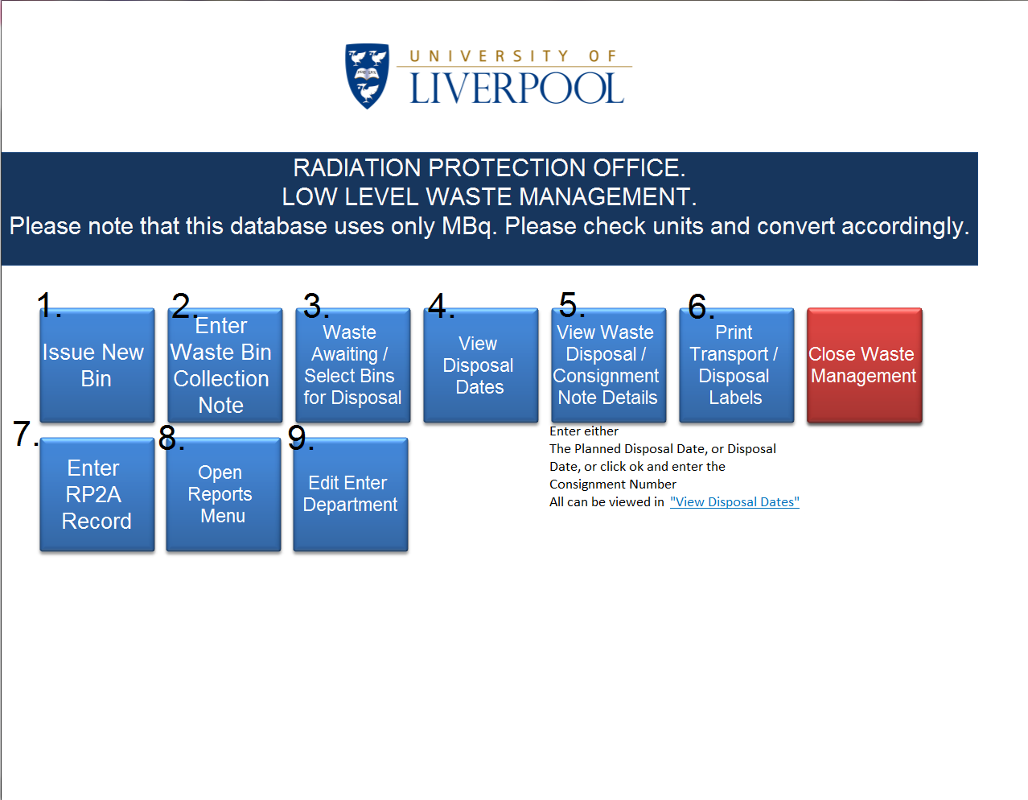
The Database has the following functions
- To Issue and print labels:
Select the Issue New Bin Button and the following form will open.
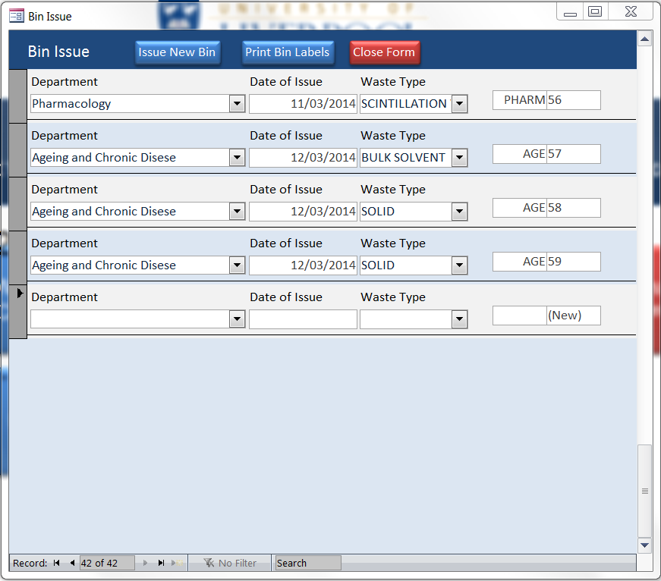
Using the drop down box select the department you wish to issue bins to.
Insert the date of issue (usually todays date).
Select the waste type, for normal low level waste the choice will be either Solid or Scintillation vials, and very occasionally bulk solvent, but you would normally be asked to provide a bin for this.
The last two boxes will automatically will fill with an abbreviation of the department name and an automatically generated number which runs in sequence for all the bins.
Click the Print Bin Labels Button and the Label report will open, please note that only records where Date of Issue and today’s date are the same will be available for printinge.g. in the form above, if the date of issue is 12/03/2014 and todays date is 12/03/2014 only the three records for Ageing and Chronic Disease will print out.
If the date of issue is the 11/03/2014 and today’s date is the 11/03/2014 then only the record for Pharmacology will print out.
Click the Print button at the top of the pop-up report. Labels should be printed out in colour and on to L2601 labels (there are 6 to a sheet A4, two across by three down).
Labels are then stuck on to the empty bins over the Bio Hazard sign ready for delivery.

- To record the information on the Waste Declaration Form and collate it.
Select Enter Waste Bin Collection Note Details and the following form will open:
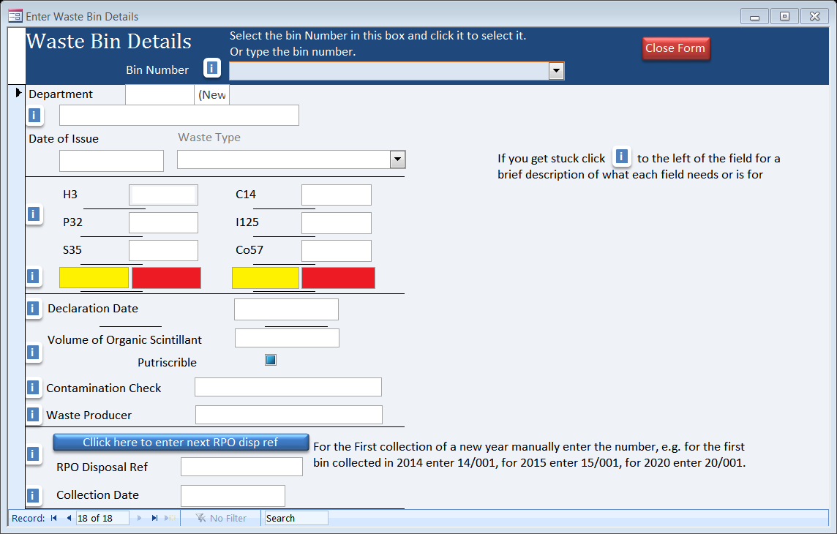
The form will only allow you to select a bin that has been previously issued using the Issue New Bin Form.
The form is annotated with reminders to show what each section is for. By clicking a description will pop up.
To select a bin either use the drop down box at the top or type the full bin number in the drop down box highlighted above with the red square, when selected the fields Department, Date of Issue and Waste Type will automatically fill with data.
You must transcribe the information from the waste declaration form to the database form. Taking care to make sure all activities are entered in MBq (Pharmacology work in kBq so any activity given must be divided by 1000 before entering into this form).
RPO Disposal Ref: There is a button to assign a new unique number to each waste bin entered, however, for the first bin of each year the number should be entered manually, e.g. for the first bin collected in 2014 enter 14/001 for the first bin collected in 2015 enter 15/001, for the first bin of 2017 enter 17/001, where the first two numbers are the last two of the current year and the last three numbers show the count of bins collected.

- To view waste waiting for disposal or to select bins for disposal
Click the Waste Awaiting / Select Bins For Disposal Button
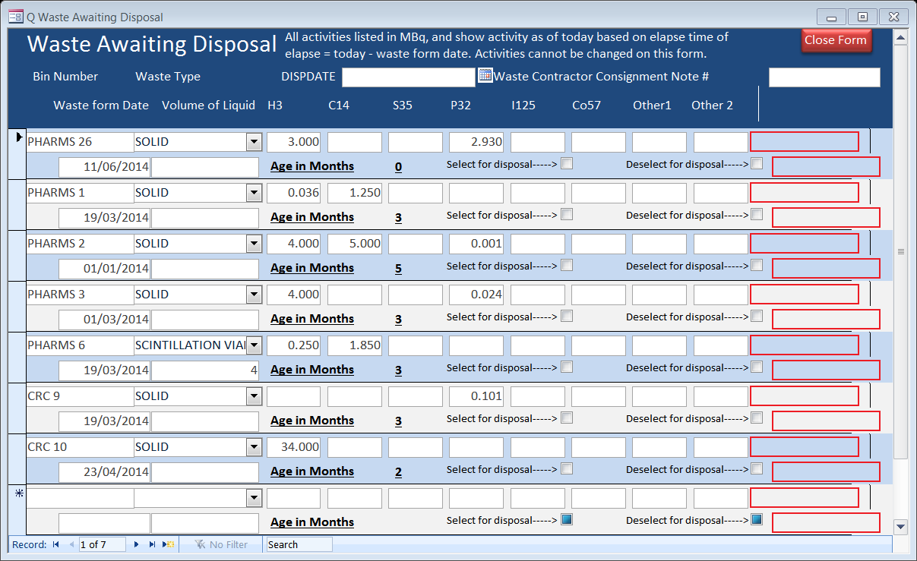
First get the consignment note from SITA, we tend to have a couple at a time in the office and they are kept in the short metal cabinet next to the big cupboard and the kettle in the draw labelled waste consignment notes.
The form above shows today’s activity in MBq and the age in months from when the Waste Bin Collection Form was signed, not the collection date.
The form will only allow you to enter a date and the waste contractor’s reference number. This reference number is found at the top of the waste contractors waste consignment note and is usually a letter followed by numbers e.g. R0000204 or R0000205.
In the form header enter the planned disposal date in the “DISPDATE” text box and the waste contractors consignment note number. 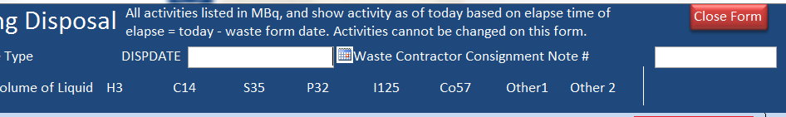
Then by moving on to the form you can use the check boxes to either select or deslect a bin for disposal
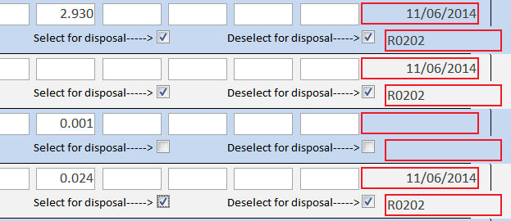
The top box highlighted in yellow with a red border is for the date and the lower box offset to the right is for the contractor’s reference number. Use the tab key to scroll through records or to move to the next after entering data into a field.
The form also shows how old a bin is, this is calculated by taking today’s date minus declaration date divided by the average number of days in a month e.g. CHEM 23 in the example above (12/03/2014 – 28/10/2013) / 29.6 = 5 Months old.
When you have selected the bins you wish to dispose of make a note of the proposed disposal date and consignment number, close the form and go to step 5.
- Viewing Disposal dates and contractor consignment note numbers
By clicking on View Disposal Dates a pop up window will open showing the disposal dates and the matching consignment note number.
This is useful as in step 5 will you will be asked to enter either the Disposal Date or the consignment reference number.
The pop up looks like this: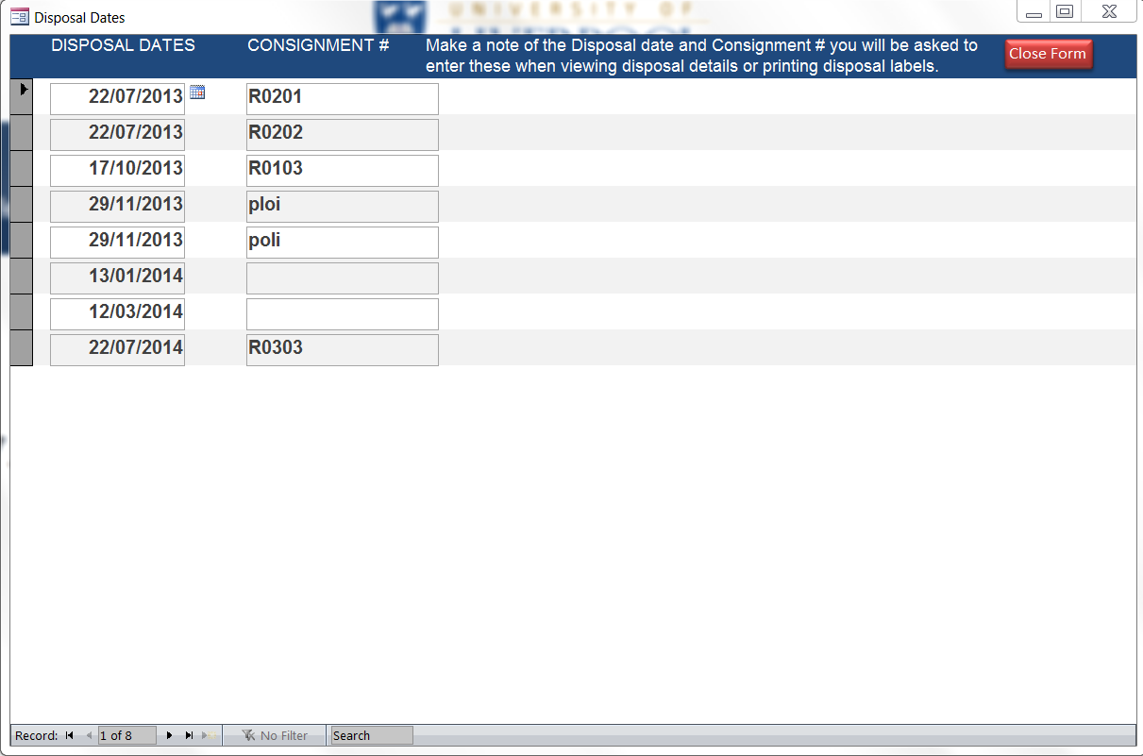
- Viewing the details of disposal
Click the View Waste Disposal / Consignment Note Details to view and print the information need to fill out the consignment note.
You will be asked to enter either the Disposal date or the consignment number. Do not worry if you cannot remember the consignment number you can leave this blank and just click ok.
The report will open in a pop up window and by clicking print will print out the report.
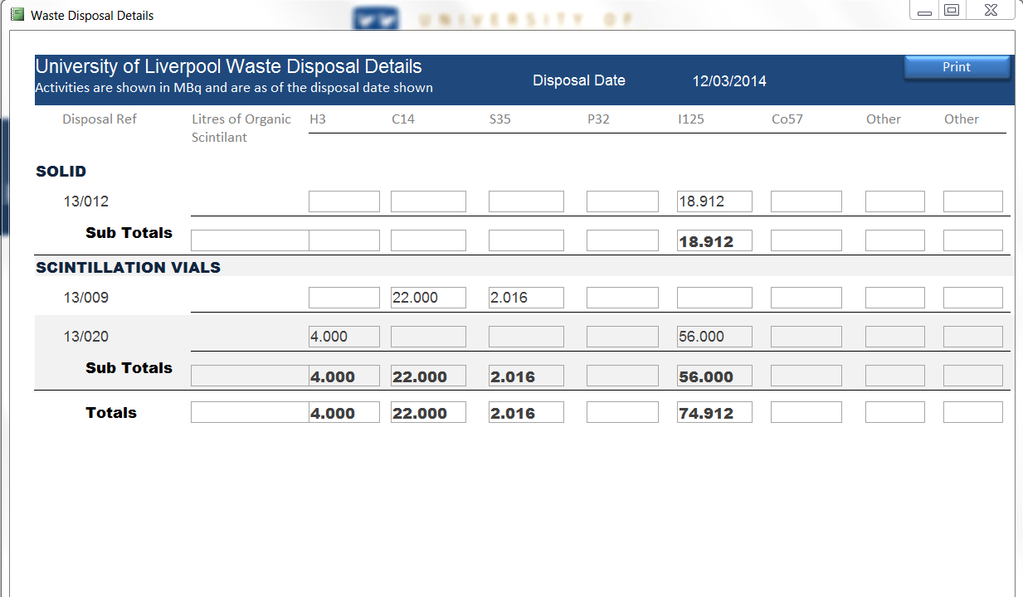
- Printing Labels
Clicking the Print Transport / Disposal Labels opens a report in a pop up window, again you will be asked to enter the disposal date and or the consignment number.
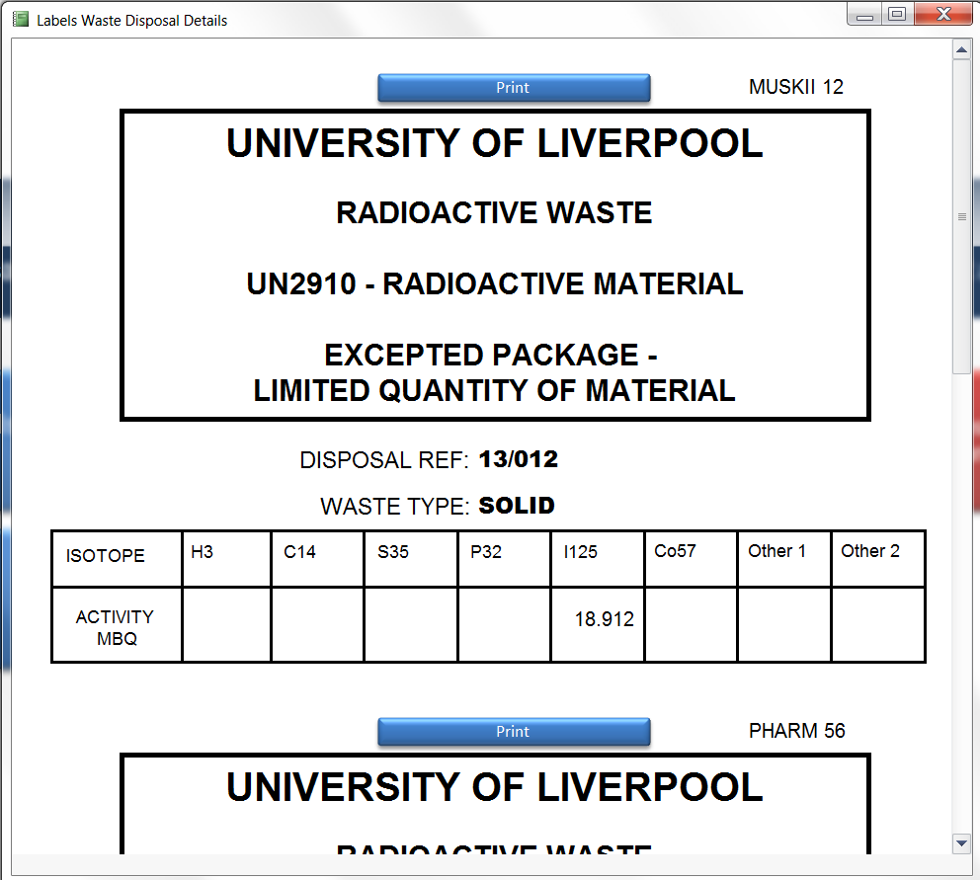
The report is printed on L2601 labels (A4 sheet one across by two down). Labels then need to be stuck to the corresponding bins. The top right of the label shows the bin number that it belongs to.
- Recording Stock and disposals direct from the department.
By clicking the Enter RP2A Record button the following screen will open
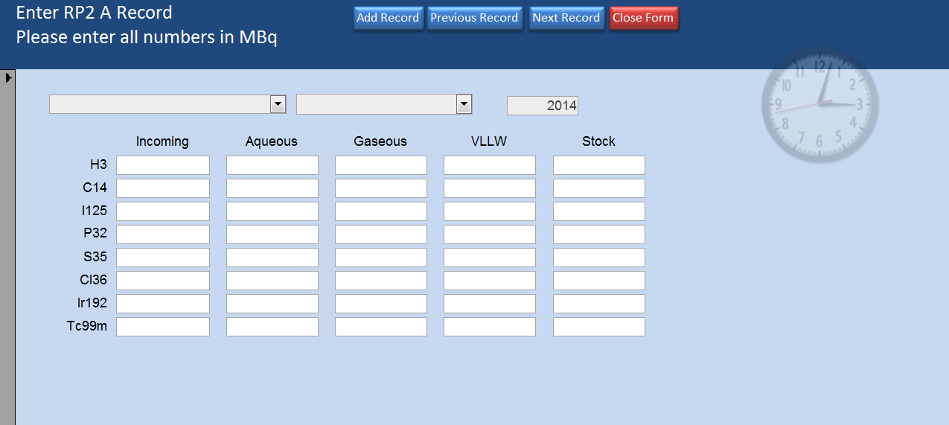
The form will allow you to transcribe the RP2A form information in to it.
The first selection box is for department, the second is for the reporting Month and the last is the Year. The Year field will automatically insert the current year.
Again all units must be entered in MBq notation.
- Viewing and printing reports
The database has a reports menu which allows the printing of various reports, such as information needed when submitting the EA Pollution Inventory, or the number of bins used by a department.
The reports have been set up in such a way that they will show a running total based on the information entered.
- Entering and Changing Departments names
Edit Enter Department allows the user to add a new department which will then be available to issue bins to and to record the stock movements and other disposals made.
When entering the department it is important to get the site location correct and add an abbreviated department name as this will form part of the bin number issue.
ARRANGING A DISPOSAL TO INCINERATION
Redditch Treatment Faculty Permit Number ZB3930DS
A. Check when the accumulation time limit is approaching or when 12 to 24 containers have accumulated (these can be checked using Waste Awaiting Disposal report on the Open Reports Menu or by going back to step 3) or the monthly disposal limit is reached.
Choose a suitable disposal date (14 to 21 days ahead), request a Radioactive Waste Consignment Note to be sent (examples in Appendices 6). The forms are available from Ian Bateman. Although we tend to keep a few in the RPO in the small metal file cabinet near the kettle.

The contacts for SITA are as follows:-
Ian Bateman, logistics and transport division.
Ian.Bateman@sita.co.uk
Siobhan Fletcher deals with invoices and it is worthwhile coping Siobhan into emails to Ian Bateman.
Siobhan.Savage@sita.co.uk
David Howe at Redditch is the plant manager
David.Howe@sita.co.uk
B. Allocating disposal date
Go into see step 3 above and enter the disposal date into the relevant fields.
Make note of the planned disposal date, and close the Form.
On the main menu open the “View Waste Disposal / Consignment Note Details” report and enter your planned disposal date, and or the waste contractors consignment note number.
Print out the Report using the print button on the report.
C. Completing Consignment Note
When Consignment Note arrives from SITA complete it using previous Notes as a guide (but entering the activity and isotope data from the intended consignment along with a volume of organic solvent [max 180 litres] and if it is special waste or prutrifiable).
D. Printing waste report and producing Consignment Declaration
See step 5 above.
Depending on the form format which has been sent to you, either electronic excel version or carbon copy pad.
For the electronic copy you will need to print and make three copies of the electronic SITA Consignment Note (Appendix 5) and staple a copy to each “Waste Disposal Details” report (Appendix 4), one for us, one for SITA logistics and one for the incinerator plant. The Carbon copy pad already has this done.
E. Paperwork
Label a new foolscap folder with WASTE SITA and disposal date on front.
Paper work need for the folder is the SITA consignment note, the print out detailing the activities and types of waste.
Place all paperwork in the folder (the remaining stapled set of Consignment Note and Declaration, are for SITA) this is now the waste folder for that particular consignment.
Scan all paper work in and rename and save on the R drive in the “Waste folder” (R:\Radiation\WASTE)
F. Labelling containers
See step 6 above. You will be prompted to enter the disposal date. Insert blank 1.486.482 labels (A4 sheet with two A5 Labels) into printer then click to print. Go to waste store and attach the labels to the respective containers ready for disposal
G. Disposal
On the arranged day go over to the Waste Store and pass the relevant bins to the driver. There will be some paperwork to do. The driver will complete the Consignment Note. You and he will sign the respective sections of the Consignment Note. You will then retain one sheet for university records in the Waste Wallet (card folder) as mentioned in E. The wallets are then kept in the RPO in a box file labelled “Disposals Incineration 2009, 2010, 2011, 2012, etc.” kept next to the filling tambour cupboard in front of the window.
Solvent waste
All solvent waste (whether vials or bulk) MUST go for incineration disposal. The disposal type entered as ‘bulk solvent’ or ‘solvent vials’ as appropriate.
Solid waste
Solid waste can go incineration and may be stored for decay before disposal.
Solid waste includes organic biological materials

NOTES
Leigh Environmental, our original incineration contractors, were taken over by Onyx who were in turn taken over by Eurocare, then by Sterile Technologies and now operates as Polka Crest who in turn now operate as POLKACREST SITA The original incinerator at Leigh Environmental, Wolverhampton, was closed because it did not comply with EPA95. Incineration was then conducted by Blue Circle, who were later renamed Medical Energy (Worcs) Ltd, at their incinerator in Redditch, which was then taken over by Polka Crest who operated the service, Polka Crest have now been taken over by SITA solutions.
The former in-house incinerator was financed and maintained by Buildings and Estates Department. Subsequent to its removal from service Buildings and Estates Department have not continued to finance the incineration of wastes formerly incinerated in-house and this includes radioactive material. Consequently, invoices from SITA/Polka Crest are paid by Radiation Protection Office and recharged to the departments producing the waste. Cost is based on activity with a minimum of around £100 per container for 2 to 3 MBq. This is significantly increased for activities greater than 10 MBq per container
Duty of Care Certificates: The Waste Consignment Note acts as a Duty of Care Certificate for each SITA/PolkaCrest consignment.

APPENDIX 1 (Waste Container Declaration Form)
UNIVERSITY OF LIVERPOOL
RADIOACTIVE WASTE
UN2910 – RADIOACTIVE MATERIAL
EXCEPTED PACKAGE – LIMITED QUANTITY OF MATERIAL
CONTAINER NO :
e.g. Pharm 0001 or Physiol 0002

WASTE CATEGORY: SOLID / VIALS / BULK SOLVENT
circle relevant category

ALL ACTIVITIES ARE NOTED IN: MBq / kBq
circle relevant unit

ISOTOPE | H-3 | C-14 | S-35 | P-32 | I-125 | Co-57 | P-33
ACTIVITY

Volume of organic solvent (Litres)
Contamination Check Result | e.g. Background

I certify that the above details are, to the best of my belief, correct

I hereby declare that the contents of this consignment are fully and accurately described above by proper shipping name and are classified, packed, marked and labelled, and are in all respects in proper condition for transport by road according to the applicable international and national government regulations.

NAME (BLOCK CAPITALS)

SIGNED DATE: ___/___/20__

DEPARTMENT PHONE: 0151
To be completed by Radiation Protection Office
Container Disposal Ref : /
APPENDIX 2 (Waste Categories and Routes)
Disposals directly from Department
Aqueous, Gaseous and Solid VLLW wastes are disposed of directly from the Department via designated drains or extracts or to a waste contractor’s skip respectively. Each disposal must be recorded in an appropriate log-book and a collated record must be sent to Radiation Protection Office (Campus, Leahurst and LSTM sites) or IRS Ltd (RLUBH site) monthly on the RP2A form or equivalent. The RP2A form (Appendix 6) has a column for aqueous, gaseous waste, and solid VLLW.
The return from each Department is then further collated with returns from other Departments to create a total return for the Environment Agency
Disposals via Radiation Protection Office
Solid and Non-aqueous liquid waste must be disposed of via Radiation Protection Office and a Waste Container Declaration Form (Appendix 1) completed for each container
The ultimate disposal routes are indicated below :-

APPENDIX 3 (Radioactive Waste labels)

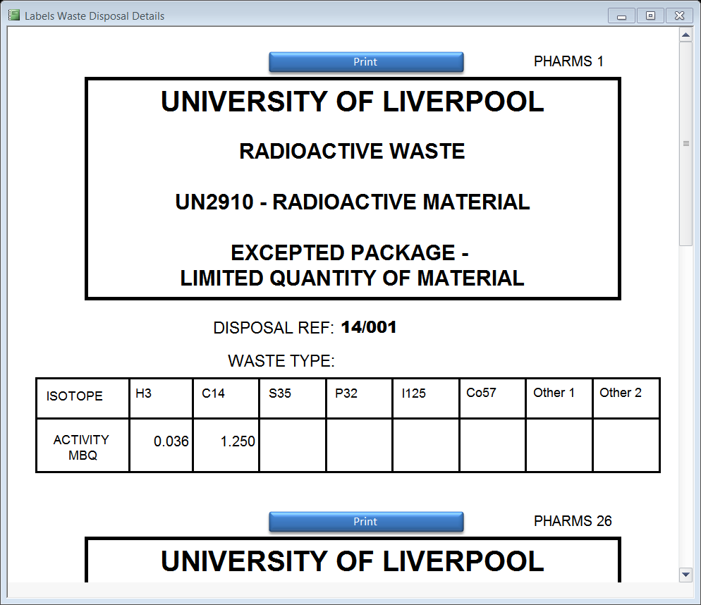

Upper section: Container Disposal Reference and activities inserted on printout
Lower section: Excepted Package label for side of container

APPENDIX 4 (Details of Disposal Report)

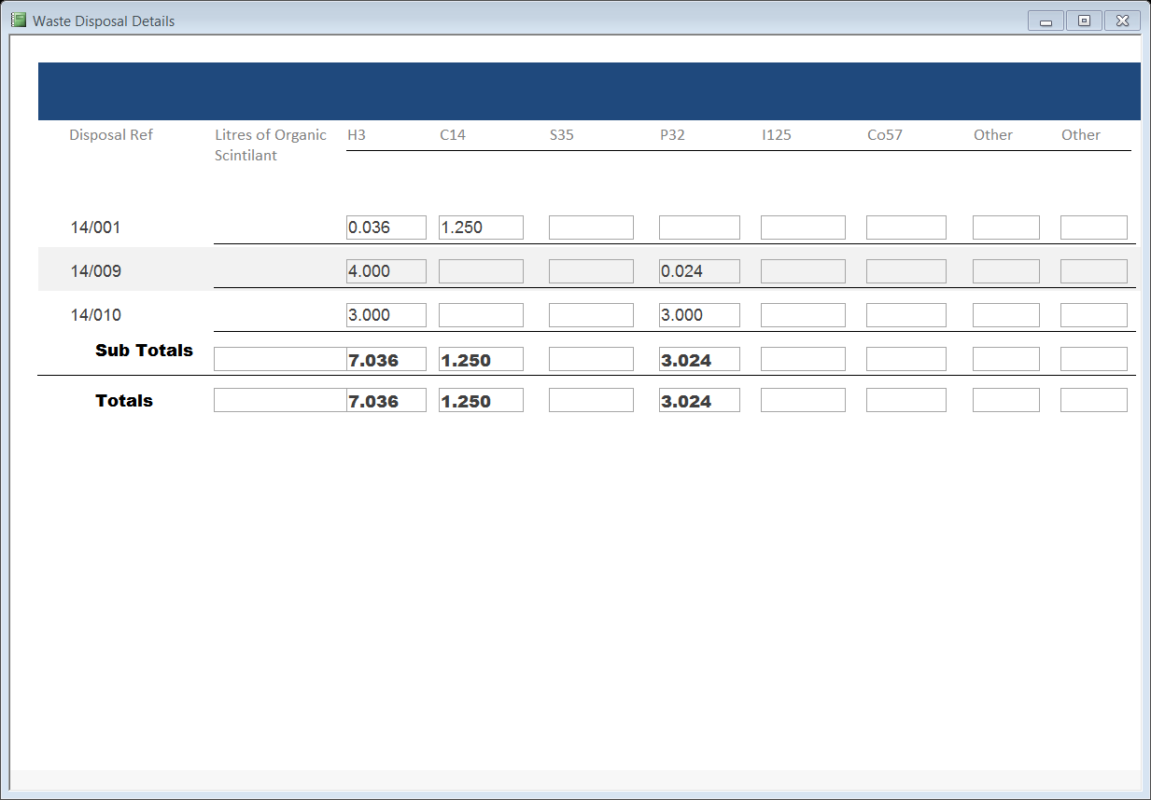

(APPENDIX 5 – Example Incineration Consignment note)
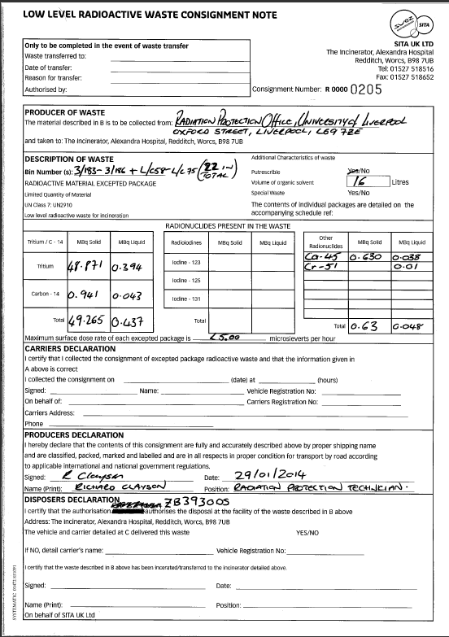

APPENDIX 6 (Radioactive Waste Monthly Return – RP2A)

Department RP2A

Month Year …………

ACTIVITY MOVEMENT TABLE UNIT USED: kBq / MBq

ISOTOPE | TOTAL NEW INCOMING ACTIVITY FOR THIS MONTH ONLY | DISPOSALS – Direct from Department |  |  | STOCK ACTIVITY REMAINING AT END OF MONTH (PLEASE ALLOW FOR DECAY WERE APPROPIATE)
 |  | AQUEOUS LIQUID | GASEOUS | VLLW to Skip / Decay Store
H-3
C-14 | This section is to show a cumulative total for any isotopes that have been brought into the department in the reporting month only. | This section is for disposals that have been made by a radiation worker within the division. This section should NOT be used to record normal Low Level waste i.e. solid and scintillant waste in yellow bins that is collected by the RPO for disposal via a waste contractor. |  |  | This section should take into account all activity of ‘stock’ that is still held within the division at the end of the reporting month. ‘Stock’ includes unaliquoted stock in pots, aliquots, and any stored samples or results of work carried involving isotopes.
I-125
P-32
Ir-192
Tc99m

DETAILS OF INCOMING STOCK TABLE

SOURCE REFERENCE | ISOTOPE | ACTIVITY | COMPOUND FORM | ARRIVAL DATE
This table is to be used to give the details of individual items, and a cumulative total for each isotope entered in column 2 of the above table.

ACCUMULATED WASTE WAITING FOR DISPOSAL
BIN NUMBER | ISOTOPE | ACTIVITY | ON DATE | TYPE (SOLID/SCINTTILANT/VLLW) | DATE BIN WAS STARTED
This table can be used to list any waste that is in a department that has not been disposed of or transferred to the RPO in the reporting month. This is the table to show any ‘waste’ held within the division that is ‘pending disposal’ i.e. not yet disposed of directly or collected by RPO. This table should also be used to list any items in ‘decay store’.

To the best of my knowledge, I certify that the above details are correct:

RPS DATE

SIGNED

