Caution
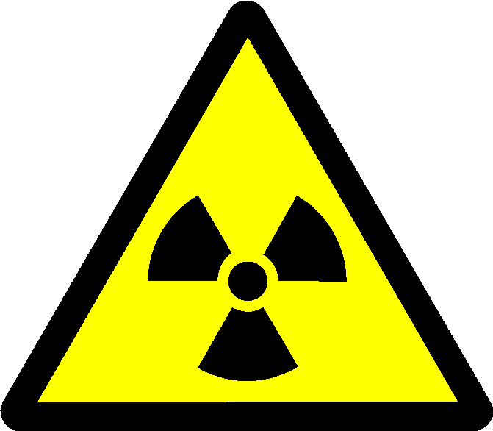
Radiation Supervised Area
Unsealed Radioactive Materials

Lab No –
Supervisor –
Contact Phone –

