WARNING
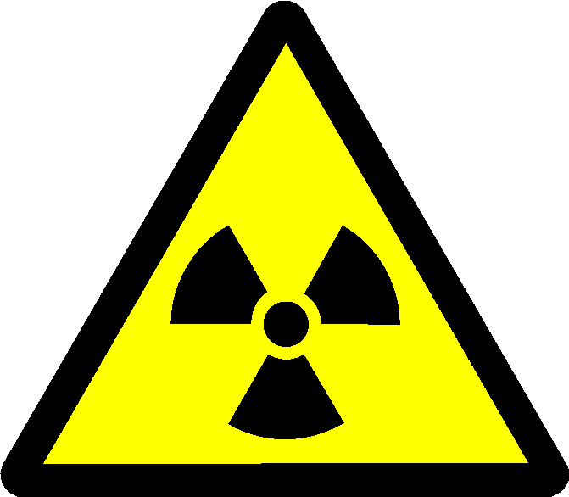

RADIATION CONTROLLED AREA
Unsealed Radioactive Materials

NO UNAUTHORISED ACCESS
RPS:
Tel:

