CAUTION
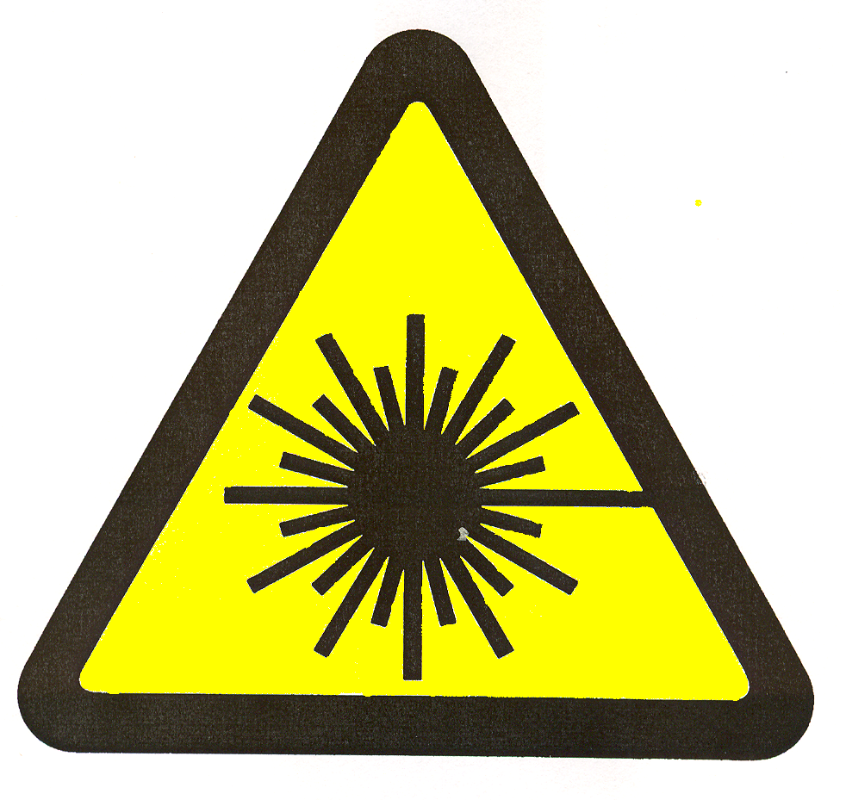

LASER IN USE
Laser Controlled Area

LPS Contact:
Phone:

