RISK ASSESSMENT: Confocal Microscope Make/Model: ZEISS LSM 800 Serial No.: 12345

Hazard Description | Who might be harmed? | Existing Control Description | Risk  (S/M/L) | Comments or any further actions required to reduce the risks
Class 3B or 4 laser radiation (typically 400 to 700nm with output of < 50mW. Also there can be a UV mode @ 355nm)  Potential eye strike from scattered laser light. | - Staff  - Students | Microscopes are housed within a room dedicated for purpose, with clearly labelled door signage to prevent unauthorised access. Within the room, the microscopes are shielded behind blackout curtains.  Laser power is adjusted to the minimum necessary to produce a signal.  Laser light is fed through optical waveguides and, therefore, completely shielded until it leaves the microscope objective and reaches the specimen. Remote safety interlocks and integrated beam-splitters on the device prevent stray laser light during scanning and should never be defeated.  Warning labels have been affixed near all apertures or removable parts where exposure to laser light is possible.  Anti-scatter laser guards are fitted near the sample to protection eyes from scattered laser radiation (see below). These must not be removed without prior consultation with the LPA.  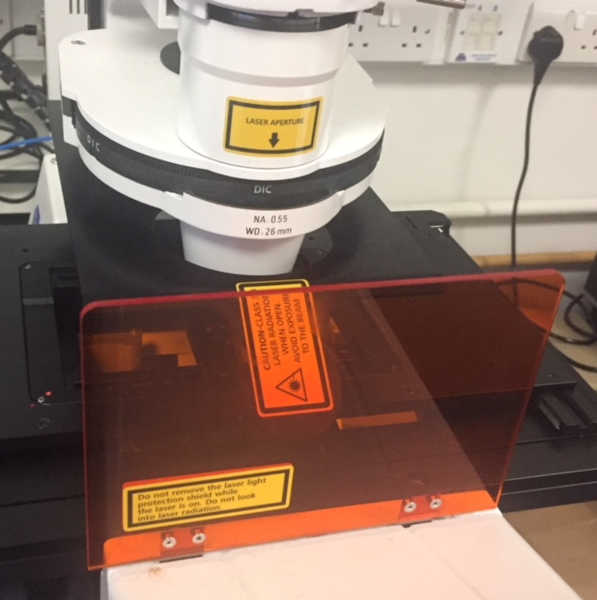  Further shielding, beyond that incorporated by the manufacturer, cannot be employed without hampering normal operation of the instrument.  Service and maintenance only carried out by qualified engineers from the equipment supplier/manufacturer.  Safety notices and precautions on and around the microscope should always be observed before and during operation.  Standard safety procedures are compulsory for all users and must be incorporated into all experimental protocols. In summary, users should:  - Never look directly into the laser beam or a reflection of the beam  - Never interfere with the beam path  - Never insert any reflective objects into the beam path  - Never change a specimen during scanning  - Never change objectives during scanning  - Never change filters during scanning  A register of users is maintained and the use of the equipment is restricted to:  Trained staff (unsupervised)  Staff under training (supervised)  Training includes safety provisions based on information supplied by equipment manufacturer/installer, the LPA, and AURPO.  A laminated contingency plan card is displayed in room and gives information for emergency medical actions. | S | None required
Broken glass | - Staff  - Students  - Cleaners | Carry slides/coverslips in suitable container.  Broken glass from histology slides or coverslips disposed of in the contaminated sharps bin. | S | None required
Biological Hazards  (live pathogens, unfixed cells or tissues, genetically modified organisms) | - Staff  - Students  - Cleaners | For each individual research application involving live pathogens, cells/tissues, a current biological agent risk assessment must identify appropriate control measures. The University Biological Safety Adviser can assist if required.  Specimens brought into the facility must be clean, dry, safe and enclosed/sealed (e.g. mounted slide). Live material must be transported correctly. Leakages and spillages should be cleaned up immediately and the area swabbed with 95% alcohol.  All live samples should be removed from the lab after microscopic observation and disposed of appropriately by the user. | S | Microscopy with GMOs must be covered by the appropriate GM risk assessment.  If it is known or suspected that Hazard Group 3 organisms may be present consult the University Biological Safety Adviser before proceeding.
Chemical hazards – immersion oil | - Staff  - Students | Some immersion oils are irritants to the skin upon contact.  Wash hands after use.  Use nitrile gloves if appropriate.  Follow instructions in hazard data sheet for such oils. | S | If applicable, obtain copy of hazard data sheet for immersion oils.  The Lab Manager must be informed before any chemicals are brought into the facility,
Mercury lamp eye damage or lamp burst | - Staff  - Students | Do not look directly at light source. Keep shutter closed when not in use. This also applies to any bright halogen lamps.  Maintenance only to be performed by authorised personnel.  Obey rules of use regarding turning on and off, and monitoring the usage of mercury lamps. If mercury lamps are unusually dim or flicker notify Lab Manager immediately.  Mercury lamp use should not exceed 800 hours. When lamp usage approaches 800 hours of use the lamps are replaced by authorised staff only. If explosion occurs evacuate room immediately, shut door, place "no entry" sign across door and notify the Lab Manager. Maintenance only to be performed by authorised personnel. | S | Associated with fluorescence microscopy if applicable
Electrical shock |  | All microscopes and associated equipment must be CE marked.  Regular checks of power cords for fault, fraying or wear and regular electrical safety checks. Maintenance only performed by authorised staff. | S
Signature of Assessor: |  | 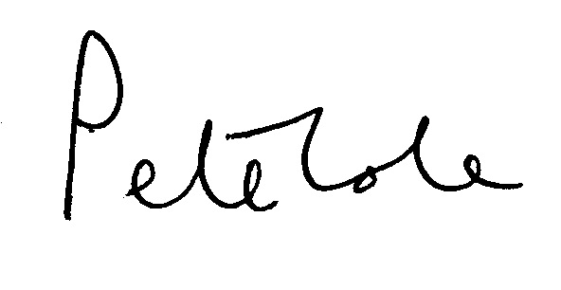

Date: 31/10/18 Assessor: Pete Cole (LPA RPA2000 Cert. No. 136) Review Date: 31/10/23 (or earlier in the event of an incident)

