

LASER EYE INJURY CONTINGENCY PLAN
IN CASE OF EMERGENCY:
Try to calm the injured party. Shock can set in very quickly. Arrange to go to St. Paul’s Eye Unit at the Royal Liverpool University Hospital as soon as possible. Identification of a laser injury is only possible within 24hrs of injury.
St. Paul’s Eye Unit is on the ground floor of the new hospital on West Derby Street (see Maps) Lower Ground Floor, W Derby St, Liverpool L7 8YA
Phone Contact for St. Paul’s 0151 706 3222
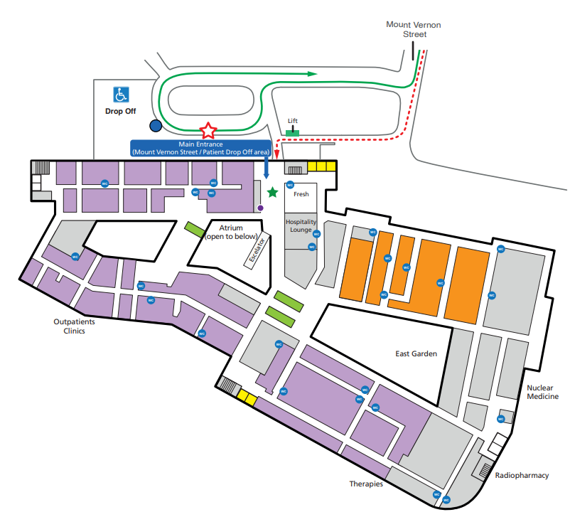

Report any laser injury (or suspected injury) to the following:
Supervisor of the Work: ……………………………………………
Local Person in Charge of Lab: ………………………………….
Laser Protection Supervisor: ……………………………………..
Laser Protection Adviser: Pete Cole, 0797 324 7821

