 | University of Liverpool  Radiation Protection Service  Ordering and Receipt of Packages Containing  Radioactive Materials

Introduction
The transport of radioactive material is governed by several sets of international, European and national legislation, in particular the Carriage of Dangerous Goods (CDG) 2009 Regulations. This legislation defines a number of categories of persons concerned with the transport of radioactive materials. Most notably amongst these are:
1. Consignor – the person and/or organisation that prepares and/or sends the package.
2. Carrier – the person and/or organisation that physically transports the package.
3. Consignee – the person and/or organisation that receives the package.
A number of different types (depending on their design) and categories of package have been defined. These are:
- Excepted – containing small amounts of radioactive materials. It may not bear any external labels to indicate that its contents are radioactive, but should bear The United Nations number for Excepted radioactive materials which is UN2910.
- Type A – containing more radioactive material than is permitted in an Excepted package. They will be externally marked with a warning label, which will incorporate the radiation ‘trefoil’ symbol, the word ‘Radioactive’, the relevant UN number and their category. This category will be either I, II or III depending on the radiation dose rates around the package (I being the least and III the most). Examples of these labels are shown in Figures 1 and 2.
- Type B and C – specially designed packages for higher activity radioactive sources. Any delivery of these would be made under special arrangements with the University’s Radiation Protection Office.
It should be noted that even for the biggest Type A (Category III) package, a person would have to be within 1m of the package for 200 hours before the UK whole body radiation dose limit was exceeded. This is highly unlikely to happen.
Most packages being delivered to The University of Liverpool will either be Excepted or Type A (Category I and II). Very occasionally a Type B or C may be delivered, however this must only happen under special arrangements with the Radiation Protection Office and as such is not of concern for the purposes of this document.
This document concerns the responsibilities and duties of the Consignee. It aims to clarify the procedures for receipt of radioactive materials in to The University of Liverpool, and in doing so ensure:
(a) the safety of University staff, University students, and the general public;
(b) the security of radioactive materials, and
(c) legislative compliance.
Procedure
- Each department shall select one person to become the ‘Receiver of Radioactive Materials’. This person could be the departmental RPS, but doesn’t necessarily have to be. The department (e.g. the RPS) should inform every supplier of radioactive materials and sources (e.g. Perkins Elmer, etc) of the name of this person, and instruct them to address every package containing radioactive materials to this person BY NAME. This will aid in the identification of packages that may contain sources of radiation.
- Each department shall draw up a list of names and contact details of the ‘Receiver’ and another 5 persons (Acceptors) who will be authorised to accept and sign for packages addressed to the aforementioned ‘Receiver’. In this way, if the actual ‘Receiver’ is unavailable at the time of delivery, there will be a choice of persons who can formally accept the package.
- The named ‘Receiver’ and the listed 5 authorised ‘Acceptors’ must be Registered Radiation Workers within The University of Liverpool.
- The status of the ‘Receiver’ and ‘Acceptors’ shall be reviewed periodically e.g. each year. The most likely forum for this being the departmental safety meeting.
- Every person (e.g. Building Manager, secretary, clerk, technician etc.), who is likely to be the first point of contact with a person (e.g. driver) delivering a package containing radioactive materials, must be made aware of the name of the ‘Receiver’ and the names and contact details of all people on the ‘Acceptors’ list.
- Each department shall draw up a set of local instructions (based on this document) for members of University staff who are likely to be the first point of contact with a person (e.g. driver) delivering a package containing radioactive materials. Steps should be taken to ensure that all relevant personnel have read and understood the instructions. These instructions need only to be brief (e.g. one side of A4) and could also incorporate the names and contact details of the ‘Receiver’ and ‘Acceptors’. They could be laminated and displayed at all likely delivery points.
- ‘First contact’ persons must never sign for and/or accept a package addressed to the ‘Receiver’, no matter how insistent the deliverer may be. Instead, they must contact either the ‘Receiver’ or one person from the list of ‘Acceptors’. It is essential that no-one other than the ‘Receiver’ or ‘Acceptors’ signs for, and subsequently accepts a package.
- When a package addressed to the ‘Receiver’ arrives, the Building Manager must endeavor contact either the ‘Receiver’ or, failing that, one of the ‘Acceptors’ and inform them of the arrival.
- The ‘Receiver’ or ‘Acceptor’ contacted must attend the delivery point immediately. Before accepting and signing for the package, they must check the delivery note and determine if it does indeed contain radioactive materials, and if possible match up the delivery note information with the order documents. Ideally, the package should be opened and inspected to determine if the contents match what was ordered or expected. It is acknowledged that this may be difficult at the delivery point. However, there have been reported instances where considerably more radioactive material has been delivered than was actual ordered; so much so that the Environment Agency Permit would have been illegally breached if it had been signed for and accepted. In short, departments must take all reasonably practicable steps to ensure what is delivered is exactly what was ordered before the package is accepted formally by The University of Liverpool.
- Packages should be visually inspected and, ideally, wipe tested on their exterior for possible contamination by the ‘Receiver’ before opening. If the package displays any indication of contamination (e.g. monitor reading above twice background) then the RPS (if not already the Receiver) or RPA must be contacted to conduct a more careful assessment before accepting the package. The RPS should always conduct a visual inspection and wipe test when the package is opened in the laboratory radiation area.
- At no time must a package addressed to the ‘Receiver’ be left unattended.
- Each department should carry out a risk assessment relating to delivery and receipt of radioactive materials, taking local circumstances into account. As a result of this each department should draw up a Contingency Plan detailing what actions should be taken and by who in the event of an incident e.g. discovering the package is damaged, leaking, empty, or goes missing during the receipt process. It may also be useful to have a clearly defined set of criteria for not accepting a package.
- To aid the receipt process, departments (or individuals within departments) making orders for radioactive materials should endeavour to get an indication from the supplier as to an expected delivery date and time. And communicate this to the ‘first contact’ person e.g. the building manager.
- Any redundant packaging material must be checked for contamination and any radiation symbol or words indicating radioactive materials defaced prior to its disposal with normal refuse.
- If in any doubt about the receipt of radioactive packages, or suspicion that the package may contain unexpected radioactive material, the Radiation Protection Office must be consulted forthwith (0151 794 3465).
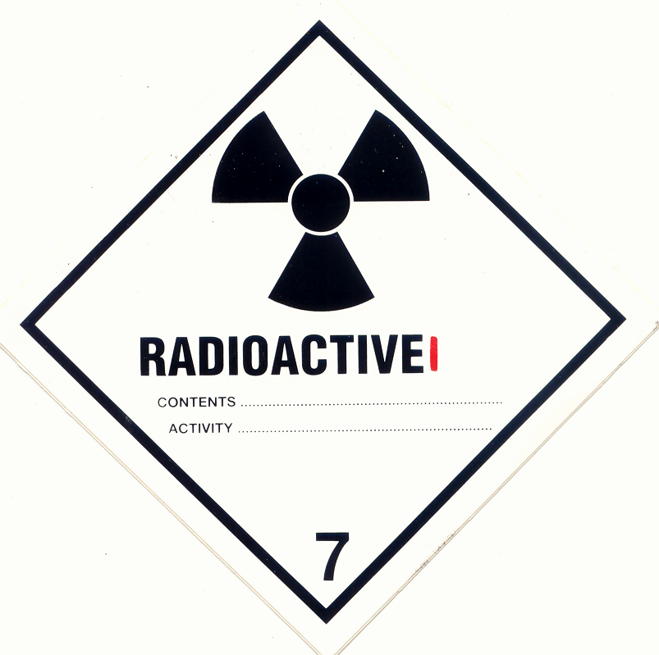

Figure 1: A typical label that will be displayed on Type A Category I packages.

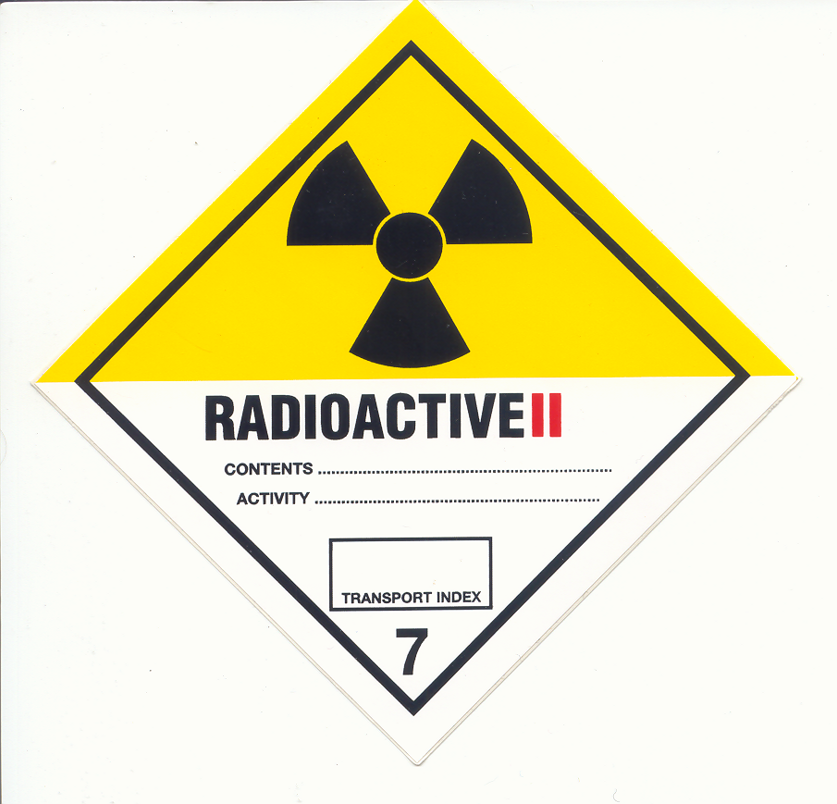

Figure 2: A typical label that will be displayed on Type A Category II packages.

