 | University of Liverpool Radiation Protection Office  DESIGN STANDARD FOR NEW RADIATION LABORATORIES OR REFURBISHMENT OF EXISTING LABORATORIES

Application of this Design Standard
1) The purpose of this Design Standard is to present the design standard that must be followed when designing new (or refurbishing) radiation laboratories. The standard applies to Radiation Supervised Areas where unsealed sources are used. It does not apply to Radiation Controlled Areas, the design for which must, in all cases, be developed in accordance with specifications, unique to each proposed Controlled Radiation Area, to be laid down by University Radiation Protection Adviser (RPA)
2) It is a legal requirement that the customer, architects, project officer, design team etc. seek the advice of the RPA from the initial planning stage. Moreover, the RPA must be kept in touch with the project during its progress. (Regulations 14, 32(2) and Schedule 4 of the Ionising Radiations Regulations 2017 states that the RPA must be consulted about the prior examination of plans, design, installation and acceptance testing of radiation facilities…and the adequacy (and functioning) of control measures provided to restrict exposure. Additionally, paragraphs 257 to 270 and paragraphs 629 to 633 of the ACoP apply.)
3) A laboratory may not be commissioned for use until a Critical Examination has been successfully carried out by the RPA.
4) The responsibility for legislative compliance with respect to the proper design, construction, installation and testing of radiation facilities lies with the 'employer who works with ionising radiation' i.e. the Head of Academic Unit. (The 'employer who works with ionising radiation' at the University of Liverpool is the Vice-Chancellor for the University and the Head of Academic Unit (School, Department, Institute, etc) for the organisational unit.)
Objective
5) This design standard has been prepared with thought to the likely future needs and directions of research, and has harmonised thinking in the specialist safety disciplines (radiological protection and bio-safety) with a view to taking an enabling approach to multidisciplinary experimental work. A laboratory that is built to the standard given herein will satisfy the basic safety requirements for most types of medium to high-risk containment work likely to be carried out in the life, medical and environmental sciences.
Legislative framework
6) This standard has been prepared with reference to the following legislation and guidance:
- IRR17: Ionising Radiations Regulations 2017: SI 1075
- Radioactive Substances Development Group. Environment Agency Guidance on Standards for Radiochemical Laboratories in Non-nuclear Premises. Environment Agency (1997).
- Health and Safety Commission. Work with Ionising Radiation (Ionising Radiations Regulations 2017, Approved Code of Practice and Guidance). HSE Books (2018). ISBN 978 0 7176 6662 1.
- International Commission on Radiological Protection. The Handling, Storage, Use and Disposal of Unsealed Radionuclides in Hospitals and Medical Research Establishments'. Annals of the ICRP 1 (2). Pergamon Press (1977). ISBN 0-08- 021510-6.
- Association of University Radiation Protection Officers. AURPO Guidance on Working with Ionising Radiations in Research and Teaching. AURPO (2010 edition).
- British Standard BS4247-2. Surface Materials for use in Radioactive Areas. Part 2: Guide to the Selection of Materials.
- The Environmental Permitting Regulations 2016.
Overview
7) This design standard is in two parts, containing information relevant to both the Academic Unit and Project Design Team, and information which is solely a matter for the Academic Unit, but which should be taken into consideration when assessing their needs.
8) The appendices to this report present typical layouts for radiation laboratories, and show the main features discussed in this design standard.
BASIC LABORATORY REQUIREMENTS (MATTERS FOR THE ATTENTION OF BOTH THE ACADEMIC UNIT AND PROJECT DESIGN TEAM)
Floor coverings
9) 2.5 to 3mm continuous vinyl sheeting with a minimum number of welded joins, and which is coved to the walls to a height of 15cm. Where the flooring material is penetrated by screw holes, for example, sealant should be applied. It is recommended that the flooring should be coved up the legs of workbenches. All edges at the walls should be sealed or welded.
10) Great care should be taken if consideration is being given to non-slip floor coverings, as many of these surfaces are pervious and could retain spilt radioactivity or biological materials.
11) Any non-slip sealant material used to facilitate cleaning may be applied provided that spilled materials can be easily removed during the decontamination procedure. Generally, epoxy resin coatings are easily decontaminated.
Walls and ceilings
12) Walls and ceilings should be smooth, intact and any areas of poor plasterwork should be made good. Any gaps sealed with a suitable hard bonding sealant.
13) The walls and ceilings should generally be smooth and painted with oil-based paints such as eggshell, hard gloss, or high quality waterproof vinyl emulsion to facilitate cleaning without causing damage. Painting with vinyl emulsion is not acceptable. The use of stippled surfaces or a paint finish applied to unplastered concrete blocks is not acceptable.
14) Joints should be sealed or filled with silicone type materials to facilitate cleaning (or removal in the event that decontamination cannot be achieved). Service penetrations in walls and ceilings should be sealed and coved.
15) Suspended ceilings may potentially cause problems due to penetration of contamination.

Doors and Windows
16) Wooden surfaces should be covered with plastic laminate material or painted with a good quality polyurethane gloss paint or varnish.
17) A good level of security is essential for radiation labs, and therefore doors should usually be lockable to ensure safekeeping or to restrict access in the event of major spillage of the materials. Doors leading off public places and which are frequently opened may additionally be secured by use of a swipe-card or keypad lock. For some sites, the user may provide a high level of security for a building as an alternative to securing an individual laboratory within a building.
18) Where opening windows are fitted, care should be taken that no persons will be affected by any release of radioactivity immediately outside. Open windows should not be used as intentional discharge routes.
19) Ground floor or accessible windows should be secured to prevent unauthorised entry.
20) Doors, door/window frames and glass panels must be sufficiently robust to deter forced entry if material that is scheduled under the Anti-Terrorism, Crime and Security Act 2001 and/or HASS is in use (i.e. the lock is of little use if the surroundings are weak).
21) Areas holding HASS materials will have to be compliant with the requirements of the HASS section of EPR2016 and the National Counter Terrorism Security Office (NaCTSO) guidance.
Benches and Work surfaces
22) All work surfaces must be impervious to water and should offer a high degree of resistance to acids, alkalis, solvents, chelating agents, detergents and disinfectants. Care must be taken in the selection of surfaces as certain bench materials preferentially bind specific ions (e.g., Corian fixes iodine, laminates fix sodium, and stainless steel fixes phosphorous, chromium and calcium ions) and easily chipped surfaces may facilitate the incorporation of biological materials into the fabric of the bench.
23) A laboratory may be fitted with a mix of 'active' workbenches where experimental materials are handled, and (flat-edged lower grade) 'support' benches on which equipment is housed. The customer should give serious consideration to their needs in this respect. It is difficult and costly to convert support benching to active benching at a later date; having active benching throughout builds flexibility into the future uses of a laboratory.
- ‘Active’ work surfaces in Radiation Supervised Areas should preferably be
- made of Corian (or similar) (Corian is a resin-based homogeneous material that is cast in a single piece (including backstand, lips and sink). The advantage is that it is seamless and highly resistant to wear and tear.)
- or Trespa, (Trespa is a solid laminate that is reasonably resistant to wear and tear, but which is produced in single sheets. Thus lengths, corners, backstand, lips need to be joined or bonded after fitting.)
- 'lipped' (not dished) to retain spilt liquids, or ‘flat edged’ where radiation work is intended to be done in a containment tray,
- have an integral or tight fitting sink for the disposal of aqueous radioactive waste and denatured biological materials, and,
- be fitted with coving that rise to a height of 10cm.
25) It is recommended that active benches are coloured to enable them to visually stand out from other work areas.
26) All gaps in benches and between benches and walls, sinks, etc. must be sealed with a chemically resistant non-absorbent sealant; silicone and 'no nails' type sealants are particularly good.
27) For minor refurbishments and modifications it is acceptable to recycle older style laminated workbenches providing they can be retrospectively fitted with lipped edges and back stands. 'Trespa' is an acceptable material to use to create lipped edges providing it is firmly bonded onto the existing bench.
28) Exposed wood, including under benches and under bench cupboards, should be painted with a good quality hard gloss paint or polyurethane varnish or laminated. The use of wood surfaces should be avoided on all new laboratory designs.

Waste Disposal Sinks and Drainage Pipes
29) Sinks for the disposal of radioactively contaminated aqueous liquid waste should be constructed of suitable material: for most applications, integral Corian® sinks are preferred for radiation work although stainless steel is acceptable. Ideally, an easily cleanable rear splash plate should extend a reasonable distance up the wall behind the sink. Side splashguards may also be useful.
30) As noted previously, phosphate and calcium ions may bind strongly on to stainless steel, and this may cause problems in laboratories where P³² is used in quantity. (Similar problems may arise where old-fashioned sinks have been sealed with putty or in hard water areas where a calcium phosphate layer may be precipitated in the sink).
31) Simple U-bend traps or small catch-pots should be used so that aqueous wastes are immediately flushed away and not 'retained' in the laboratory drainage system: large traps or catch pots must not be used.
32) The drain should be connected directly (without any other branches) to the nearest vertical downfall and thence to the main foul water sewer leaving the premises.
33) Drainage system materials should take into account the possible build up of contamination on surfaces.
34) The most useful type of drainpipe material for radiation laboratories is 'vulcathene'. However, it must be borne in mind that all materials will absorb ions to a greater or lesser extent, for example, vulcathene tends to fix iodine very strongly, and this could prove to be significant where large quantities of radioiodine have to be disposed of through drains of this material (Prior to iodine work, vulcathene drainpipe runs can be pre-flushed with concentrated molasses, which lines the pipe and preferentially absorbs iodine ions.). Borosilicate glass may be used as a drainpipe material in high-risk areas such as Radiation Controlled Areas; however, it is not greatly favoured because of its fragility and the difficulties in making good connections.
35) The discharge route should be mapped and recorded for future reference in case of maintenance on the system. Also, sinks and drainage systems used for the disposal of aqueous radioactive waste should be labelled with the ionising radiation symbol, up to a point at which their contents are diluted substantially with frequently - flowing, non-radioactive effluents. This is to alert maintenance staff and thus prevent unauthorised disposal of any contaminated pipes removed during maintenance work. Pipes should be well supported along a suspended run, should be down-sloped to prevent accumulations of radioactivity, and, where reasonably practicable, should be made accessible - for example by the use of demountable panels - and subject to periodic inspection so as to assure their integrity.
Hand-wash Basin
36) All Supervised Areas must be provided with a hand-wash station comprising a suitable basin fitted with elbow or knee operated taps, liquid soap and paper towel dispensers, which must be sited near the exit to the laboratory.
37) A designated hand washbasin should be provided: it must never be used for the disposal of radioactive substances (other than traces from the washing of hands).
Changing Facilities and lobbies
38) As a minimum, somewhere to hang lab coats should be provided near the entrance to the facility. In some cases it may be necessary to provide a lobby/changing area to the laboratory.
39) The incorporation of lobbies into Radiation laboratory suites will be dependant upon the nature of the work likely to be undertaken therein. Specialist advice is required, and each proposal should be assessed by the RPA
Telephone
40) A telephone should be provided, ideally being sited close by the hand wash facilities in radiation areas.
Fume Cupboards, Ventilation and Containment
41) Careful thought should be given to the installation of fume cupboards and microbiological cabinets: in general, terms fume cupboards and microbiological cabinets are not compatible. Advice on the siting of microbiological safety cabinets is given in the ACDP publication 'The Management, Design and Operation of Microbiological safety cabinets'.
42) Dispensing or preparation of radioactive materials that may cause airborne contamination should be carried out under conditions to prevent dispersal of the substances, and fume cupboards have traditionally been installed in radiation laboratories for this reason.
43) It is acceptable to uses Class I - III Microbiological Safety Cabinets for dispensing radioactive materials, providing sufficient attention is given to the ease of radioactive decontamination.
44) Volatile radioactive materials should never be used in the open laboratory, only in appropriate externally ventilated or filtered containment such as a fume cupboard. Recirculating ventilation systems are inappropriate for volatile radioactive materials.
45) If a fume cupboard is to be used for containment when working with substantial quantities of a gamma emitting radionuclides then the plinth will need to installed that will support a considerable amount of lead shielding (possibly up to 1,000 kg). In addition, when handling gamma-emitting or energetic beta emitting radionuclides consideration should be given to lining the walls against which the fume cupboard is sited with 3mm lead.
46) Careful consideration should be given to laboratory ventilation and the provision for air change. Generally, airflow should move from less hazardous to more-hazardous areas of a laboratory before being extracted or discharged from the room. It should be noted that the balancing of an extract ventilation system having a number of ducts, dampers and inlet points, to achieve design airflow rates, requires considerable skill and expertise. Alterations to damper settings by unskilled operators are therefore generally to be deprecated.
47) Radiation laboratories must have either no pressure gradient between the laboratory and the corridor/outside area, or it must be held at constant negative pressure of 15 to 20 Pascals, i.e. inward airflow. What is strictly forbidden is for the room to become positively pressurised with respect to the surrounding areas.
48) When considering fume cupboards or cabinets for radiation areas, attention should be given to both internal and external surfaces, which should be smooth, hard, and non-absorbent and have the necessary heat and chemical resistant properties. Surfaces must also be easy to decontaminate
Seating
49) Stools and chairs should be either non-upholstered or upholstered in non-absorbent material
Write-up areas
50) Write-up areas are not permitted in radiation facilities, irrespective of the laboratory designation.
Power Supply
51) Electricity conduits, trunks and plug sockets should be wall mounted and set at a minimum height of 200 mm above the work surface
52) Sockets should be a minimum of 300 mm from the nearest sink: the requirement used to be a distance of 1500 mm however this was revised as sinks no longer have to be earth-bonded, and pipes are changing to plastic.
53) Provision should be made for under-bench equipment such as refrigerators and freezers.
54) Sufficient sockets should be installed at suitable locations to power fridges, freezers, centrifuges, bench-top and freestanding equipment.
Security Arrangements
55) Supervised Areas should be lockable, doors should preferably be self-locking and with keypad entry systems. See also paragraphs 16 to 21. If material scheduled under the anti-terrorism act or in the HASS section of EPR2016 is being handled then labs should be alarmed (the advice of the RPA will be required).
LABORATORY EQUIPMENT AND ARRANGEMENTS FOR RADIATION WORK (MATTERS FOR THE ATTENTION OF ACADEMIC UNIT)
Storage and Waste Disposal
General storage
56) Adequate storage space should be available to keep essential equipment in order to minimise the cluttering of equipment near working areas, and reduce the risk of spreading contamination. It may be desirable to have an area set aside for the storage of equipment awaiting decontamination.
57) Storage cupboards should ideally be constructed of non-absorbent materials. Where wooden cupboards have to be re- used, they should be painted with a thick layer of gloss paint or varnish (see also paragraph 28).
Storage and the Anti-Terrorism Act
58) Scheduled material must be stored in a locked freezer/refrigerator. If domestic appliances are used the door and hinges must be reinforced in some way as well as fitting padlocks and hasps.
Refrigerators and freezers
59) Refrigerators and freezers are commonly used for the storage of radioactive sources, biological materials, stock solutions and samples. All refrigerators/freezers and the radioactive/biological materials within them, should be easily identified (labelled). (Refrigerators / freezers should be regularly defrosted. It should be noted that volatile radionuclides, in particular tritium, might accumulate in the ice: it is good practice for the user to check this periodically.)
60) Refrigerators/freezers used to store radioactive materials should be lockable and kept locked unless they are under continual surveillance or sited in locked laboratories.
Waste storage and disposal
61) Waste disposal bins in the laboratory (used for storing radioactive wastes awaiting disposal) should be constructed of a material that is robust, and must provide an acceptable level of shielding. If the waste contains hard beta emitters, the bins may need to be shielded by 1cm Perspex, or lead if the waste contains gamma-emitting radionuclides. The lid should be closed when not in use and the contents in the bag sealed or secured before removing them from the bin.
62) All sharps, bottles, tubes, etc should be placed in sharps containers to ensure safe handling of the materials. Bins located outside the control of the user must be secured to prevent misuse of the contents.
63) Adequate storage space (e.g. a bunker or storeroom) should be available for radioactive wastes, either inside or outside the laboratory. The storage space must be kept locked and may need to be under surveillance.
64) Radiation waste must be secure at all times, and must never be left unattended (even for a moment) between the laboratory and the disposal area.

Space Allocation
66) As a guideline, a space allocation of approximately 24 m³ per worker (which assuming a ceiling height of 2500 mm, equates to approximately 9.5 m2 per worker) is recommended for users of Supervised Areas.
Hazard Warning Signs and Signals
67) Clearly and legibly marked hazard warning signs must be posted on laboratory doors, cupboards, equipment, refrigerators, working areas, drainage pipes, sinks, storage facilities, sewers, exhausts as appropriate. All signs should comply with the requirement of the Health and safety (Safety Signs and Signals) Regulations 1996, i.e. signs should be clear, unambiguous, indicate the hazard and level of risk, and state where the hazard is to be located. The Radiation Protection Service usually provides hazard warning notices after a Critical Examination.
Radiation Workstations
68) Unsealed radioactive materials may only be handled on a ‘workstation’, therefore radiation laboratories should be designed with a mind for the number of workstations required therein. The workstation is delineated by taping an appropriate sized piece of Benchkote® (absorbent side uppermost) to an 'active' bench using 'radioactive' labelled tape. A drip tray within which the work will be done is sited on the Benchkote®; the drip tray will be used in conjunction with disposable liners of absorbent paper (towels or Benchkote®).
69) Shielding will need to be used where appropriate to reduce radiation dose rates at all accessible points. This means that if two workstations are situated side-by-side, it is likely that a Perspex screen will be needed between the workstations. Screens may also be needed at the ends of workbenches.
STAGES IN THE DESIGN PROCESS
The Project Design Team of Facilities Management and the Academic Unit should follow the following steps, in sequence, when designing and building/refurbishing Radiation Supervised or Controlled Areas. External designers and architects must be made aware of this 'sequence of events' at the time of the preliminary contractual negotiations.
- Academic Unit
- Determine usage and research needs, fittings, furniture, equipment, budget, etc.
- Make a rough plan of how the laboratory is envisaged (use Appendices as guide)
- Complete a Best Available Techniques (BAT) assessment
- Academic Unit and RPA
- Proposals discussed with Radiation Protection Adviser (RPA)
- Project Design Team, External designers and Architects
- To prepare/receive drawings
- RPA
- To undertake a Design Assessment
- Academic Unit, Project Design Team, RPA and architects etc.
- To liaise
- To modify plans and design assessment
- Continual liaison, particularly over modifications to the plans
- Project Design Team
- Construction works
- Academic Unit and Project Design Team
- Before hand-over, to agree that the final build has taken place according to specification, and also in compliance with this and other relevant documents
- RPA
- On completion of the construction works, but before hand-over, to undertake Critical Examination
- Project Design Team and Academic Unit
- Hand-over
APPENDIX 1
Layout of typical Multi-user Laboratory in which work with radioactive material is conducted within a designated radiation area
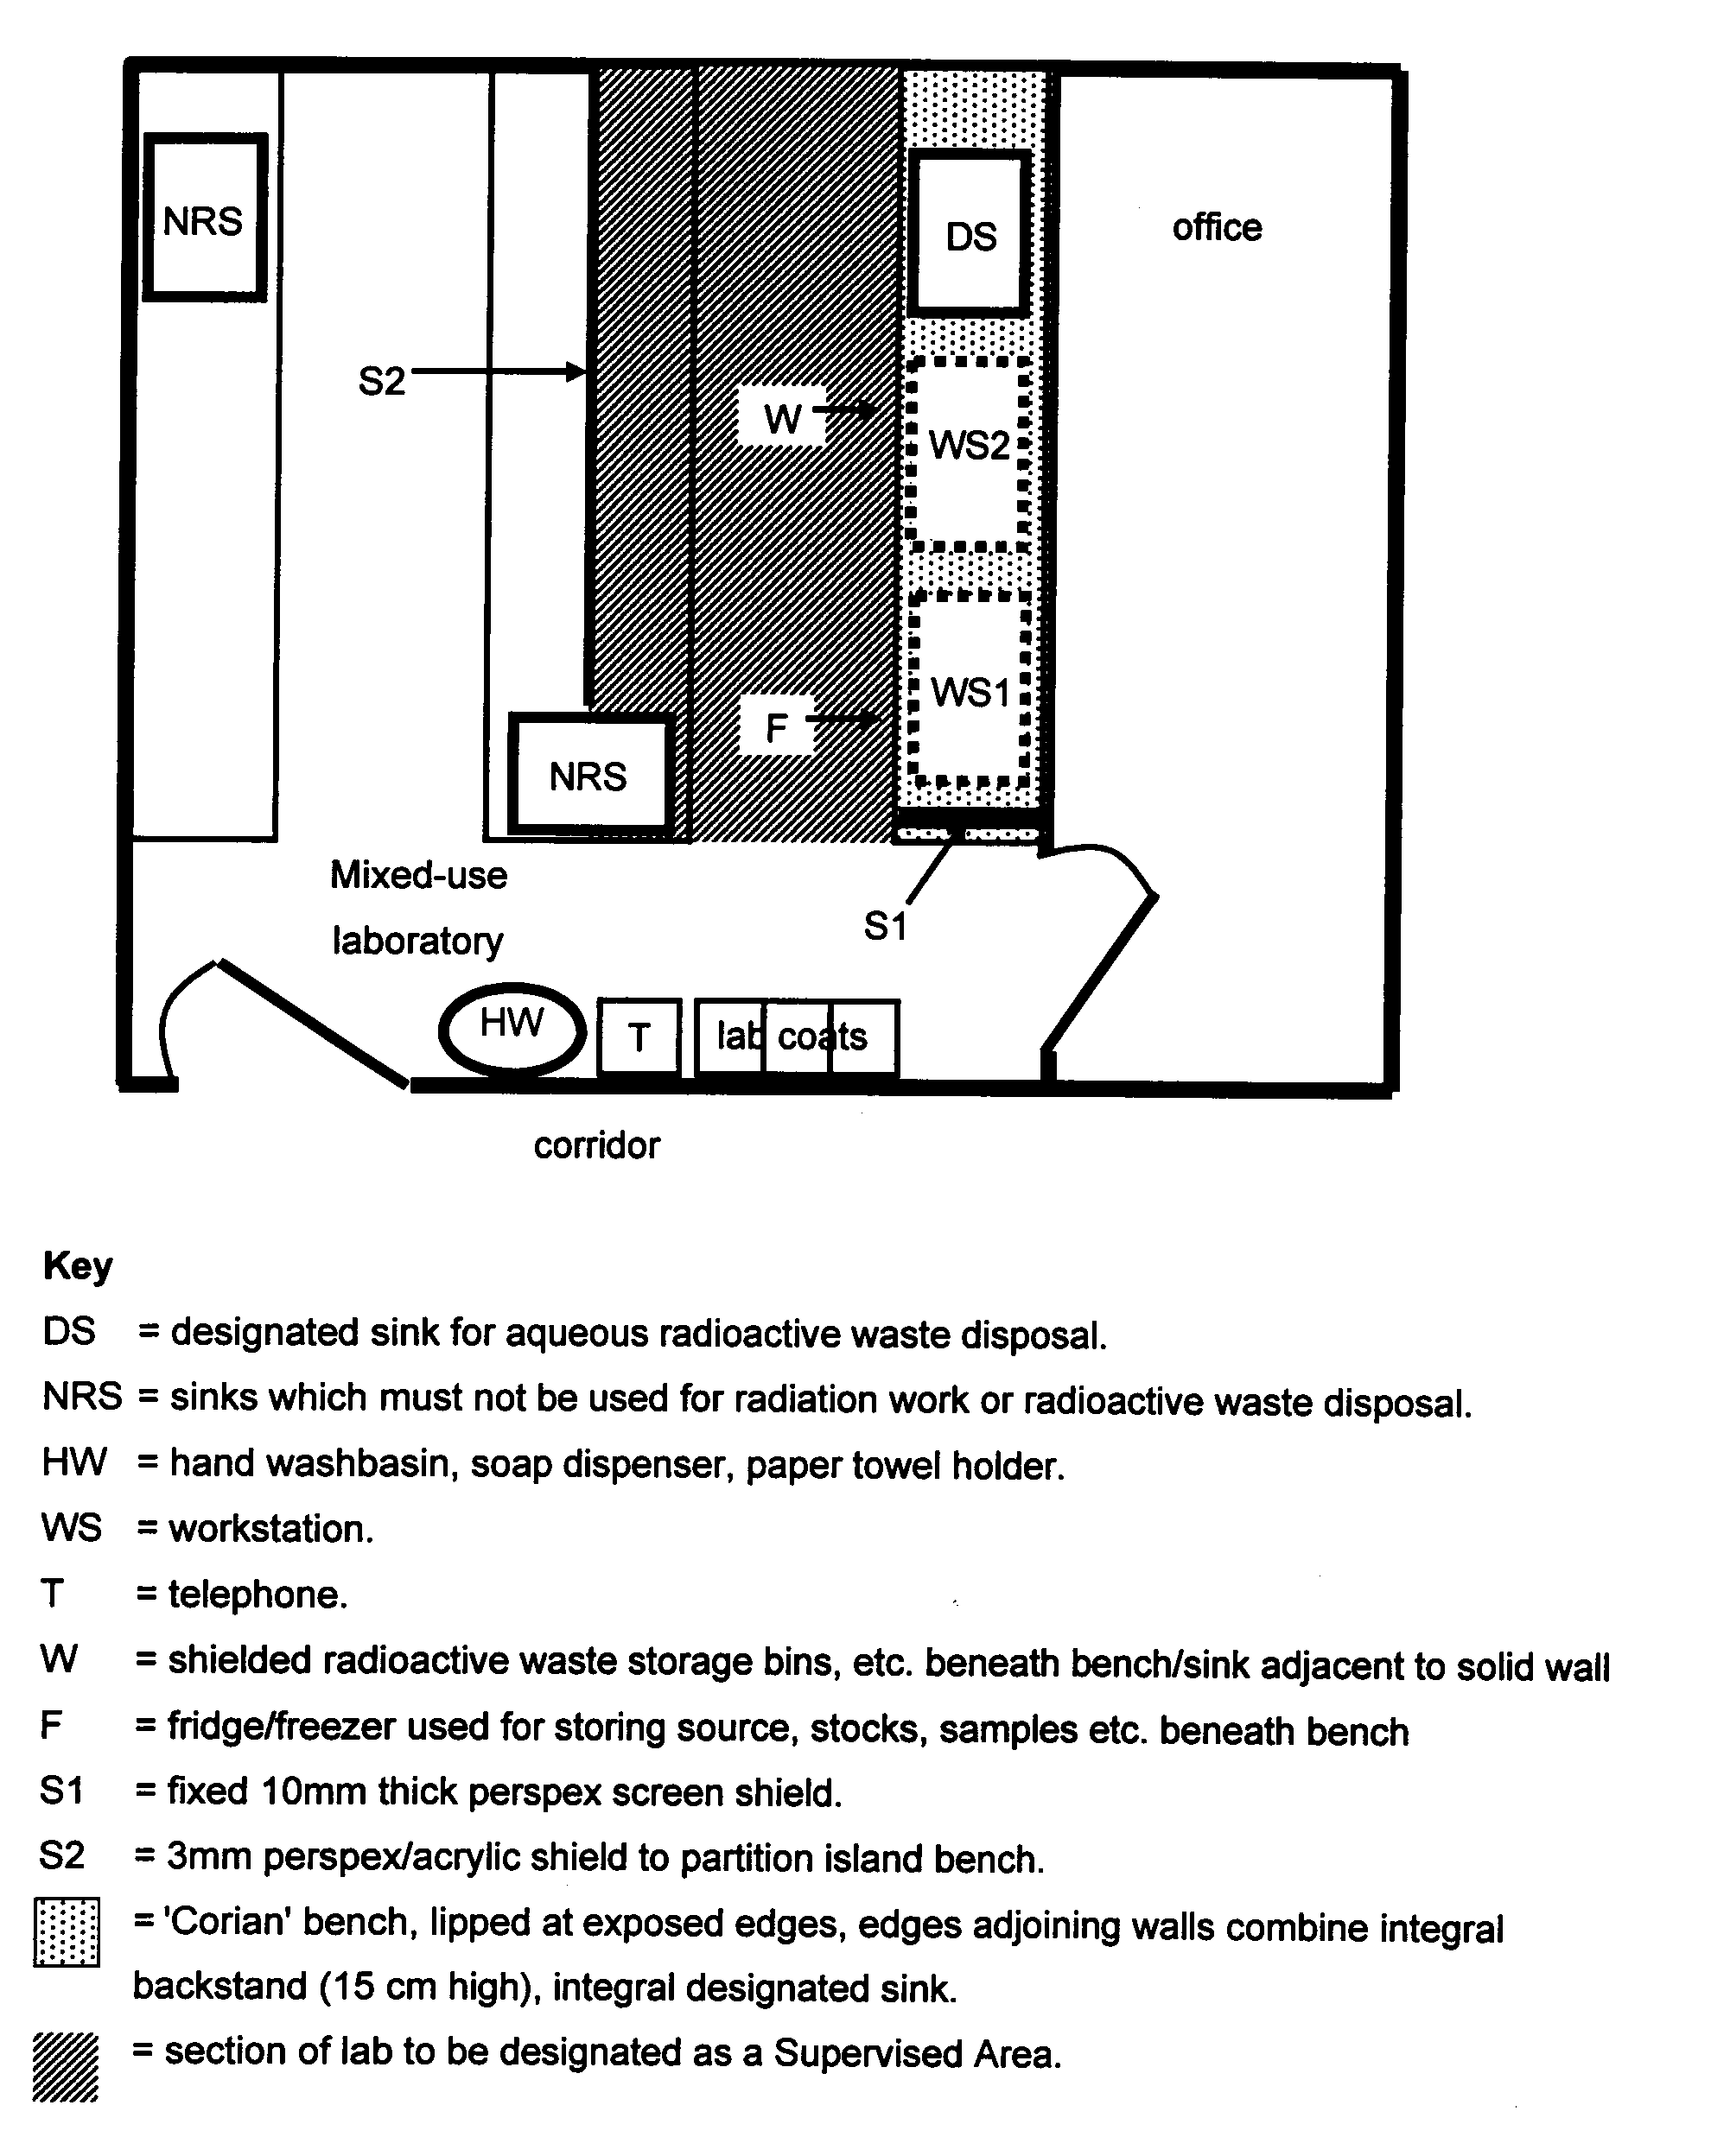
APPENDIX 2
Layout of typical Laboratory designated as a Radiation Supervised Area
