Activities
for ages 10-18

The following activities all involve thinking creatively about how we make and use energy – electricity, warmth, light and physical energy in our bodies - and then exploring these ideas through storytelling and poetry.

- Energy Poetry
- Future Energy Stories
- Exploring Energy Stories
- Natural Energy
- A Guide to Creating Great Characters

These activities will help you get started, then your imagination can do the rest!

Energy Poetry
Where does energy come from? What things make energy? What natural sources of energy are there? Can I describe something that helps make energy?

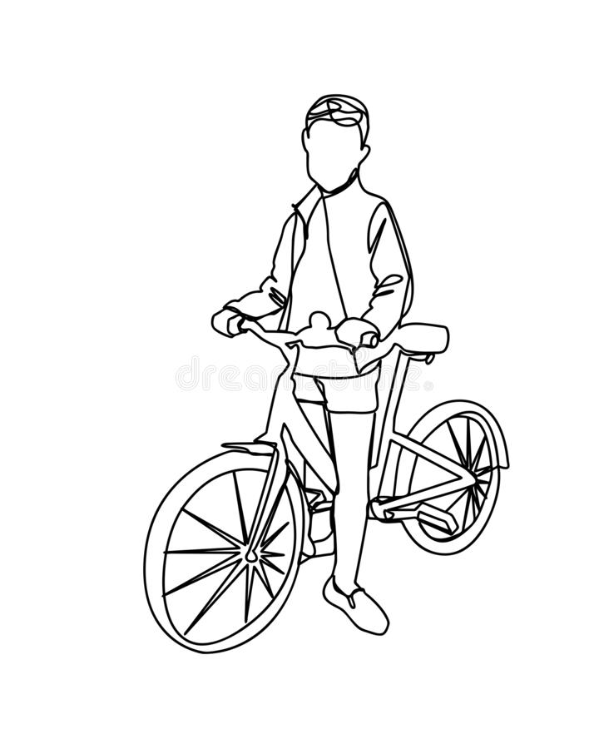
Getting Started…
Use these questions to help think of words for your poem.

Your poem
Use the words, feelings and ideas from this sheet to help you write a short poem about energy.
You can describe your own experience of using energy, or the things you see or hear about at home or out and about, or completely new invented things!

………………………………………………………………………………………………………………………………………………………………………………………………………………………………………………………………………………………………………………………………………………………………………………………………………………………………………………………………………………
………………………………………………………………………………………………………………………………………………………………………………………………………………………………………
………………………………………………………………………………………………………………………………………………………………………………………………………………………………………

Think of five words related to energy

Think of some feelings related to energy

Think of some colours related to energy

Think of some sounds and smells related to energy

Future Energy

Situation: You have travelled 20 years into the future. Natural resources used to make energy and electricity, such as gas and oil, are almost gone. The world needs clever, creative people like you to find a new energy solution!
Mission: You need to find a new way to make energy to power houses, hospitals and shops.

- What do you use?
- How do you build your energy generator?
- Does it work?
- How do you feel about the invention?
- What difference does it make to the world?

Write a short story that shows your invention being created and used
Or
Write any story about our world in the future that excites you!

Exploring Energy

Imagine you are an explorer and have travelled to an isolated place.

- What is the landscape like?
- Is it hot or cold?
- Is there something you could use to make electricity to charge your phone so you can call home?
- How do you build the generator?
- What do you say when you make the call?
Write a short story about this experience. Let your imagination go wild!

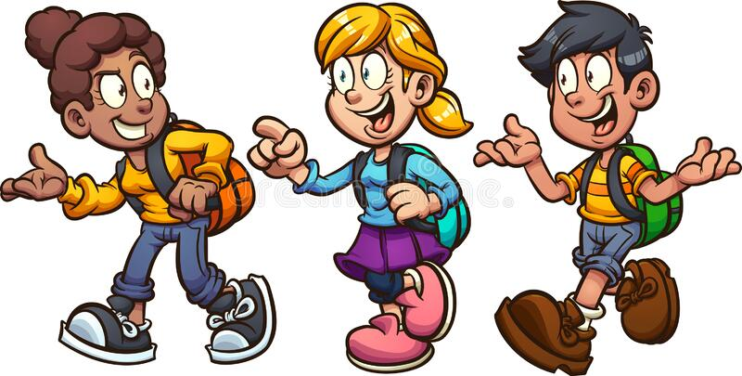

NATURAL ENERGY

Energy is all around us. It is power which has been made from chemical or physical resources and turned into light, heat or electricity.
You also make energy inside your body, from food! This helps you to think, play, run and learn.

Use your senses….
What can you see that uses energy?
What can you hear that uses energy?
What can you smell that provides energy?

How is energy made?
Can you think of sources of energy that can be used to make electricity?
What natural sources of energy are there?
Can you describe something that helps make energy, such as water, wind or sun?
Write a poem or short story based on your ideas and notes!
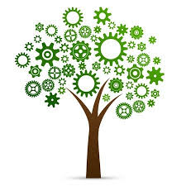

Creating great characters for your stories

The stories that are most fun to write and read have interesting and memorable main characters. Think of Roald Dahl’s Matilda, Katniss Everdeen from the Hunger Games by Suzanne Collins, or J. K. Rowling’s Harry Potter…

Use the following prompts to help you invent a truly amazing and unforgettable character for your own short story.

- Choose an interesting name – maybe make up a new name by mixing words together!

- Do they have a special talent or skill? This can be a real-life skill, like using a wheelchair, or a fantasy/science-fiction skill, like flying. Are they able to climb like a spider, or read people’s minds? Can they control the weather?

- Describe what they look like. Do they have any special features, like amazing freckles or a beautiful birthmark?

- Do they have a friend or companion to help them? A faithful dog or magical cat?

- What is their goal in the story?

- Finally, what other characters will they meet?

These are just some ideas to get you started, let your imagination do the rest!
Once you have an idea of your character in your mind, you’ll be able to write a really exciting story using our activity sheets! We can’t wait to hear them!

