HLS Wellbeing Newsletter
14TH May 2020

CONTENTS

- Introduction, University Support - Staff, University Support - PGR
- New resources, Tips and Links
- Tips and Links, Top tip from you, Exercise options
- Exercise options, Lockdown tips and tricks, Fun, Frivolity and forgetting Corona, Last week’s quiz winners revealed
- Fun, Frivolity and forgetting Corona, This week’s quiz

Introduction

With uncertainty running around us, it can be very easy to get bogged down in the worries, debates in the media on the best way forward and arguments at home about who’s turn it is to do the washing-up! This week’s newsletter is to help update you on support available, new resources, events to look out for and some reminders that there are fun activities you can throw yourself into!

University support:
Staff: Check out the University Wellbeing Hub which is the home to all the University information about wellbeing including self-help wellbeing support, on-line CBT courses and resilience courses.
It also has detail on the staff confidential counselling and advice service the Employee Assistance Programme
Additional help and advice can be found on the Researcher hub pages.
The Thriving during Isolation module from The Academy comes with a downloadable workbook which is a programme to guide you through building your personal thriving during isolation strategy.

PGRs:
COVID-19 FAQs webpage for PGRs now live: The Liverpool Doctoral College COVID-19 FAQs page for PGRs to help answer questions and direct you to the relevant support. The page will be updated frequently with news and additional information as soon as it is available. Please view the link here.
The University Student Services are available for support to all PGRs via telephone and email, please view their intranet pages for full details. There is also a dedicated Wellbeing Resources page providing specific support information on how to stay safe and well during COVID-19.

External support for mental health: NHS webpages provide support for many mental health and wellbeing difficulties and an extensive list of links to organisations.

NEW RESOURCES
Culture at home: The University working in partnership with Liverpool City Council have created an online hub of fascinating cultural activities, apps, blogs and activities that you can enjoy no matter where you are. It is available to all students, staff and the wider Liverpool community.
There is a wide range of activities for all ages and interests including concerts, exhibitions, writing for wellbeing and many more.
Read the full news story here
Visit the culture at home hub here

Tips and links to articles:
Feeling lonely doesn’t always mean being alone
During this time it is easy to feel disconnected from friends, relatives, colleagues and partners which can lead to feelings of loneliness.
This may be felt more strongly by those who are living alone BUT you can also feel incredibly lonely surrounded by people.
This week Jenna talks in her vlog about feelings of loneliness that often come with depression and anxiety and how you can support someone who is struggling.
If you like Jenna’s videos, this week she was also interviewed by Radio City Talk on her mental health journey for #MentalHealthMonday which you can listen to here
Thinking about your wellbeing during uncertain times
With the slight shift in lockdown rules causing uncertainty and the unknown of what the coming months could mean for you as an individual, it is very easy to neglect your mental wellbeing.
Maintaining the beneficial routines you have set up for yourself during lockdown is really important so that you keep consistency in what may feel like to you a very uncertain world.
Keep that daily work routine, connecting with loved ones, a healthy sleep routine and limit your news and social media intake on the outbreak. Find out more tips on lots of different areas and ways to look after your mental wellbeing here.

Fika App: Build your mental fitness
The University of Liverpool has partnered with mental fitness app Fika during COVID-19 to give all staff and students access to an additional tool to stay motivated, productive, focused and connected during this period of remote work and study.
Staff and students can gain invaluable insights into the science behind your mental health and develop the seven skills of Mental Fitness: focus, confidence, motivation, connection, positivity, meaning and managing stress.
See more on the University news page
PGR events to look out for….
- Monday 18th May – Online Research Cafe
- Peers for PhD’s are running regular virtual coffee mornings each week. Dates for the next meetings are: Tuesday 19th May 9am, Thursday 28th May 10am, Tuesday 2nd June 9am. To find out more information on how you join the mailing list read their news article here
- The Liverpool Doctoral College PGR training and development programme for May is available, you can find out more on all sessions here

Top tip from you

We are really enjoying hearing tips and tricks from the HLS community!
Please keep sharing: this can be useful articles you have read, activities you are involved in, practises that are working well in your research group, recommended tips to managing working from home or anything else you feel could be helpful. Please email Maizy Jenner with these suggestions and we will include them in the next newsletter.
Top tips shared from members of the HLS community:
One way of dealing with unusual times is to start a journal. This could be a written journal to express how you are feeling or it could be drawings. Some people have mentioned to us that they have started taking photographs to capture what every day life is like during the pandemic so they have something to show their children and grandchildren.
If you like taking photographs there are a lot of competitions currently ranging from capture your workspace to lockdown selfies. If you think you have got a picture that really sums up this time the National Portrait Gallery is also running a competition called Hold Still 2020. This could be your chance to honour a helper or key worker or maybe a chance to show the world what it looks like to be a scientist in this crazy time.

Exercise options

Mark has recorded another video on the YouTube channel civic duty. This week’s video is a breakdown of Shibashi move 1 – Heaven and Earth in a bit more detail than just following along.
There are many more videos on his channel so take a look. You can also find a playlist for all the moves here.

Lockdown tips and tricks

What can I do that is fun this weekend?
If you are staying in, going out for a walk, have a garden, don’t have a garden, children, no children, there are still lots of activities you can do whilst keeping safe this weekend.
Take a look through these guides (we know not all activities will appeal but you never know until you try it!) for ideas and inspiration to fill that time.
National Theatre
Future learn
Telegraph guide of ideas to keep children entertained!
The guide Liverpool 20 ways to beat boredom
Light Night at home Friday 15th May from 5pm

Fun, Frivolity and forgetting corona

WEEKLY QUIZ
I hope you enjoyed both the quiz last week. It seems like lots of people have watched the same films as me as we had lots of correct answers.
This week’s winner was…… Drum Roll please……
Champions of the Quiz
David Starns
Justin Shanahan
Angela Garner- Williams
Hazel Scott
Susan Canning

Helen Hubbard
Mark Powell
11/12
12/12
10/12

David MacEwan
Julie Spence

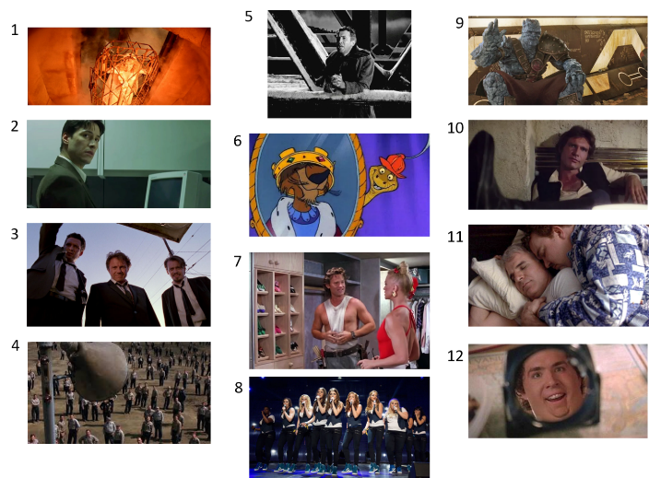
Answers:
- Indiana Jones and the temple of doom
- The Matrix
- Reservoir dogs
- Shawshank redemption
- It’s a wonderful life
- Disney’s Robin Hood
- Overboard
- Pitch Perfect 2
- Thor Ragnarok
- Star Wars – A New Hope
- Planes, Trains and Automobiles
- Just Friends

After seeing a number of pets in zoom meetings recently as well as all the videos showing how wild animals have been enjoying us humans being locked away I thought I would make this week’s quiz animal themed! Can you guess the animal from the picture?
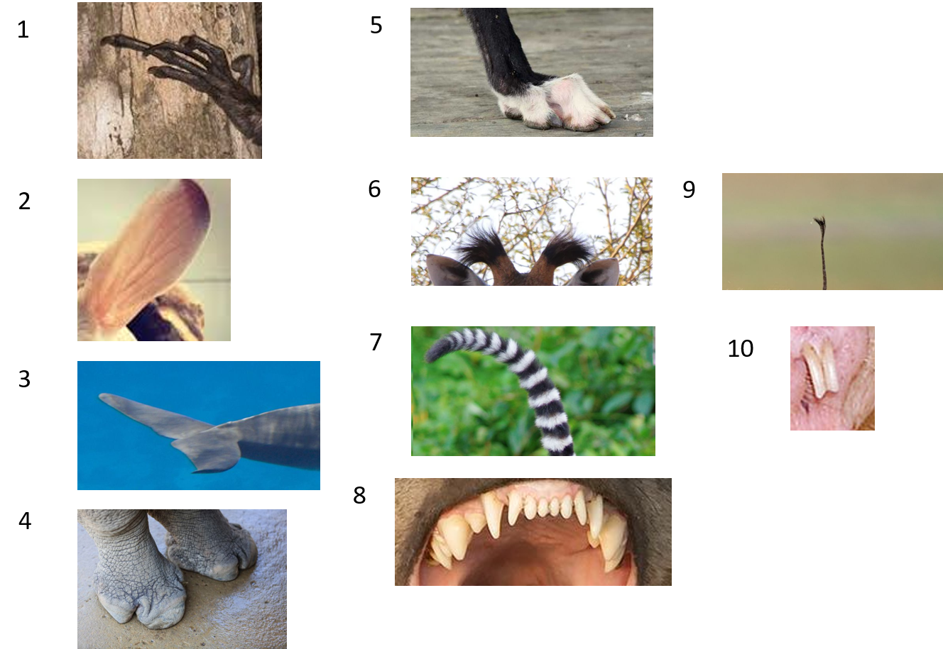

As last week email your answers to j.kenyani@liverpool.ac.uk and I will reveal the winner next week! Good Luck!

