HLS Wellbeing Newsletter

**30th April 2020**

# CONTENTS

1. *Introduction, University Support for Staff, University Support for PGRs*
2. *External Support*
3. *External support, Tips and Links*
4. *Tips and Links*
5. *Top tips from you, Exercise options*
6. *Lock down tips and tricks, Fun, Frivolity and forgetting Corona*

*7&8. Fun, Frivolity and forgetting Corona*

# Introduction

As the media, government and even the University start discussing the future, when lockdown will be lifted and what the new ‘normal’ will look like, it can feel very overwhelming and uncertain. We hope that this week’s newsletter will not only give you some light relief from the more serious topics but also offer some support and tips with managing the concerns you may be having.

# University support:

**Staff:** Check out the University [Wellbeing Hub](https://www.liverpool.ac.uk/intranet/wellbeing/) which is the home to all the University information about wellbeing including self-help wellbeing support, on-line CBT courses and resilience courses.

It also has detail on the [Employee Assistance Programme](https://staff.liverpool.ac.uk/our-workplace-and-community/support-and-development/employee-assistance-programme/)

Additional help and advice can be found on the [Researcher hub pages.](https://www.liverpool.ac.uk/researcher/work-life-balance/wellbeing-covid-19/)

The [Thriving during Isolation module](https://your.mindset.co.uk/thriving-during-isolation/) from The Academy comes with a downloadable workbook which is a programme to guide you through building your personal thriving during isolation strategy.

**PGRs:** The University Student Services are available for support to all PGRs via telephone and email, please view their [intranet pages](https://www.liverpool.ac.uk/studentsupport/advice/) for full details. There is also a dedicated [Wellbeing Resources](https://www.liverpool.ac.uk/studentsupport/advice/resources/) page providing specific support information on how to stay safe and well during COVID-19.

The LDC have a number of online courses, workshops and webinars available to help during this period, find out more [here](https://www.liverpool.ac.uk/pgr-development/offering/catalogue/) for dates and times.

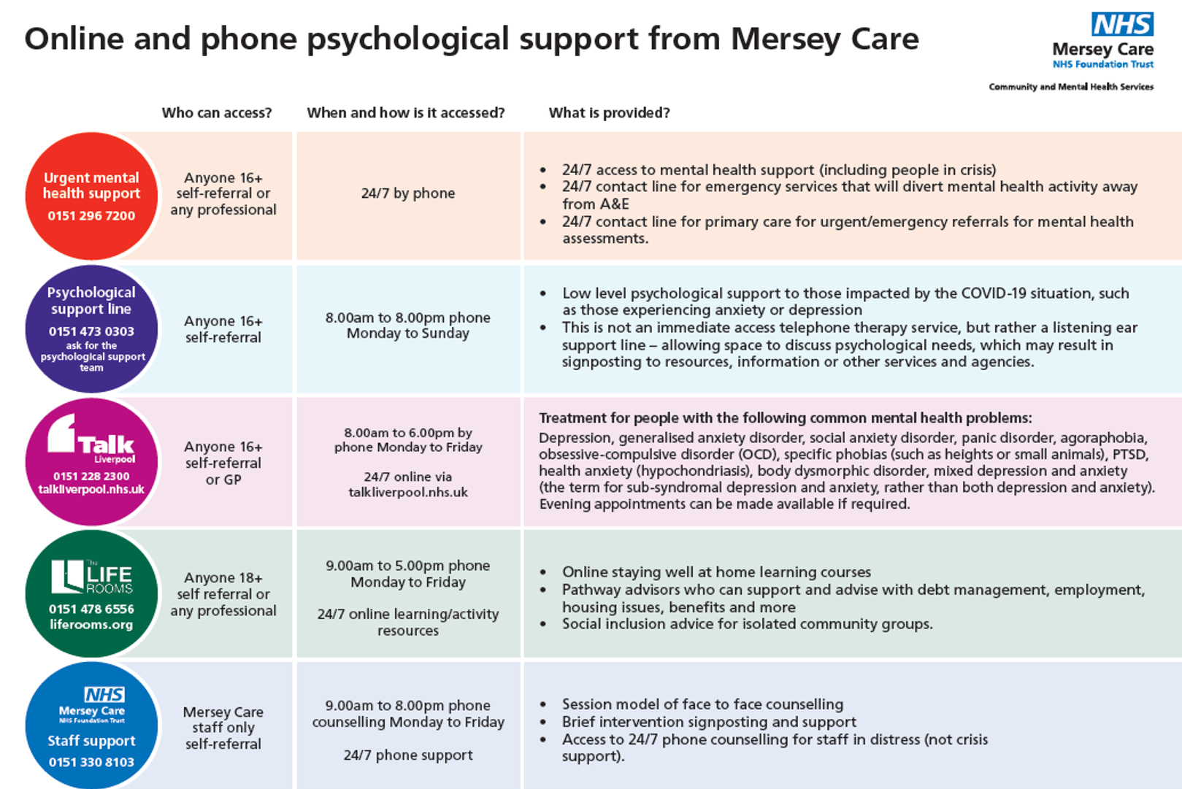

**Support in the local Liverpool area:**

The ‘Psychological Support Line’ is for anyone 16 or over across Merseyside and Sefton that has been impacted by the COVID-19 situation and are in need of low level psychological support. It is staffed by clinical psychologists and practitioners from Mersey Care, open from 8am – 8pm every day.

Telephone number: 0151 473 0303

Please note this is not a crisis line and it is separate from the ‘Urgent mental health support’ line that has also been set-up. Please view full details in the grid above.

# Tips and links to articles:

**Journaling**

A lot of therapists and counsellors will often recommend journaling as a way to deal with emotions.

Journaling doesn’t have to mean keeping a diary. Lots of people can find that overwhelming. It could be just writing a few bullet points each day or even drawing how you feel. Find what works best for you.

By writing/drawing/talking about how we have felt that day can help us deal with those emotions.

Alongside your thoughts and feeling it is also helpful to write down one positive thing that has happened that day. It can be small from enjoying a nice sandwich for lunch to something much bigger like having a paper accepted.

By acknowledging that good thing it reminds you that there are still good things even in the tough times.

**Support for young people and children struggling with their mental health**

This is a difficult time for all and can effect children and young people in many ways.

If you have a child who is struggling and are worried about them there is plenty of support.

Liverpool CAMHS (child and adolescent mental health service) is working with its partners across the city to ensure children, young people and families get the support they need during this time.

Their [website](https://www.liverpoolcamhs.com/support-category/covid-19-support/) has lots of resources and advice.

If you are a child or young person, parent or carer in crisis, you can call the Alder Hey CAMHS [crisis care](https://www.liverpoolcamhs.com/support/camhs-crisis-care-team/) line 24 hours a day, seven days a week on **0151 293 3577 or freephone 0808 196 3550**

**Email CrisisCare@alderhey.nhs.uk**

Anxiety about the future

If you are feeling worried, scared or overwhelmed by what the future may hold post COVID then you are not alone.

This is a worrying time for everyone. If you already suffer with anxiety or are now experiencing high anxiety due to the feeling of change, this can make you feel out of control. It is really important if you are feeling like this to find ways to ground yourself to bring yourself into the present. Concentrate on getting through the next hour, day or week rather.

Jenna has also been struggling with this and has talked honestly in her latest [video](https://www.youtube.com/watch?v=RbklBKM6Fb4&t=25s)

**University events to get signed up for….**

**For staff and PGRS**

* **Wellbeing week** is underway with a number of virtual events to join. Find information for [staff here](https://news.liverpool.ac.uk/2020/04/27/university-launches-wellbeing-week/)  and [students here](https://news.liverpool.ac.uk/2020/04/28/wellbeing-week-campus-5k-at-home/)
* Susan Canning, Centre of Educational Development and Support, is hosting a **series of webinars on ‘How to work successfully from home’**. The purpose is to share some of the useful tips that Sarah has learned, as well as allowing staff and PGRs to share any challenges that they are facing whilst working from home. The session is designed to be informal to offer everyone a chance to discuss any issues or problems they are facing and to also connect with people as working from home can be quite isolating. Webinar dates are as follows:

Wednesday 6th May, 11am – 12pm

Wednesday 13th May, 1 – 2pm

Wednesday 20th May, 11am – 12pm

Tuesday 26th May, 11am – 12pm

If you would like to attend one or all of these sessions, please email Sarah at [scanning@liverpool.ac.uk](mailto:scanning@liverpool.ac.uk) and you will be added to the Teams site.

**For Staff**

* The Academy will be running a **4-week programme on ‘The Positive Approach’** which uses the emerging scientific field of positive psychology to help you lead a happier and more rewarding life. Full details of the programme can be found [here](https://announce.liv.ac.uk/rss/main/article.asp?article=23560485)

The Academy has 100 places available on this programme. If you would like to book a place please email [theacademy@liverpool.ac.uk](mailto:theacademy@liverpool.ac.uk) providing your Name and staff number.

**For PGRS**

* The Library Team are taking their **PGR Research Café** online! The first session will be Monday 18th May 2-3pm with the opportunity to hear from three PhD students about how their research is going, learn about research from outside your discipline, and network (remotely) with other early career researchers. There are 50 spaces available so sign yourself up quick using the registration form link [here](https://libcal.liverpool.ac.uk/calendar/library-training/researchcafes) and you will be sent a Microsoft Teams link the day before.

# Top tips from you

We would really like to hear from the HLS community about what you are doing to help boost your wellbeing during this time. This can be useful articles you have read, activities you are involved in, practises that are working well in your research group, recommended tips to managing working from home or anything else you feel could be helpful. Please email [Maizy Jenner](mailto:m.jenner@liverpool.ac.uk) with these suggestions and we will include them in the next newsletter.

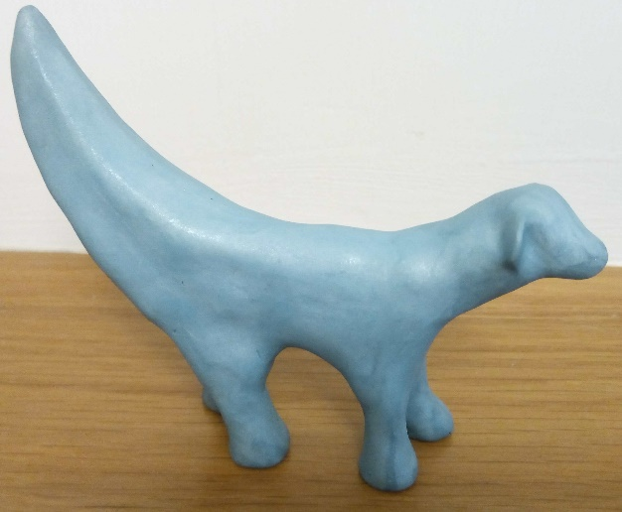***Top tips shared from members of the HLS community:***

This week Jonathan Taylor, shared with us his Lockdown lamb banana creation! We think it looks great and he had lots of fun doing it.

Being creative is a great way to practise mindfulness as well as being fun and a nice break from the stresses the current situation can bring.

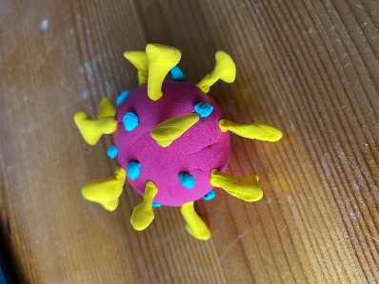Other ideas to be creative:

1. [Learn to knit](https://www.glamourmagazine.co.uk/gallery/how-to-knit-beginner-sets)
2. Get building with Lego kits to [benefit your mind](https://www.telegraph.co.uk/news/2020/01/04/millennials-finding-mindfulness-lego/)
3. Create your own zoo of [origami animals](https://www.youtube.com/watch?v=dI7i1_M_OYk)
4. Make a playdough model of the COVID virus model (see example)
5. Make a collage of all things you want to do when this is over
6. [Build a den](https://metro.co.uk/2020/04/23/george-clarke-shares-expert-tips-make-perfect-den-12600460/) to escape from the world, fight off pirates with your children in [imaginary play](https://www.persil.com/uk/dirt-is-good/real-play/what-is-imaginative-play.html) or just watch a film (we have it on good authority that this is perfectly acceptable thing to do even without children! Haha)
7. Make your own gin/beer
8. Become a [volunteer mask sewer](https://www.sewcialmask.com/)

If you want to show us any of your creations please email us with pictures!

# Exercise options

If you were a regular to exercise before lockdown or have now taken this time to get yourself into it, there are plenty of free exercise workouts and guides out there!

Here [Sport England](https://www.sportengland.org/) talk you through their best recommended selection of exercise platforms for: on demand content and apps, free video content and activities, child-friendly exercise activities, Disability or long-term health conditions, pregnant women, older adults, Yoga and Pilates, strength and conditioning and general fitness. [Visit their page here](https://www.sportengland.org/stayinworkout#get_active_at_home)

# Lockdown tips and tricks

Are you a Bruce Springsteen fan? This weekend there is a 24hr “house party” housed by the best Bruce themed nights Hungry Heart events. You can join them live from their living room on Saturday 2nd May via <https://www.hungryheartevents.com/>

# Fun, Frivolity and forgetting corona

WEEKLY QUIZ

I enjoyed seeing so many of you emailing in for the 4th wellbeing quiz. This week 1st, 2nd and 3rd place were allocated via points. Well done to all who took part, I am very impressed with everyone’s music knowledge.

This week’s winners are…… Drum Roll please……

**Champion of the Quiz**

Joseph Towler

Tom Heathcote

Giusy Russomano



Helen Hubbard

David MacEwan

Gemma Roberts

Jackie Bradshaw

20 Points

18 Points

### 19 Points

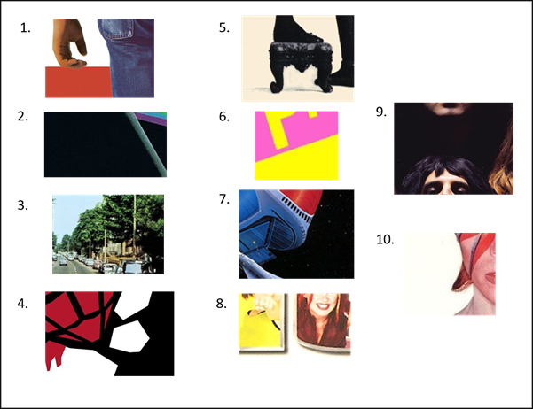

Answers:

1. Bruce Springsteen – Born in the USA
2. Pink Floyd – Dark side of the moon
3. Beatles – Abby Road
4. Greenday – American Idiot
5. Fleetwood Mac - Rumours
6. Sex Pistols – Never mind the Bollocks
7. ELO – Out of the blue
8. Spice girls - Spice
9. Queen – Queen II
10. Bowie – Aladdin Sane

This week I am giving you TWO quizzes!

The first is a brain teaser:

Sid Shady asked his wife to accompany him to a war movie being featured that night. During a scene when grenades were exploding and guns firing, Shady decided the time was right; he pulled put a gun and shot his wife. He then took her out of the theatre without anyone trying to stop him. Why not?

The second is a picture round as normal. As I am really missing travelling this week’s quiz is on countries and their flags. 1 point for the country whose flag is shown below and 1 point for the capital of the country. I will trust you not to google!

You can enter one or both. As always email your answers to [j.kenyani@liverpool.ac.uk](mailto:j.kenyani@liverpool.ac.uk) and I will reveal the winner of both next week! Good Luck!

