HLS Wellbeing Newsletter

**23rd April 2020**

# CONTENTS

1. *Introduction*
2. *University Support – Staff*
3. *University Support – PGR*
4. *Tips and Links*
5. *Top tip from you*
6. *Exercise options*
7. *Fun, Frivolity and forgetting Corona*

# Introduction

One month of lockdown done! For some people you may be starting to get used to this new life, finding new routines and work patterns. For others this may feel never ending. It is completely ok to have changing moods. The longer this goes on the more important it is to find ways to look after our own mental wellbeing and hopefully this week’s newsletter will help.

# University support:

**Staff:** Check out the University [Wellbeing Hub](https://www.liverpool.ac.uk/intranet/wellbeing/) which is the home to all the University information about wellbeing including self-help wellbeing support, on-line CBT courses and resilience courses.

It also has detail on the [Employee Assistance Programme](https://staff.liverpool.ac.uk/our-workplace-and-community/support-and-development/employee-assistance-programme/)

Additional help and advice can be found on the [Researcher hub pages.](https://www.liverpool.ac.uk/researcher/work-life-balance/wellbeing-covid-19/)

The [Thriving during Isolation module](https://your.mindset.co.uk/thriving-during-isolation/) from The Academy comes with a downloadable workbook which is a programme to guide you through building your personal thriving during isolation strategy.

**PGRs:** The University Student Services are available for support to all PGRs via telephone and email, please view their [intranet pages](https://www.liverpool.ac.uk/studentsupport/advice/) for full details. There is also a dedicated [Wellbeing Resources](https://www.liverpool.ac.uk/studentsupport/advice/resources/) page providing specific support information on how to stay safe and well during COVID-19.

The LDC have a number of online courses, workshops and webinars available to help during this period, find out more [here](https://www.liverpool.ac.uk/pgr-development/offering/catalogue/) for dates and times.

External support for mental health: [NHS webpages](https://www.nhs.uk/conditions/stress-anxiety-depression/mental-health-helplines/) provide support for many mental health and wellbeing difficulties and an extensive list of links to organisations.

## NEW RESOURCES

A new campaign, [Kind to your Mind](https://liverpoolexpress.co.uk/new-campaign-wants-you-to-be-kind-to-your-mind/), led by Cheshire & Merseyside Health & Care Partnership, has been launched that aims to support the mental wellbeing of people living and working across the region.

The campaign also sees the launch of the new [ALMA](https://kindtoyourmind.org/) wellbeing online portal that has a suite of mental and physical wellbeing resources that has been exclusively developed for people in Merseyside and Cheshire.

The campaign launched on Monday 13 April and will run for six weeks.

A new podcast series covering topics such as building resilience, mental health, nutrition, physical activity and sleep will also be released from Monday 20 April.

Mersey Care NHS Trust has also launched a 24-hour helpline to support mental health assessments away from emergency services.

# Tips and links to articles:

PhD and ECR’s worried about how COVID may impact your research?

There is a chance to have your say!

[SMaRteN](https://www.smarten.org.uk/), in partnership with Vitae, is conducting research into the impact of COVID-19 on the working lives of doctoral researchers and research staff.

The survey asks about the impact of COVID-19 on research work, mental wellbeing and social connection. As well as employment outside of academia, living arrangements, caring arrangements and the consequent effect of these changes on research work. It also considers the support provided by supervisors / line managers and by universities.

[Take part in the survey now](https://www.smarten.org.uk/covid-19-study.html)

**Wellbeing week 27th April – 1st May**

The universities annual Wellbeing Week will be going ahead next week with a twist: all events will be delivered virtually.

The university will be theming each day around the [5 steps to wellbeing](https://www.nhs.uk/conditions/stress-anxiety-depression/improve-mental-wellbeing/) with links, activities and more available online each day.

Keep a look out on the University news webpages for more information on [student](https://news.liverpool.ac.uk/students/) and [staff](https://staff.liverpool.ac.uk/) events. Information will also be updated through the main university [social media channels](https://www.liverpool.ac.uk/contacts/social-media/).

**Positive outcomes of being in lockdown**

It can be difficult to see the positive outcomes that are occurring from the country being in lockdown as it reaches what feels like day 569 of lockdown life. However, there are many positive’s that can come out of the current situation.

It might be the reduced commute to work which now is from your bedroom to living room, stress free and a lot less cramped. Or it could be the extra time you have to now read that book you got for Christmas. Here is an [article](https://metro.co.uk/2020/04/03/people-tell-us-self-isolation-positive-effect-lives-12502944/) highlighting some of the personal positives from lockdown.

**It is ok to feel sad**

We are all dealing with a lot of emotions as the pandemic continues. It is ok to feel emotional. It is ok to not feel in control of your emotions. Some people feel irritable, some sad, some down, some anxious, some lonely.

It is ok to not be ok during all of this. It is also ok to let this emotion out, you have nothing to feel ashamed about.

As the lockdown continues you may find that your emotions are all over the place.

Jenna Kenyani is talking in her [video blog](https://www.youtube.com/watch?v=sc4U_5USiLU&t=11s) about how she is dealing with the ever increasing emotions.

# Top tip from you

*Asking staff and students to share:*

We would really like to hear from the HLS community about what you are doing to help boost your wellbeing during this time. This can be useful articles you have read, activities you are involved in, practises that are working well in your research group, recommended tips to managing working from home or anything else you feel could be helpful. Please email [Maizy Jenner](mailto:m.jenner@liverpool.ac.uk) with these suggestions and we will include them in the next newsletter.

***Top tips shared from members of the HLS community:***

[](https://www.google.co.uk/url?sa=i&url=https%3A%2F%2Fcommons.wikimedia.org%2Fwiki%2FFile%3AAntu_org.kde.plasma.timer.svg&psig=AOvVaw2LHnLK43o0TVu3xxevKsMi&ust=1587465687907000&source=images&cd=vfe&ved=0CAIQjRxqFwoTCIC55fTo9ugCFQAAAAAdAAAAABAD)**Break your day up to stay focused**

For lots of people sitting at a desk all day at a computer can be difficult and easy to lose focus and motivation.

For those of you who are used to a more active job or worked in a lab and our now sat trying to write a thesis, papers or grants this may be even more difficult.

Breaking tasks up and having regular breaks where you get away from the desk and change positon can really work for some people.

The Pomodoro Technique, created by Francesco Cirillo in the 1980s, is a popular time management life hack that some find helpful, though it is does not work for everyone.

This technique works by breaking down work into different tasks where you will work for 25min then take a break.

There are a number of apps that can be used help you to do this for example ‘Be Focused’

# Exercise options

[Mark Pountney](https://www.youtube.com/channel/UCQe8mPvR6sVvh5tAec8OoWQ) has recorded a further Tai Chi video: this week’s video is a breakdown of Shibashi [**move 1**](https://www.youtube.com/watch?v=SVDf18tP1Uc&feature=youtu.be) Heaven and Earth in a bit more detail than just following along.

Other Videos include: [**Warm up**](https://youtu.be/i8erSms2ezE), [**Warm up in seminar room**](https://youtu.be/xU3_wS5Nc8k)(In case you are missing the seminar room, here is the warm up recorded prior to WFH)

[**Shibashi:**](https://youtu.be/8jnxF3cWeB0) This is a video just running through the 18 form Shibashi which some of you will find familiar, it is quite easy to follow, each move repeats three times (although you can always choose a move and do this more, usually in multiples of three).

[**Foundation Qi Gong**:](https://youtu.be/ahmD2iY0uyc) sometimes we alternate in class between the Shibashi and this one

[**Chen style 8 form**](https://youtu.be/JTjSv-DerAs)

Moves in more depth: [**Shibashi movement 1**](https://youtu.be/SVDf18tP1Uc)**,** [**Shibashi movement 2**](https://youtu.be/-a3b5cKryNk)**,** [**Shibashi movement 3**](https://youtu.be/iMarFR5vGUI)

# Lockdown tips and tricks

Are you missing meeting up with friends or loved ones for a drink? Do you like rum? Well [Revolucion de Cuba](https://www.fatsoma.com/revolucion-de-cuba-) will be hosting a live rum tasting on Instagram! Tickets are £9 and you get sent rum samples to enjoy along with the hosts. Find out more [here](https://www.fatsoma.com/revolucion-de-cuba-/z3plldoj/live-instagram-rum-tasting-with-havana-club)

# Fun, Frivolity and forgetting corona

PHOTO COMPETITION

Thank you to all who took part in our Lockdown fails wellbeing challenge. I think it is really important to see that not everyone is having the perfect life. For lockdown life that means that there are lots of people who are NOT achieving loads, taking up new hobbies, creating amazing activities to home school their kids, losing weight and looking fabulous with their new exercise regime or turned their garden into something from garden’s world! For lots of us the lockdown involves Netflix, anxiety, sleepless nights, worrying about home-schooling, Gin, days were nothing seems to get done, constant housework and hours trying to process what is going on and what the future holds! Do not be too hard on yourself. Do not be fooled by social media. Just do the best you can.

Here are a couple of tweets and photos from twitter in case anyone isn’t on twitter about lockdown fails…

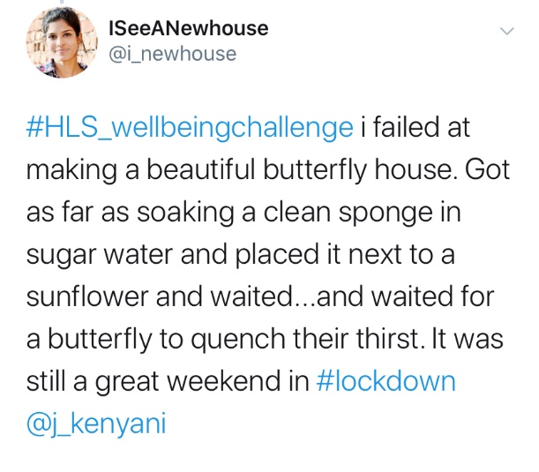

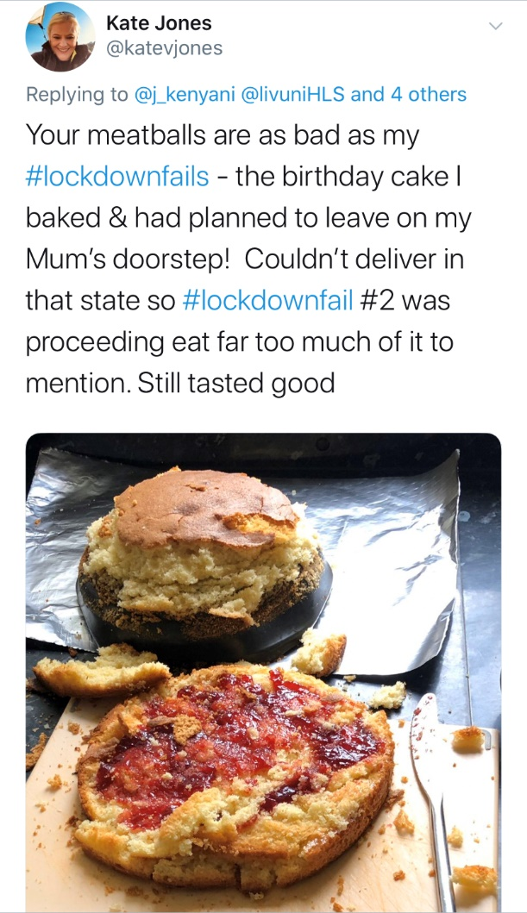

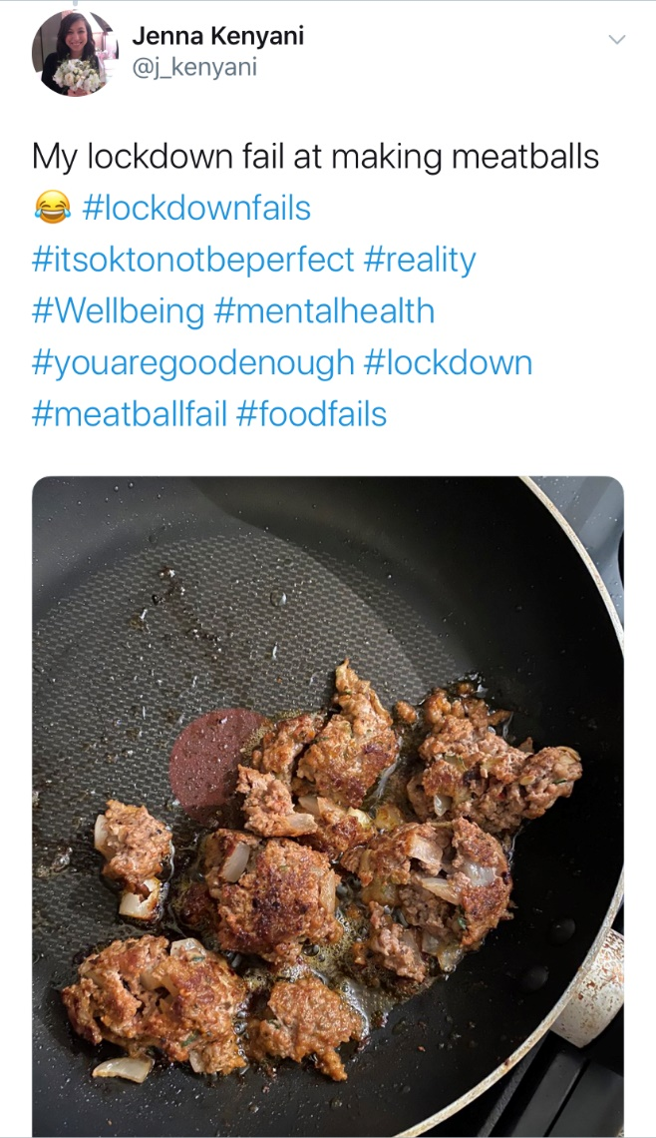

WEEKLY QUIZ

I hope you enjoyed the 3rd wellbeing quiz. This one seemed to stump a few of you but it was great to see some of your guesses.

This week’s winners are…… Drum Roll please……

**Champion of the Quiz**

Hazel Scott

Dean of the School of Medicine



Oliver Celestino

Marie Hardy

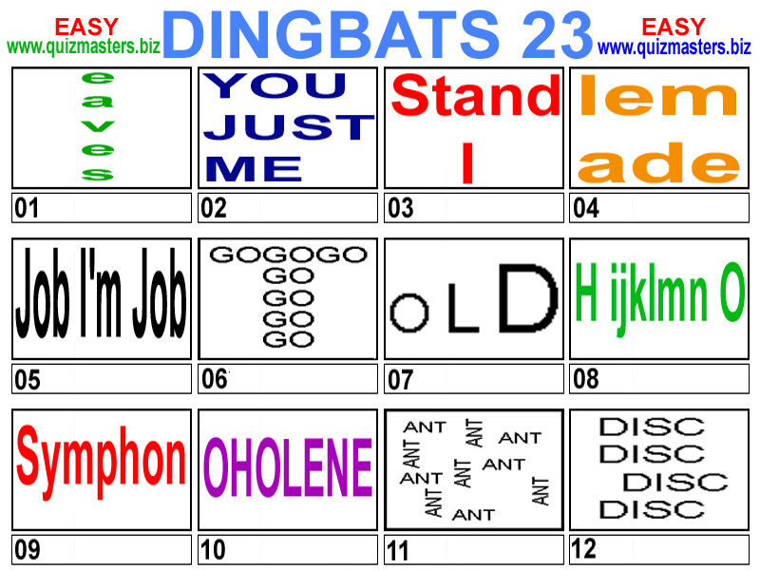Answers:

1. Eavesdrop/Eavesdropping
2. Just between you and me
3. I understand
4. Lemonade
5. I’m in the middle of two jobs
6. Goatee
7. Growing old
8. H20
9. Unfinished symphony
10. Hole in one
11. Tennant
12. Slipped Disc

I have been listening to an awful lot of music over the last week so this week’s quiz is music related. Can you recognise these classic albums from only a small square? I am looking for just the artist but there will be extra bonus points if you can name the album as well.

So that is 1 point per artist and 1 point per album name. The winner will be the person with the highest score and the fastest.

As last week email your answers to [j.kenyani@liverpool.ac.uk](mailto:j.kenyani@liverpool.ac.uk) and I will reveal the winner next week! Good Luck!

