HLS Wellbeing Newsletter

**17th April 2020**

# CONTENTS

1. *Introduction*
2. *University Support – Staff*
3. *University Support – PGR*
4. *Tips and Links*
5. *Top tip from you*
6. *Exercise options*
7. *Fun, Frivolity and forgetting Corona*

# Introduction

Hello. Do you know what day is it? What time it is? Or what month it is? If all the days are blurring into one you are not alone. With it looking like the lockdown will continue for some time we want to once again stress how important it is to look after both your physical and mental health.

# University support:

**Staff:** Check out the University [Wellbeing Hub](https://www.liverpool.ac.uk/intranet/wellbeing/) which is the home to all the University information about wellbeing including self-help wellbeing support, on-line CBT courses and resilience courses.

It also has detail on the [Employee Assistance Programme](https://staff.liverpool.ac.uk/our-workplace-and-community/support-and-development/employee-assistance-programme/)

Additional help and advice can be found on the [Researcher hub pages.](https://www.liverpool.ac.uk/researcher/work-life-balance/wellbeing-covid-19/)

**PGRs:** The University Student Services are available for support to all PGRs via telephone and email, please view their [intranet pages](https://www.liverpool.ac.uk/studentsupport/advice/) for full details. There is also a dedicated [Wellbeing Resources](https://www.liverpool.ac.uk/studentsupport/advice/resources/) page providing specific support information on how to stay safe and well during COVID-19.

The LDC have a number of online courses, workshop, webinars and writing retreats available to help during this period, find out more [here](https://www.liverpool.ac.uk/pgr-development/offering/catalogue/) for dates and times.

External support for mental health*:* [NHS webpages](https://www.nhs.uk/conditions/stress-anxiety-depression/mental-health-helplines/)provide support with many mental health and wellbeing difficulties and an extensive list of links to organisations.

## NEW RESOURCES

The academy have launch a new module “Thriving During Isolation” This self-coaching module comes with a downloadable workbook and is a programme to guide you through building your personal thriving during isolation strategy. <https://your.mindset.co.uk/thriving-during-isolation/>

# Tips and links to articles:

There are lots of really useful articles and websites to help support your wellbeing and we will highlight a number of these in this newsletter each week.

**Trouble sleeping**

If you are having weird and vivid dreams or nightmares during the lockdown you are not alone.

The guardian released [this article](https://www.theguardian.com/commentisfree/2020/apr/12/coronavirus-stress-lockdown-dreams-vivid-scientists) discussing the reasons why

If you are struggling with sleep this can have an impact on your mental health.

There are a number of apps out there that can be useful for example:

Insight Timer, Headspace, Pzizz, Sleepio, Sleepstation.

**Being sick/loved ones being sick and dealing with anxiety**

Getting sick, especially with COVID symptoms, or seeing loved ones getting unwell can bring a huge amount of anxiety.

For those who have mental health issues it can be even more difficult with anxiety or depression sky rocketing.

Jenna Kenyani talks in her video blog this week about how difficult she found it when dealing when this happened

<https://www.youtube.com/watch?v=kMiLuulRwCA>

**Living alone**

For those who live alone they are now coming up to nearly a month potentially without seeing other people. That may also be a month without any physical contact.

Living alone can be challenging. It may be easy to start to feel very lonely and isolated. To lose focus and feel overwhelmed that it may not end. [Here are some helpful points to remember about loneliness.](https://www.redcross.org.uk/stories/disasters-and-emergencies/uk/coronavirus-six-facts-about-loneliness)

If you live alone, stay connected to loved ones through phone calls and video apps and [build on those relationships remotely](https://www.bbc.co.uk/news/world-52196670). Or get involved in an [online live exercise class](https://www.sportengland.org/stayinworkout#get_active_at_home) to feel connected to others.

If you know anyone living alone please keep checking in with them, suggest meeting for a video chat where you can watch a film or have a drink so they feel like they have people to share moments with.

# Top tip from you

*Asking staff and students to share:*

We would really like to hear from the HLS community about what you are doing to help boost your wellbeing during this time. This can be useful articles you have read, activities you are involved in, practises that are working well in your research group, recommended tips to managing working from home or anything else you feel could be helpful. Please email [Maizy Jenner](mailto:m.jenner@liverpool.ac.uk) with these suggestions and we will include them in the next newsletter.

***Top tips shared from members of the HLS community:***

****Sparkle Class’ mental minute**

An honest, relevant and importantly quick tip to digest to help in the current situation. You can follow on twitter [here.](https://twitter.com/SparkleClass)

**Get Colouring!**

## Dr Sarah Barnett, ITM

There are some studies which have started to show the benefit of colouring for mental health.

It is thought there are a number of benefits to taking some time to do some colouring including:

1. Focussing on the present helps you achieve mindfulness
2. Stress and anxiety levels have the potential to be lowered.
3. Unplugging from technology has benefits in bringing calm
4. Colouring can be done by anyone, not just artists and allows your creative side to flourish.

If you fancy some science related colouring then abcam have created [a colouring book](https://go.myabcam.com/abcam-colouring-book?utm_content=6%7cNewsletter%7cText%7cNone%7c&utm_source=Eloqua&utm_medium=Email&utm_campaign=Newsletter%7CAwareness%7C2020-04-05%2019%3A00%3A00.000%7CN%2FA%7CGLOBAL%7CEN%7CNewsletter%20-%20Global&mi_u=1006914)

If you don’t have a printer then there are also a number of colouring apps which can be used on phones or tablets/ipads for example colorfy.

# Exercise options

[Mark Pountney](https://www.youtube.com/channel/UCQe8mPvR6sVvh5tAec8OoWQ) has recorded another Tai Chi video:

This week’s video is the [*Chen style 8 form*](https://www.youtube.com/watch?v=JTjSv-DerAs&feature=youtu.be)

Other Videos include:

[Warm up](https://www.youtube.com/watch?v=i8erSms2ezE&feature=youtu.be): This is the normal warm up Mark does in his class

[*Shibashi*:](https://www.youtube.com/watch?v=8jnxF3cWeB0&feature=youtu.be)This is a video just running through the 18 form Shibashi which some of you will find familiar, it is quite easy to follow, each move repeats three times (although you can always choose a move and do this more, usually in multiples of three).

*Shibashi* Moves broken down with a bit more detail:

Move 1: [Heaven and Earth](https://www.youtube.com/watch?v=SVDf18tP1Uc&feature=youtu.be) this is just the one move with a little bit more detail in case you’re interested ☺

[Foundation Qi Gong](https://www.youtube.com/watch?v=ahmD2iY0uyc&feature=youtu.be): Sometimes we alternate in class between the Shibashi and this one.

Some of the benefits claimed for Tai Chi & Qi Gong include:

* Better mood, with lower levels of depression, stress, and anxiety.
* Greater aerobic capacity and muscle strength.
* More energy and stamina.
* Enhanced flexibility, balance, and agility.
* Lower blood pressure and improved heart health.
* Reduced Inflammation.
* Improved sleep quality and much more...

# Lockdown tips and tricks

Missing going to your favourite restaurants? Looking for new recipes to try? Check out this [article](https://theguideliverpool.com/5-popular-liverpool-restaurant-dishes-you-can-now-make-at-home/) showing you how to make some of the signature dishes from local restaurants

# Fun, Frivolity and forgetting corona

PHOTO COMPETITION

Thank you to all who took part in our Easter Lockdown wellbeing challenge. It was great to see how you were spending this unusual Easter. I know for a lot of people it was not easy being apart from friends and family. However, it was lovely to see people unwind and relax over the weekend and make the best of the situation. The photo competition was hopefully a way to get us all more connected and share in our fun moments. Below are some of the pictures sent in or tweeted, I hope you enjoy seeing what your colleagues have been up to.

For this week we are putting a twist on how social media usually works. One thing I have been really struggling with is feeling productive or feeling like I am doing lockdown “as well as other people”. I have compared myself to all the pictures and posts on social media of people having fun or doing amazing things with their time. I have spoken about this before in [my video](https://www.youtube.com/watch?v=xAI9wSBGwQc).

The most important thing is however you are getting through this, whatever you manage to do each day, it is enough, it is good enough! So for this week’s challenge instead of showing the world something great I want to see your lockdown fails. Whether that is, like me, baking a completely flat banana loaf or finding your kids drawing on the walls or a DIY disaster, I want to see how things are not perfect in lockdown life. Life doesn’t have to be perfect to be good!

Email in to [j.kenyani@liverpool.ac.uk](mailto:j.kenyani@liverpool.ac.uk) or if you are on twitter use the hashtag #HLS_wellbeingchallenge

HLS tag: @livuniHLS

Jenna Kenyani tag: @j_kenyani

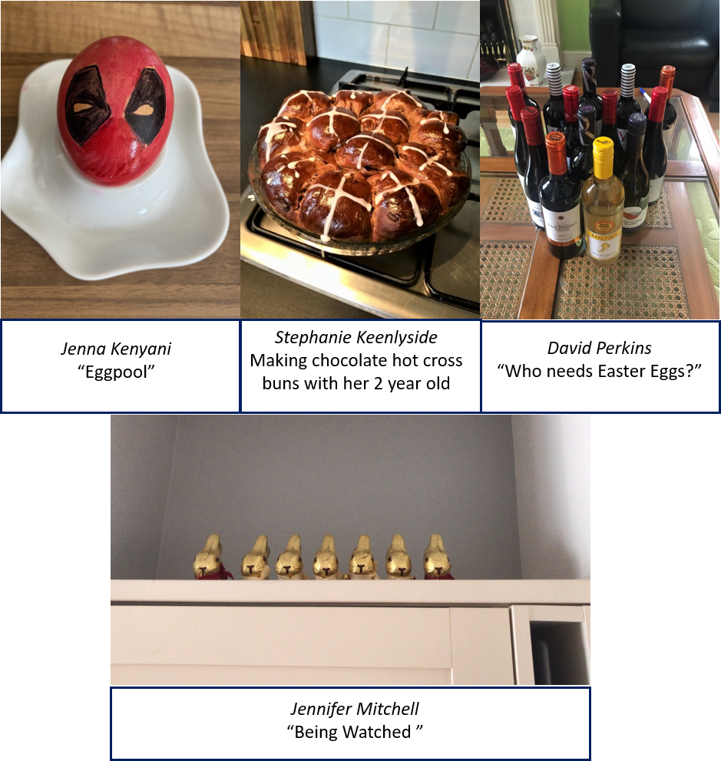

WEEKLY QUIZ

I hope you enjoyed the 2nd wellbeing quiz. I must apologise that it ended up being harder than it was supposed to as unfortunately the clue to start you off was missed off.

If you would still like to have a go at this quiz I have left the quiz in below with the answers on the next page so you can guess away then check.

The clue should have been….On the basis that number 1 is the Simpson’s, can you work out the others?

However, we do have our next winners who took part…… Drum Roll please……

**Champion of the Quiz**

Karen Wilding

Women’s and Children’s health, ITM

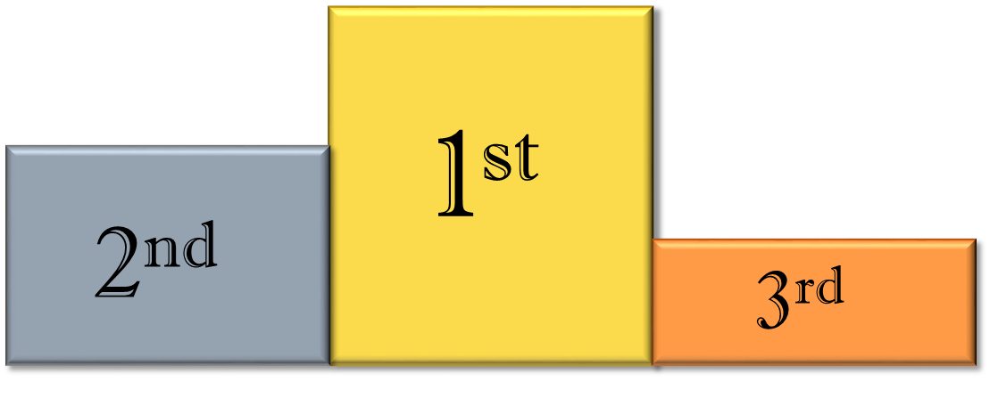

James Birchall

Ana Alfirevic

(and family)

This week’s quiz is a bit different. Below are some dingbats. Here you need to say what you see!

As last week email your answers to [j.kenyani@liverpool.ac.uk](mailto:j.kenyani@liverpool.ac.uk) and I will reveal the winner next week! Good Luck

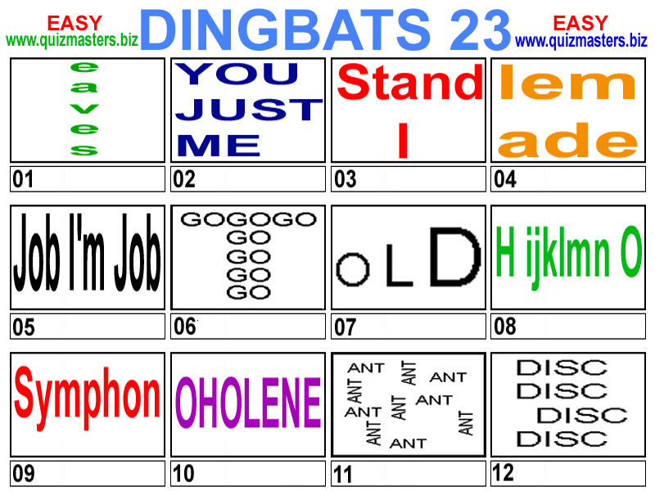

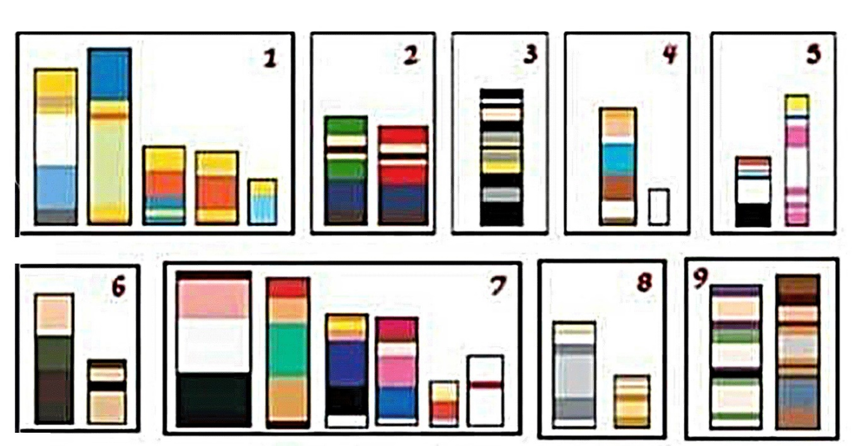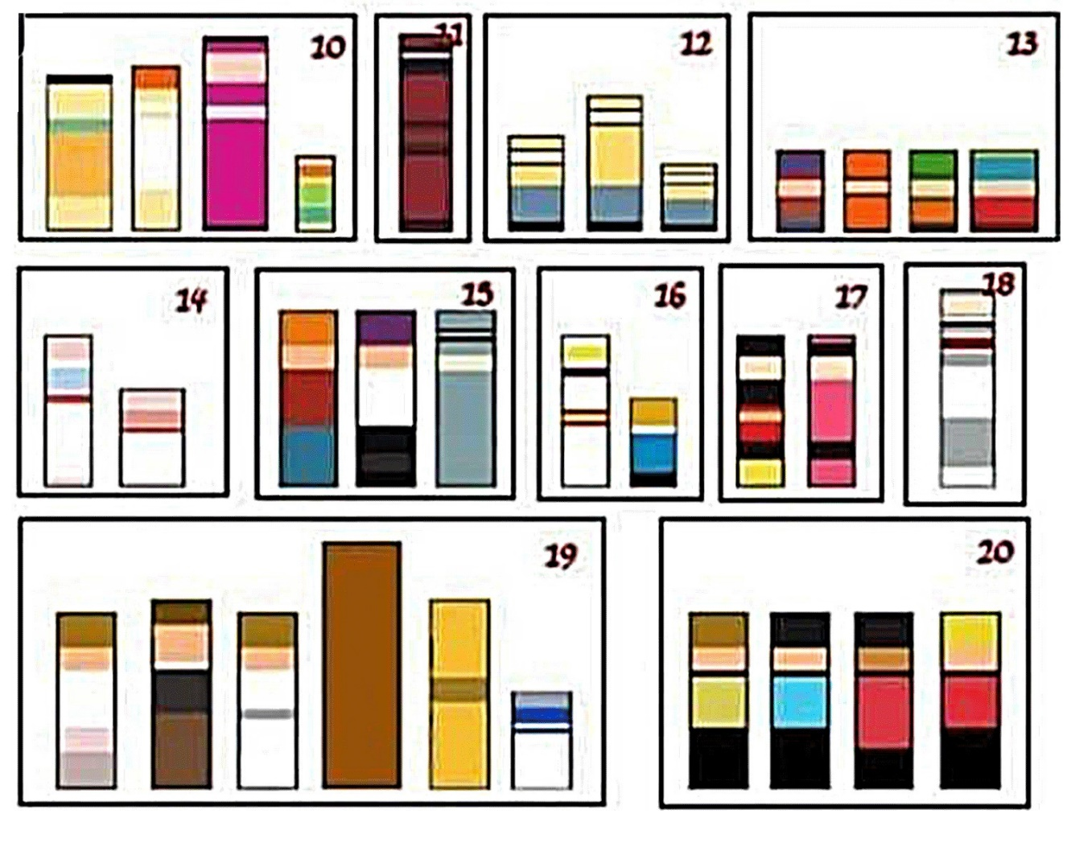

|  |  |
| --- | --- |
| 1. Simpsons | 11. Deadpool |
| 1. Mario and Luigi | 12. Minions from Despicable me |
| 1. Batman | 13. South park |
| 1. Tin Tin and Snowy | 14. Pinky and the Brain |
| 1. Dexter’s Laboratory | 15. Futurama |
| 1. Griffin’s, Family Guy | 16. Danger Mouse |
| 1. Wallace and Gromit | 17. Micky and Minnie Mouse |
| 1. Tom and Jerry | 18. Bugs Bunny |
| 1. Buzz and Woody (Toystory) | 19. Star Wars |
| 1. The Flinstones | 20. Star Trek |