HLS Wellbeing Newsletter
9th April 2020

CONTENTS

- Introduction
- University Support – Staff
- University Support – PGR
- Tips and Links
- Top tip from you
- Exercise options
- Fun, Frivolity and forgetting Corona

Introduction

As we have now nearly completed our third week in lockdown we hope you are all managing these unusual times. It was nice to hear from so many of you over the past week on how you enjoyed this newsletter.
Please do not forget that COVID-19 has changed the world and by doing so this can put a strain on your wellbeing. It is really important to keep looking after both your physical and mental health.
This newsletter is to help all staff and students within HLS during these unusual times. We hope to bring you advice and guidance as well as tips and tricks to help look after yourselves. But we also want to put a smile on your face so there will be some light hearted segments as well.

University support:
Staff: Check out the University Wellbeing Hub which is the home to all the University information about wellbeing including self-help wellbeing support, on-line CBT courses and resilience courses.
It also has detail on the Employee Assistance Programme
Additional help and advice can be found on the Researcher hub pages.

PGRs: The University Student Services are available for support to all PGRs via telephone and email, please view their intranet pages for full details. There is also a dedicated Wellbeing Resources page providing specific support information on how to stay safe and well during COVID-19.
The LDC have a number of online courses, workshops and webinars available to help during this period, find out more here for dates and times.

External support for mental health:
https://www.nhs.uk/conditions/stress-anxiety-depression/mental-health-helplines/

Tips and links to articles:

There are lots of really useful helpful articles and websites to help support your wellbeing and we will highlight a number of these in this newsletter each week.
Working from home
Gretchen Rubin is one of today’s most influential and thought-provoking observers of happiness and human nature. Gretchen is known for her ability to distil and convey complex ideas with humour and clarity. Here she talks about tips on coping with working from home:
https://gretchenrubin.com/2020/03/coping-with-covid-19-work-from-home

Productivity
It is so easy to beat yourself up about how you use your time. From not doing enough, not working hard enough, not home schooling well enough.
This is a difficult time. Be kind to yourself.
Jenna again gives an honest talk about dealing with these thoughts https://www.youtube.com/watch?v=xAI9wSBGwQc

Take a break this weekend
It is Easter bank holiday this weekend and we really encourage you to take this time to take a break. There are lots of activities that you can do whilst staying safe at home:
For the kids:
Edinburgh Science festival have moved their annual festival online with lots of different sessions to view. Listen to Audio Stories with David Walliams. Take a virtual museum tour at The Natural History Museum or The British Museum. Find lots to do with the Scouts ‘Great indoors’ with over 100 of the best activities for staying at home.
Something for the adults:
Watch a West End show with the National Theatre or stream an Andrew Lloyd Webber musical with The Shows Must Go On. Listen to performances from The Royal Opera House or Take a tour of The National Gallery.

Taking some time out to focus on you
It can be difficult to find a calm headspace during this stressful time, you might be finding it hard to switch off, relax or have trouble falling asleep. Taking some time out each day to reset the mind is really important, you can try the 31 day meditation challenge, Relaxation techniques or listen to mindfulness or sleep relaxation podcasts to help you have some downtime.

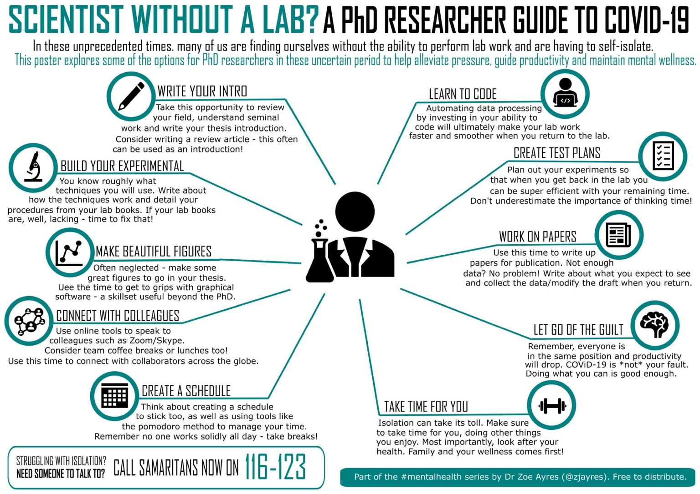

Top tip from you

Asking staff and students to share:
We would really like to hear from the HLS community about what you are doing to help boost your wellbeing during this time. This can be useful articles you have read, activities you are involved in, practises that are working well in your research group, recommended tips to managing working from home or anything else you feel could be helpful. Please email Maizy Jenner with these suggestions and we will include them in the next newsletter.

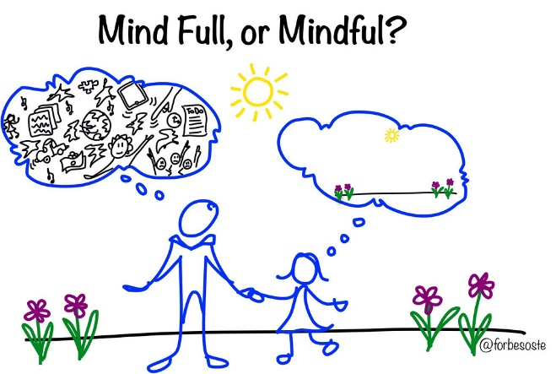
WELLBEING TOP TIP: Get mindful!

Jennifer Mitchell, ITM PGR wellbeing advocate
Have you heard of mindfulness, meditation or breath awareness? Have you given any of it a go? You might be surprised that taking some time out could make you more productive at work!
Mindfulness meditation is associated with increased performance on a range of cognitive tasks. There are many ways to get started including meditation apps and groups.
Find out more in this Nature review article: https://www.nature.com/articles/s41598-018-32046-5

Exercise options

Some of you may have already attended the Tai Chi classes that the LBIH have organised and taught by Mark Pountney over the last year.
Mark has recorded a second video on the youtube channel civic duty - https://www.youtube.com/channel/UCQe8mPvR6sVvh5tAec8OoWQ
This is a video just running through the 18 form Shibashi which some of you will find familiar, it is quite easy to follow, each move repeats three times (although you can always choose a move and do this more, usually in multiples of three).
Warm up: https://youtu.be/i8erSms2ezE
Shibashi: https://youtu.be/8jnxF3cWeB0
Foundation Qi Gong: https://youtu.be/ahmD2iY0uyc
Some of the benefits claimed for Tai Chi & Qi Gong include:
- Better mood, with lower levels of depression, stress, and anxiety.
- Greater aerobic capacity and muscle strength.
- More energy and stamina.
- Enhanced flexibility, balance, and agility.
- Lower blood pressure and improved heart health.
- Reduced Inflammation.
- Improved sleep quality and much more...

Lockdown tips and tricks

If you are missing going to your favourite restaurant like me or fed up of cooking then there are still plenty of restaurants who are still delivering food across the city. If you are on Instagram check out @deliver_pool as they are listing places that are not always on deliveroo.

Fun, Frivolity and forgetting corona

Last week’s Quiz went down a storm and it was nice to get so many of you giving it a go! However, I need to apologise, as I stole the quiz off social media I hadn’t noticed that not all the answers were viruses! The scientist in me is deeply horrified haha!
However, we have our first quiz winner…… Drum Roll please……
Champion of the Quiz
Danielle Johnson
Biostatistics, ITM

Zohra Butt

Roy Goodacre

Also congratulations to: Nikki Farrington, Gemma Marshall, Cath McNamara, Paul Atkinson.
The answers where:
- Black Death
- Foot and Mouth
- TB
- Swine Flu
- Yellow Fever
- Ebola
- Chicken Poz
- Corona virus
- Typhoid
- Rubella
Bonus: SARS

This week’s quiz is less topical but I hope you find it just as fun! As last week email your answers to j.kenyani@liverpool.ac.uk and I will reveal the winner next week! Good Luck

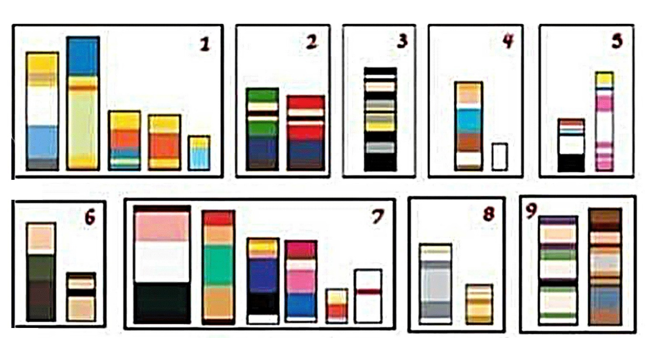

PHOTO COMPETITION

This week will be also be starting our weekly photo competition. If you are on twitter you have seen IACD challenging ITM in their last competition. So we thought we would bring the challenge to the whole faculty.

As it is Easter weekend we are asking to see how you are doing Easter lockdown style. Show us one pic which sums up your Easter weekend whether it is funny, cute or down right weird we want to see. The best ones will be showcased in the next newsletter.

Email in to j.kenyani@liverpool.ac.uk or if you are on twitter use the hashtag #HLS_wellbeingchallenge

HLS tag: @livuniHLS
Jenna Kenyani tag: @j_kenyani

