 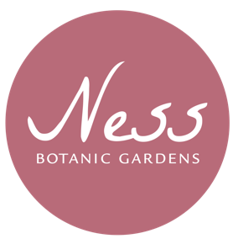

**Job Opportunity at Ness!**

***Visitor Services Assistant: Casual Contract***

The Visitor Service Assistant is a front facing role, ensuring that all visitors receive the highest standard of welcome and customer care.

The post-holder will enrol paying visitors as Members of Ness Botanic Gardens, effectively promote the Gift Aid on entry admission scheme, process general admissions and event payments and encourage shop sales too. Under the direction of the Operations Manager, the post-holder will handle stock purchases for the Gift Shop area, whilst ensuring high quality visual merchandising ensuring product pricing, ordering and replenishing of stock is kept up to date.

17.5 hours per week

Regular weekend work

Maximum of 12 weeks-Casual Contract

£16,341 (pro rata) or

£8.95 (p/h)

Application Deadline: 26/8/19

Interview Date: 28/8/19

Informal enquiries to Kate Hotson on 0151 795 6310.

Email: khotson@liverpool.ac.uk