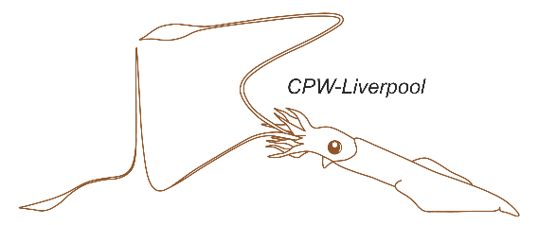
41st Cell Physiology Workshop in Liverpool
Application deadline: 19th April 2026 (outcomes announced by 15th May)
Held at the University of Liverpool, UK.

17th – 28th August 2026 Supported by:
Title: |  | Surname: |  | First Name(s):
Preferred pronouns: |  | Nationality: |  | Date of Birth:

Career stage: | PhD / MD: ☐ | Post-doctoral: ☐ | Other:
I am happy to be included with email contact details on the participant list provided to all workshop students, Speakers, teachers and invited companies: |  |  | Yes: ☐ No: ☐
Require visa supporting letter for entry to UK? |  | Place of birth:

Company / Organisation / Educational Establishment you belong to:
Preferred correspondence address for postal mail:
Email Address:
Contact phone number (including country prefix):
Supervisors / sponsors name:
Supervisors / sponsors email:
Current funding body:
Special dietary requirements:

In no more than 500 words, outline your current research project:

In no more than 300 words, outline your reasons for wanting to attend CPW-Liverpool and your previous experience with electrophysiological techniques:
Please submit this application form, and:
- CV (no more than 2 pages)
- A letter of recommendation from you supervisor or sponsor that indicates how your research, the laboratory and the area of research will benefit from your participation on the course.
To cpw@liverpool.ac.uk by 19th April 2026.
Fees for this workshop will be £1,800 payable by 14th August 2026

