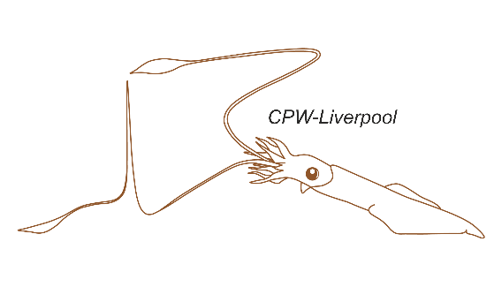40th Cell Physiology Workshop

Application deadline: 28th April 2025 (outcomes announced by 16th May)

Held at the University of Liverpool, UK.

11th – 22rd August 2025 Supported by:

|  |  |  |  |  |  |
| --- | --- | --- | --- | --- | --- |
| Title: |  | Surname: |  | First Name(s): |  |
| Preferred pronouns: |  | Nationality: |  | Date of Birth: |  |

|  |  |  |  |
| --- | --- | --- | --- |
| Career stage: | PhD / MD: | Post-doctoral: | Other: |
| I am happy to be included with email contact details on the participant list provided to all workshop students, Speakers, teachers and invited companies: | | | Yes:  No: |
| Require visa supporting letter for entry to UK? |  | Place of birth: |  |

|  |  |
| --- | --- |
| Company / Organisation / Educational Establishment you belong to: |  |
| Preferred correspondence address for postal mail: |  |
| Email Address: |  |
| Contact phone number (including country prefix): |  |
| Supervisors / sponsors name: |  |
| Supervisors / sponsors email: |  |
| Current funding body: |  |
| Special dietary requirements: |  |

|  |
| --- |
| In no more than 500 words, outline your current research project: |
|  |

|  |
| --- |
| In no more than 300 words, outline your reasons for wanting to attend CPW-Liverpool and your previous experience with electrophysiological techniques: |
|  |

Please submit this application form, and:

1. CV (no more than 2 pages)
2. A letter of recommendation from you supervisor or sponsor that indicates how your research, the laboratory and the area of research will benefit from your participation on the course.

To [cpw@liverpool.ac.uk](mailto:cpw@liverpool.ac.uk) by 28th April 2025.

Fees for this workshop will be £1,800 payable by 8th August 2025