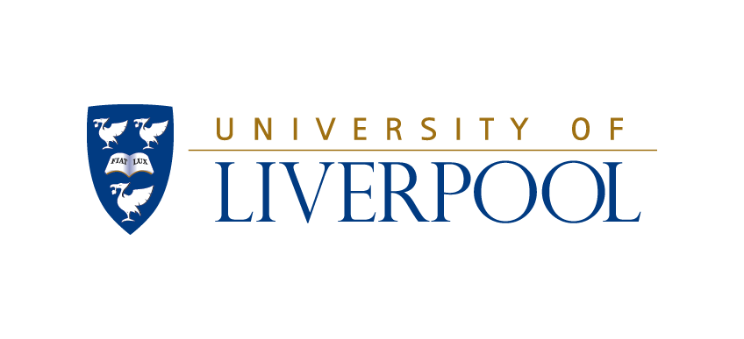

Guild Gazette, 6th December 1991, p3

Protest over ‘no gay’ Navy

The AIESEC, (Association of International of Students in Economics and Commerce), careers fair attracted companies and organisations, of which the Royal Navy were only one. However, the presence of the Royal Navy at the fair did create hostility from some quarters concerning its recruitment policy. An emergency executive committee was called on to debate the issues of whether the organisation should be allowed to be retained at the fair.
A Royal Navy recruitment spokesman did confirm that their policy of employment does not allow for the gay population. They make it specially clear before employment that homosexuality is forbidden from the services and if a members of the services is discovered to be gay he will be immediately discharged or possible court martial.
This view by the Royal Navy is in breach of the University Guild’s anti-discrimination policy. However, the emergency meeting found in favour of retaining the organisation at the careers fair. This decision being due to the fact that other companies who were present at the fair were also in breach of other Guild guidelines – such as the Green Charter.
Consequently, if the Royal Navy was to be banned, this should have been imposed before the AIESEC fair – and not discussed afterwards.
During the debate the sabbaticals expressed shock about the contravention of our anti-discrimination policy and apologised for not being aware of this. They guaranteed to ensure a tightening up of practice to ensure enforcement of policy where possible and to encourage the University and AIESEC, when they organise such events, to acknowledge Guild policy as well.

