GUIDANCE FOR USING EASY CHAIR

1. Submission Guidance for BILETA 2013
Submission of an abstract for Presentation, Works in Progress or Concept Paper (not exceeding 700 words), which includes Title, Theoretical/Empirical Framework and Argument via EasyChair Conference Management System by 18 January 2013 at the following address: https://www.easychair.org/account/signin.cgi?conf=bileta2013

2. Signing up for EasyChair: Step 1. Click on the Link above (or paste it on your browser) and you will see the following information:
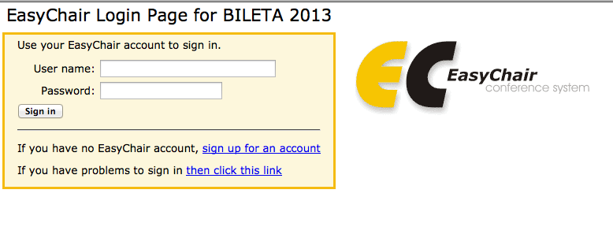

**********************

To use EasyChair, one should first create an account. This is done to prevent misuse of the system. The procedure for obtaining an account is the following.

You should type the two words that you see in the image below and click on "Continue".
If you type the words correctly, you will be asked to fill out a simple form with your personal information.
After you filled out the form, EasyChair will send you an email with a link that you can use to create an account.

3. Signing up for EasyChair: Step 2. Fill out the Details accordingly

**********************

Please fill out the following form. The required fields are marked by (*)

Note that the most common reason for failing to sign up is an incorrect email address so please type your email address correctly.

4. Account Application Received. Step 3. You will be sent a link to activate your account:

We received your application. A mail with further instructions has been sent to the email address joeblogs@gmail.com

5. Email with link. Step 4.

Dear XXXX,

We received a request to create an EasyChair accountfor you. To create an EasyChair account, please clickthis link:

https://www.easychair.org/account/create.cgi

Best regards,
EasyChair.

6. Signing Up for EasyChair: Last Step 5.

Hello JoeBlogs! To complete the creation of your account please fill out the following form. You should create the account within 20 minutes, otherwise you will have to fill out this form from scratch.

Account Created

Your EasyChair account has been created.

To log in for BILETA 2013 click this link.

BILETA 2013 (author)
Overview New Submission BILETA 2013 EasyChair
BILETA 2013 Login for JoeBlogs

JoeBlogs, welcome to EasyChair! You are logged in as author.

This session will expire after two hours of inaction.

If you log in and cannot find information you are looking for, for example, you are a PC member but EasyChair only recognizes you as an author, please read the Help page on frequently asked questions..

New Submission for BILETA 2013

**********************

Follow the instructions, step by step, and then use the "Submit" button at the bottom of the form. The required fields are marked by (*).

More information about submission to BILETA 2013 can be found on BILETA 2013 Web site.

**********************
Authors

For each of the authors please fill out the form below. Some items on the form are explained below.

Email address will only be used for communication with the authors. It will not appear in public Web pages of this conference. The email address can be omitted for authors who are not corresponding. These authors will also have no access to the submission page.
Web site can be used on the conference Web pages, for example, for making the program. It should be a Web site of the author, not the Web site of her or his organization.
Each author marked as a corresponding author will receive email messages from the system about this submission. There should be at least one corresponding author.

