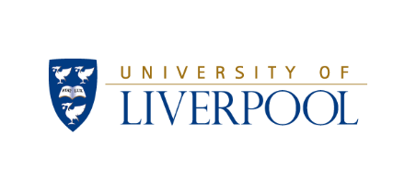

Statutory Pay Gap Report 2022

Gender, Ethnicity, Disability, and Sexuality Pay Gaps

Contents
1. Introduction 4
2. Executive Summary 5
2.1 In Summary……………………………………………………………………………………………………………5
2.2 A Summary of the Main Causes of the Pay Gaps are…………………………………………….6
3. Statutory Gender Pay Gap 8
4. Ethnicity Pay Gap 10
4.1. BAME+ Pay Gap 10
4.2. People of Colour Pay Gap 11
5. Disability Pay Gap 13
6. Sexual Orientation Pay Gap 14
7. Sector Comparison 15
7.1 Gender Comparison 15
7.2 Ethnicity Comparison 16
7.3 Disability & Sexual Orientation Comparison 16
8. Actions Taken to Address Pay Gaps…………………………………………………………………………….17 9. Recommendations…………………………………………………………………………………………..………….18
10. Glossary of Terms……………………………………………………………………………………………………….19

Introduction
This report sets out the Statutory Gender Pay Gap Report for 2022 as per the requirements in the Equality Act 2010 (Specific Duties and Public Authorities) Regulations 2017. In addition, the report includes the BAME+ Pay Gap, People of Colour Pay Gap, Disability Pay Gap, and Sexual Orientation Pay Gap using the same calculation methodology and data sample.
The Statutory Pay Gap calculation includes all Full Pay Relevant Employees (FPRE) in March 2022, after Salary Sacrifice deductions (pensions, travel loans, etc.) have been made.
Ordinary Pay, which the mean and median is calculated from, is a calculation of the hourly income of an employee composed of their basic pay, allowances, shift premium pay, and any pay for piecework. Ordinary Pay is calculated from monies received in March 2022.

Bonus Pay is any form of money, vouchers, securities, securities options, or interests received by an employee which is awarded as a result of profit-sharing arrangements, productivity, performance, incentives, or commission. Bonus Pay is calculated from monies received in the 12 months leading up to March 2022.

Where a pay gap number is a positive figure and black, this means that there is a pay gap in favour of baseline group e.g. men, where a number is a negative figure and red, this means that there is a pay gap in favour of the comparison group e.g. women. A green arrow indicates a positive change to reduce the pay gap, a red arrow indicates a negative change, and a black arrow indicates a change that is not deemed to be positive or negative. - Please see Glossary of Terms for a full list of all baseline groups.
Clinical Pay Scales:
Employees with a Clinical Contract are paid in accordance with the NHS Agenda for Change Pay Scale and not that of the University. Some clinical staff will be eligible for additional payments based on their length of service, role/expertise, and whether they deliver clinics. Clinical Staff may also be eligible for Clinical Excellence Awards, a NHS bonus scheme. The process for awarding CEA is determined by the NHS and not the University, but the payment of these awards is processed by the University and therefore is included within Clinical staff pay.
Legislative Background:
The Equality Act 2010 defines the protected characteristic of “sex” to mean being male or female. Gender Pay Gap Reporting of The Equality Act 2010 (Specific Duties and Public Authorities) Regulations 2017, is a reference to a comparison between the male and female sex groups only. The Gender Pay Gap calculations within this report therefore are in accordance with the statutory requirements and do not include other genders.
There is no legal duty or prescribed methodology for the calculation and reporting of a pay gap between other equality characteristics, and therefore the methodologies adopted within this report e.g. Disabled v No Known Disability has been formulated by the University of Liverpool.

Executive Summary

2.1 - IN SUMMARY:
- Gender Pay Gap: The pay gap continued to favour the male population, the Mean, Median, Mean Bonus, and Median Bonus Pay Gaps all increased on 2021 figures as the University returned to work following COVID-19. The Mean is now 21.01%, the Median is 16.09%, the Mean Bonus is 45.11% and the Median Bonus is 75% in favour of the male population.

- BAME+ Pay Gap: The Mean and Median pay gaps continued to be in favour of the BAME+ population, with both pay gaps decreasing to their lowest levels; the Mean is now -7.95%, the Median is -11.60%. The Mean and Median Bonus Pay Gap significantly changed to being in favour of White British population; the Mean Bonus is 10.98% in favour of the White British population, and the Median Bonus is 58.33% also in favour of White British population.

- People of Colour Pay Gap: The Mean pay gap is in favour of the White population and increased to 6.49%. The Median pay gap is in favour of the People of Colour population and decreased to -0.09%. The Mean Bonus pay gap is in favour of the White population with a significant change to 19.14%. The Median Bonus Pay Gap further increased in favour of the White population to 75%.

- Disability Pay Gap: The Mean and Median pay gaps continued to be in favour of the No Known Disability population with the Mean decreasing to 14.47% and the Median increasing to 7.62%. No disabled FPRE received a bonus payment.

- Sexuality Pay Gap: The Mean and Median pay gaps continued to be in favour of the Heterosexual population. The Mean Pay Gap decreased to 5.88% and the Median Pay Gap decreased to 1.21%. No LGBO FPRE received a bonus payment.
Tables 2-5 (below) outline the mean, median, mean bonus and median bonus pay gaps from March 2019 to March 2022.
Table 1: Mean Pay Gap Trend
 | 2019 | 2020 | 2021 | 2022
Female v Male | 22.01 | 21.17 | 20.50 | 21.01 | ↑
BAME+ v White British | -12.40 | -13.23 | -10.86 | -7.95 | ↓
POC v White | 4.20 | 1.26 | 2.21 | 6.49 | ↑
Disabled v No Disability | 11.28 | 15.04 | 14.77 | 14.47 | ↓
LGBO v Heterosexual | 2.11 | 5.90 | 6.78 | 5.88 | ↓
Table 2: Median Pay Gaps Trend
 | 2019 | 2020 | 2021 | 2022
Female v Male | 15.49 | 16.18 | 14.12 | 16.09 | ↑
BAME+ v White British | -12.34 | -14.57 | -12.49 | -11.60 | ↓
POC v White | -0.53 | -0.83 | -1.12 | -0.09 | ↓
Disabled v No Disability | 9.59 | 9.73 | 7.02 | 7.62 | ↑
LGBO v Heterosexual | 2.89 | 3.23 | 4.15 | 1.21 | ↓
Table 3: Mean Bonus Pay Gap Trend
 | 2019 | 2020 | 2021 | 2022
Female v Male | 79.10 | 68.35 | 39.74 | 45.11 | ↑
BAME+ v White British | -121.15 | -118.81 | -4.06 | 10.98 | ↑
POC v White | -123.60 | -84.40 | -11.38 | 19.14 | ↑
Disabled v No Disability | 84.89 | 89.76 | 0.00 | 0.00 | ↔
LGBO v Heterosexual | 80.33 | 38.79 | 0.00 | 0.00 | ↔
Table 4: Median Bonus Pay Gaps Trend
 | 2019 | 2020 | 2021 | 2022
Female v Male | 82.92 | 82.87 | 66.67 | 75.00 | ↑
BAME+ v White British | -382.56 | -704.27 | 45.70 | 58.33 | ↑
POC v White | -503.20 | -503.21 | 58.33 | 75.00 | ↑
Disabled v No Disability | 0.00 | 0.00 | 0.00 | 0.00 | ↔
LGBO v Heterosexual | 0.00 | -354.63 | 0.00 | 0.00 | ↔

2.2 - A SUMMARY OF THE MAIN CAUSES OF THE PAY GAPS ARE:
In March 2022 there were 7811 employees within the sample population compared to 7737 in 2021 (a 1% increase). Of these 7811, 809 (10.4%) were excluded from the population for the mean and median pay gap calculations for not meeting the definition of full pay relevant employee (FPRE).
- Gender Pay Gap: The main causes of the gender pay gap is the higher proportion of women compared to men who occupy lower pay grades, and the higher proportion of women who occupy manual and clerical roles. The main cause of the bonus pay gap is the larger proportion of men who receive the Clinical Excellence Award (CEA) and that a larger proportion of male CEA recipients received a higher value award than women.

- BAME+ Pay Gap: The main cause of the BAME+ pay gap is the higher proportion of the BAME+ population which occupy research and academic roles compared to the White British population. Research and academic roles are on the higher pay bands meaning that the average income of BAME+ population is higher. The Bonus Pay Gap is in favour of White British because of the relatively small population size of Clinical Excellence Awards being significantly affected by small changes in the BAME+/White British cohort size (55 in 2021 to 49 in 2022) and individual bonus values.

- People of Colour Pay Gap: There is an effective Median pay gap of 0%. The cause of the Mean pay gap is the lower number of POC on higher pay grades and the relatively high proportion of POC cohort who are student staff occupying casual and zero hour roles which has the effect of lowering the average and median income points relevant to White. The Bonus Pay Gap is in favour of White because of the relatively small population size of Clinical Excellence Awards being significantly affected by small changes in the POC/White cohort size (55 in 2021 to 49 in 2022) and individuals’ bonus values.

- Disability Pay Gap: The disability pay gap is mainly caused by the higher proportion of known disabled FPRE in lower pay grade compared to the no known disability FPRE cohort. This is further affected by the relatively small number of disabled FPRE (406 v 6566) where the population size, and changes in the number and location of disabled FPRE has a greater effect on the mean/median hourly pay rate compared to No Known Disability FPRE. No disabled employees received a bonus.

- Sexuality Pay Gaps: 32% of the Full Pay Relevant Population have not disclosed their sexual orientation to the University, therefore the data should be interpreted with caution. However, of those that have disclosed, the causes of the sexuality pay gap in favour of Heterosexual employees is that a slightly higher proportion of LGBO staff occupy lower pay grades. This is further affected by the relatively small number of LGBO FPRE (338 v 4448) where the population size, and changes in the number and location of LGBO FPRE has a greater effect on the mean/median hourly pay rate compared to Heterosexual FPRE. No LGBO employees received a bonus.

Ongoing Impact of the Pandemic:
It should be noted that COVID-19 has continued to impact on the way in which the University operated up to March 2022, for example through the government guidance in late 2021/early 2022 that staff who were able to should continue to work from home. In particular, the interplay of various activities may have impacted on the Statutory Pay Gap calculations when reviewing and comparing the 2022 statutory pay gap. Specifically:
- A significant proportion of teaching remained online/hybrid resulting in a reduction in casual/zero-hour student demonstrators.
- Key events and onsite activities which may have previously required additional casual / zero-hour workers, or overtime, remained relatively low compared to pre-pandemic levels as these activities either did not take place or remained online.
- Annual Review (Academic Promotion) and the Exceptional Performance Award (EPA) system was reintroduced for the 2021-2022 academic year, however the outcome of this process took place later than in previous years meaning that the promotions are not reflected in the population data, and the Exceptional Performance Awards (EPA) had not been paid by March 2022.
Overall there was a 1% increase of the eligible Staff Post population size between 2021 and 2022 with the population level being 2.6% lower than March 2020 at the onset of the pandemic. There was 0.8% reduction of the Full Pay Relevant Employee population (FPRE), and a 13.6% increase in the size of the omitted staff for not being full pay relevant in March 2022.

Table 5: Pay Gap Population Trend
 | 2018 | 2019 | 2020 | 2021 | 2022 | Change  20 to 21
Total # Job Posts | 7359 | 8173 | 8020 | 7737 | 7811 | +1%
Full Pay Relevant | 7197 | 7509 | 7318 | 7025 | 6972 | -0.8%
Not Full Pay Relevant | 162 | 664 | 702 | 712 | 809 | +13.6%
% Not Full Pay Relevant | 2.2% | 8.1% | 8.8% | 9.2% | 10.4%

Statutory Gender Pay Gap
In this section we report the Statutory Gender Pay Gap. A positive black number means that there is a pay gap in favour of men, whereas a negative red number means that there is a pay gap in favour of women. As mentioned previously, a green arrow indicates a positive change to reduce the pay gap, a red arrow indicates a negative change, and a black arrow indicates a change that is not deemed to be positive or negative.
6972 (down from 7025) Full Pay Relevant Employees are included in the Statutory Gender Pay Gap calculation, of which 3913 (56.1%) are female, and 3059 (43.9%) are male.
Table 6: Statutory Gender Pay Gap Data
 | 2020 | 2021 | 2022
# Women | 4040 | 3904 | 3913 | ↑
# Men | 3278 | 3121 | 3059 | ↓
% Women | 55.2 | 55.6 | 56.1 | ↑
- Mean | 21.17 | 20.50 | 21.01 | ↑
- Median | 16.18 | 14.23 | 16.09 | ↑
- Mean Bonus | 68.35 | 39.74 | 45.11 | ↑
- Median Bonus | 82.87 | 66.67 | 75.00 | ↑
% Female Staff in Receipt of Bonus Pay | 1.27 | 0.19 | 0.21 | ↑
% of Male Staff in Receipt of Bonus Pay | 2.10 | 1.35 | 1.16 | ↓
% Bonus Pay Recipients Who Are Female | 42.42 | 14.55 | 18.37 | ↑
% Bonus Pay Recipients Who Are Male | 57.58 | 85.45 | 81.63 | ↓
Quartile 1 % Female | 68.84 | 70.01 | 69.31 | ↓
Quartile 2 % Female | 62.40 | 61.10 | 63.05 | ↑
Quartile 3 % Female | 48.77 | 49.72 | 50.89 | ↑
Quartile 4 % Female | 40.79 | 41.46 | 41.25 | ↓

Figure 1: FPRE Gender Population by Grade 2022

Figure 2: Gender % by Job Group 2022
Please see section 2 ‘Executive Summary’ for a summary of key observations and causes of the gender pay gap.

Ethnicity Pay Gap
For the purposes of this report the term BAME+ refers to all ethnic groups excluding White British. The term ‘People of Colour’ (POC) refers to all ethnic groups with the exception of the ‘White’ category which includes White British, White Irish, White Other, and Gypsy/Traveller.
520 (7.5%) full pay relevant employees had an Unknown/Undisclosed ethnicity and are therefore excluded from the calculation.

BAME+ Pay Gap
A positive black number, means that there is a pay gap in favour of the White British group, whereas a negative red number means that there is a pay gap in favour of the BAME group. As mentioned previously, a green arrow indicates a positive change to reduce the pay gap, a red arrow indicates a negative change, and a black arrow indicates a change that is not deemed to be positive or negative.
Of the 6452 full pay relevant employees included in the calculation, 1783 or 27.6% were BAME+ and 4669 or 72.4% were White British:
Table7: BAME+ Pay Gap
 | 2020 | 2021 | 2022
# BAME+ | 1821 | 1812 | 1783 | ↓
# White British | 5131 | 4773 | 4669 | ↓
# Unknown | 366 | 440 | 520 | ↑
% BAME+ | 24.88 | 25.92 | 25.57 | ↓
% BAME+ of Known | 26.19 | 27.52 | 27.64 | ↑
% Unknown Ethnicity | 5.00 | 6.26 | 7.46 | ↑
- Mean | -13.23 | -10.86 | -7.95 | ↓
- Median | -14.57 | -12.49 | -11.60 | ↓
- Mean Bonus | -118.81 | -4.06 | 10.98 | ↑
- Median Bonus | -704.27 | 45.70 | 58.33 | ↑
% BAME+ Staff in Receipt of Bonus Pay | 1.23 | 0.93 | 0.77 | ↓
% of WB Staff in Receipt of Bonus Pay | 1.92 | 0.69 | 0.60 | ↓
% Bonus Pay Recipients Who Are BAME+ | 18.60 | 33.96 | 34.04 | ↑
% Bonus Pay Recipients Who Are WB | 81.40 | 66.04 | 65.96 | ↓
Quartile 1 % BAME+ | 16.80 | 17.76 | 21.45 | ↑
Quartile 2 % BAME+ | 20.43 | 23.21 | 22.13 | ↓
Quartile 3 % BAME+ | 35.21 | 34.63 | 34.97 | ↑
Quartile 4 % BAME+ | 32.34 | 33.48 | 31.99 | ↓

Figure 3: FPR BAME+ Population by Grade 2022
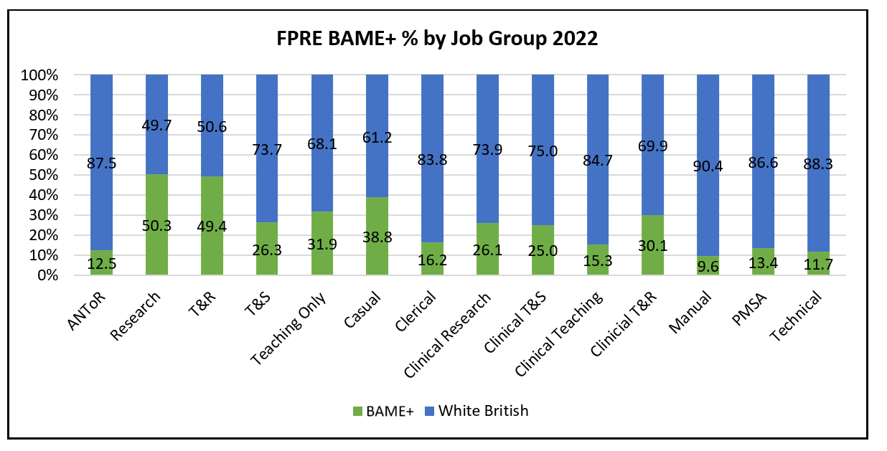
Figure 4: FPRE BAME+ % by Job Group 2022

People of Colour Pay Gap
A positive black number means that there is a pay gap in favour of the White group, whereas a negative red number means that there is a pay gap in favour of the People of Colour group. The White group includes White British, White Irish, White Other, and Gypsy/Traveller. The People of Colour group includes Black, Asian, Mixed, and Other Minority Ethnic groups.
Of the 6451 full pay relevant employees included in the calculation, 13.75% were POC and 86.25% were White:

Table 8: Statutory People of Colour Pay Gap Data
 | 2020 | 2021 | 2022
# POC | 808 | 844 | 887 | ↑
# White | 6144 | 5741 | 5564 | ↓
# Unknown | 366 | 440 | 521 | ↑
% POC | 11.04 | 12.49 | 12.72 | ↑
% POC of Known | 11.62 | 13.37 | 13.75 | ↑
% Unknown Ethnicity | 5.00 | 6.26 | 7.47 | ↑
- Mean | 1.26 | 2.21 | 6.49 | ↑
- Median | -0.83 | -1.12 | -0.09 | ↓
- Mean Bonus | -84.40 | -11.38 | 19.14 | ↑
- Median Bonus | -503.21 | 58.33 | 75.00 | ↑
% POC Staff in Receipt of Bonus Pay | 1.25 | 0.99 | 0.86 | ↓
% of White Staff in Receipt of Bonus Pay | 1.81 | 0.72 | 0.62 | ↓
% Bonus Pay Recipients Who Are POC | 8.53 | 16.98 | 19.15 | ↑
% Bonus Pay Recipients Who Are White | 91.47 | 83.02 | 80.85 | ↓
Quartile 1 % POC | 11.45 | 12.51 | 15.56 | ↑
Quartile 2 % POC | 9.32 | 11.30 | 11.28 | ↓
Quartile 3 % POC | 15.25 | 15.92 | 16.55 | ↑
Quartile 4 % POC | 10.47 | 11.54 | 11.60 | ↑

Figure 5: FPRE POC Population by Grade 2022

Figure 6: % Distribution of POC and White FPRE by Job Group 2022
Please see section 2 ‘Executive Summary’ for a summary of key observations and causes of the ethnicity pay gap.

Disability Pay Gap
A positive black number, means that there is a pay gap in favour of the no known disability group, whereas a negative red number means that there is a pay gap in favour of the known disability group.
6972 Full Pay Relevant Employees are included in the Statutory Disability Pay Gap calculation, of which 406 (5.8%) were known to have a disability, and 6566 (94.2%) had no known disability. This represents an increase from 383 known disabled staff in 2021.
Table 9: Statutory Disability Pay Gap Data
 | 2020 | 2020 | 2022
# Disabled | 367 | 383 | 406 | ↑
# No Disability | 6951 | 6642 | 6566 | ↓
% Disabled | 5.02 | 5.45 | 5.82 | ↑
- Mean | 15.04 | 14.77 | 14.47 | ↓
- Median | 9.73 | 7.02 | 7.62 | ↑
- Mean Bonus | 89.76 | 0.00 | 0.00 | -
- Median Bonus | 0.00 | 0.00 | 0.00 | -
% Disabled Staff in Receipt of Bonus Pay | 1.25 | 0.00 | 0.00 | -
% Non-Disabled Staff in Receipt of Bonus Pay | 1.60 | 0.75 | 0.75 | ↔
% Bonus Pay Recipients Who Are Disabled | 3.79 | 0.00 | 0.00 | -
% Bonus Pay Recipients With No Disability | 96.21 | 100 | 100 | ↔
Quartile 1 % Disabled Staff | 6.83 | 7.47 | 7.97 | ↑
Quartile 2 % Disabled Staff | 5.36 | 5.77 | 5.91 | ↑
Quartile 3 % Disabled Staff | 4.59 | 5.65 | 5.57 | ↓
Quartile 4 % Disabled Staff | 3.28 | 3.89 | 3.84 | ↓

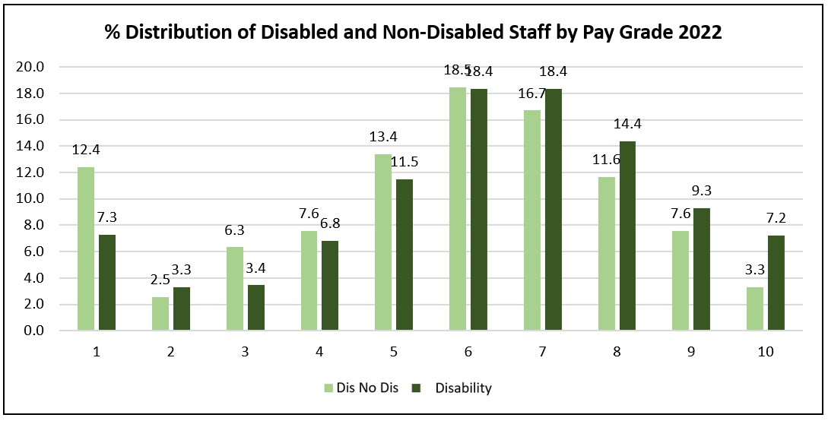
Figure 7: % Distribution of Disabled and Non-Disabled Staff by Pay Grade 2022
Please see section 2 ‘Executive Summary’ for a summary of key observations and causes of the disability pay gap.

Sexual Orientation Pay Gap
A positive black number, means that there is a pay gap in favour of the Heterosexual/ Straight groups, whereas a negative red number means that there is a pay gap in favour of the Lesbian, Gay, Bisexual and Other group.
4786 Full Pay Relevant Employees are included in the Statutory Sexual Orientation Pay Gap calculation, of which 338 (7.1%) where known to be Lesbian, Gay, Bisexual or Other identify, and 4448 (92.9%) identified as Heterosexual. The other 2186 (31.4%) FPRE have not provided information about sexual orientation and have therefore been excluded from this analysis.
Table10: Statutory Sexuality Pay Gap Data

 | 2020 | 2021 | 2022
# LGBO | 304 | 322 | 338 | ↑
# Hetero | 4677 | 4477 | 4448 | ↓
# Unknown | 2337 | 2226 | 2186 | ↓
% LGBO | 4.15 | 4.58 | 4.85 | ↑
% LGBO of Known | 6.51 | 6.71 | 7.06 | ↑
% Unknown Sexuality | 31.94 | 31.69 | 31.35 | ↓
- Mean | 5.90 | 6.78 | 5.88 | ↓
- Median | 3.23 | 4.15 | 1.21 | ↓
- Mean Bonus | 38.79 | 0.00 | 0.00 | -
- Median Bonus | -354.63 | 0.00 | 0.00 | -
% LGBO Staff in Receipt of Bonus Pay | 0.60 | 0.00 | 0.00 | ↓
% of Hetero Staff in Receipt of Bonus Pay | 1.33 | 0.57 | 0.40 | ↓
% Bonus Pay Recipients Who Are LGBO | 2.90 | 0.00 | 0.00 | ↓
% Bonus Pay Recipients Who Are Hetero | 97.10 | 100 | 100 | ↑
Quartile 1 % LGBO | 7.62 | 8.25 | 7.94 | ↑
Quartile 2 % LGBO | 6.17 | 7.25 | 6.68 | ↑
Quartile 3 % LGBO | 5.85 | 6.25 | 8.36 | ↑
Quartile 4 % LGBO | 4.73 | 5.09 | 5.26 | ↑

Figure 8: % Distribution of LGBO and Heterosexual by Pay Grade 2022

Please see section 2 ‘Executive Summary’ for a summary of key observations and causes of the sexual orientation pay gap.

Sector Comparison

Gender Comparison
It is not possible to compare the 2022 gender pay gap within the sector because the publication deadline of this data is March 2023. However, below is reported the 2021 Gender Pay Gap Comparison with the North West Universities and the Russell Group (excluding Scotland and Northern Ireland):

Figure 9: 2021 GPG Median Comparison: North West Universities
The University’s median pay gap remains relatively high compared to other universities, particularly when benchmarking against other North West based institutions.

Figure 10: 2021 GPG Median Comparison: Russell Group

Ethnicity Comparison
The Government does not require the publication of an Ethnicity Pay Gap. Therefore, it is not possible to benchmark against any formal or official ethnicity pay gap data.
However, in 2021, UCEA requested gender, ethnicity, and intersectional data from HEI institutions to conduct a benchmarking exercise of the 2020 and 2021 Pay Gap. The 2020 comparison was reported last year; however, the 2021 data has not yet been published by UCEA and therefore cannot be commented on in this report.

Disability & Sexual Orientation Comparison
The Government does not require the publication of a Disability or Sexual Orientation Pay Gap. Therefore, it is not possible to benchmark against any formal or official disability or sexual orientation pay gap data.

- Actions Taken to Address Pay Gaps
A summary of actions already taken to address equality pay gaps (following last year’s report/findings), has been shared below.
Gender Pay Gap:
The following activities took place in 2021/22 that contribute to our activities to address the gender pay gap:
- Athena Swan Awards: The University successfully achieved its second consecutive institutional Silver award. In addition, the School of Engineering achieved a Silver departmental award and the School of Physical Sciences was successful in renewing its Silver award.
- Aurora Leadership Programme: The University supported a further 20 female members of staff to complete Advance HE’s Aurora leadership programme. Since 2013, 154 women have been supported to take part in the Aurora programme.
- Annual Review: The academic promotion round resumed in 2021 after being paused in 2020 due to COVID. The result of the promotion round included:

  - 60% of applications for Chair were from women, with 69% of Chair promotions awarded to women. This was an increase from 31% of applications and 33% successful cases in 2019.
  - In total 16 women were promoted to Professor, including the first female Professors in the School of Engineering.
  - 33% of Reader applications were from women with 36% of Readerships awarded to women. This was a slight decrease from the proportion in 2019 when 35% of applications were from women, however the proportion promoted stayed the same at 36%.
  - 48% of Senior Lecturer applications were from women and 50% of successful cases were women. This category has proved most stable with gender balance achieved in the last three Annual Review rounds.

Ethnicity Pay Gap (BAME+ & POC):
The following activities took place in 2021/22 that contribute to our activities to address the ethnicity pay gap:
- Race Equality Charter: In March 2021, the University joined the AdvanceHE Race Equality Charter (REC) and subsequently appointed a Race Equality Officer in Human Resources to deliver the project. REC Governance structures were established (REC Self-Assessment Team and related Subgroups), which feed into the University Equality, Diversity & Inclusion Committee. Throughout 2021/22 the University has worked to review HR data to include recruitment and progression data to identify actions to address areas of underrepresentation.

- Diversifying HE Leadership: POC staff were supported to participate in the 2021/22 Diversifying Leadership programme delivered by AdvanceHE.
Disability & Sexual Orientation Pay Gaps:
The University’s Equality, Diversity and Inclusion (EDI) Committee has recognised that more needs to be done to address the University’s disability and sexual orientation pay gaps.
Considerations relating to actions to address the disability/sexual orientation pay gaps (alongside gender and ethnicity) have been made as part of the development of the University’s new Equality Objectives/Priority Action Plan (2022 – 2028). Once approved by SLT & Council, activities in this area will include;
- Encouraging disclosure of EDI characteristics to enable improved understanding of the issues and higher levels of confidence that actions are appropriately targeted (particularly in relation to disability/sexuality)
- The use of Positive Action statements within job descriptors/advertisements
- Further engagement with community groups (inc. where roles are advertised), etc.

- Recommendations
The Athena Swan Action Plan (2022 – 2026) already sets out a number of actions to continue to address the Gender Pay Gap. The Race Equality Charter Action Plan (2023 – 2027) will also be finalised over the coming months which will enable an intersectional approach to be taken to address the pay and bonus gap issues. As a proactive approach to mitigate risks against increasing pay gaps, the new/proposed Equality Objectives Action Plan (2022 – 2028) also includes a clear focus on this work. Specific priority areas already identified where action will be taken over the next 12 months include:
- Gender Pay Gap:
Address imbalance of genders in Lower Grades and or Manual and Clerical roles (encourage more men into these roles).

- People of Colour (POC) Pay Gap:
Increase POC recruitment in higher paid grades, as well as lower grade roles including Manual and Clerical positions.

- Disability Pay Gap:
Increase disability disclosures and use Positive Action statements within recruitment processes/advertisements to encourage more disabled people to apply for higher grade roles.

- Sexual Orientation Pay Gap:
Increase sexual orientation disclosures and use Positive Action statements within recruitment processes/advertisements to encourage more Lesbian, Gay, Bisexual, Other (LGBO) people to apply for roles within the University.

- Bonus Pay:
Review Bonus Pay Schemes for Non-Clinical Staff and Clinical Excellence Awards.

- Glossary of Terms
Term | Definition
BAME+ | Used to refer to all ethnic minority groups to compare against White British. BAME+ term includes the white minority groups of White Irish, Gypsy/Traveller, and White Other, and Asian, Black, Mixed and Other ethnic group.
Baseline Group | For the purpose of this report, baseline groups refer to groups often classed as being the majority:  - Gender baseline = Men  - Disability baseline = Non-disabled/no known disabilities  - Sexual orientation baseline = Heterosexual  - BAME+ baseline = White British  - People of Colour baseline = White
Clinical Excellence Award (CEA) | A NHS bonus payment scheme for eligible clinical staff. Administered via the University’s payroll scheme but determined by the NHS.
Disabled | Indicates that a person has disclosed that they have a disability (as defined by the Equality Act 2010) to the University and that this has been recorded in their COREHR record.
Exceptional Performance Award (EAP) | The University’s annual bonus pay scheme open to all employees, valued at a flat rate of £1500.
Female | Used to refer to employees recorded as Female in the COREHR record. Female is a sex category as defined by the Equality Act 2010. A Gender Pay Gap is calculated between the sex categories of male v female.
Full Pay Relevant Employee (FPRE) | A pay record that is included in the statutory pay gap calculation (excluding bonus). An employee is full pay if they are receiving 100% of their hourly pay, that is to say they are not receiving less than 100% of pay because of deductions, such as when receiving the lower rate of Statutory Maternity Pay, Sick Pay; deductions due to Strike Action; or because they did not work/received £0 in the census period.
Heterosexual | A sexual orientation category also referred to as straight. Used when comparing against LGBO.
Horizontal Segregation | Refers to the unequal distribution of a population group within job families/career pathways. More colloquially this can be thought of as “jobs for the boys” and “jobs for the girls”.
LGBO | Used to collectively refer to Lesbian, Gay, Bisexual and Other sexualities. Used when comparing against Heterosexual.
Male | Used to refer to employees recorded as Male in the COREHR record. Male is a sex category as defined by the Equality Act 2010. A Gender Pay Gap is calculated between the sex categories of male v female.
Mean | The pay gap calculation showing the difference between the average hourly pay of all female employees, compared to all male employees. Shown as a percentage.
Mean (Bonus) | The pay gap calculation showing the difference between the average bonus pay received in a 12 month period of all female employees who received a bonus, compared to all male employees who received a bonus. Shown as a percentage.
Median | The pay gap calculation showing the difference between the mid-point in the range of all female employees’ pay, compared to all male employees’ pay. Shown as a percentage.
Median (Bonus) | The pay gap calculation showing the difference between the mid-point in the range of all female employees who received bonus pay, compared to all male employees who received bonus pay within a 12 month period. Shown as a percentage.
No Disability / Non-disabled | Used to collectively refer to No Known Disability, Unknown and ‘Decline to Indicate’ within the COREHR record.
People of Colour (POC) | Used to collectively refer to Asian, Black, Mixed, and Other Ethnic Minority groups when comparing to the collective White population.
Quartile | One of 4 equal portions of the whole full pay relevant staff population, rank based on the hourly pay rate (lowest to highest).
Salary Sacrifice | Salary sacrifice refers to payments taken out of an employee’s pay before tax is deducted. This includes pension contributions.
Vertical Segregation | Vertical segregation refers to the unequal distribution of a population group within the pay grade structure, usually with an increasing underrepresentation of that population group the higher up the scale. Other terms that represent a vertical segregation can include a “leaky pipeline” or a glass ceiling/glass floor.
White | Used to collectively refer to White British, White Irish, Gypsy/Traveller, and White Other when comparing against People of Colour.
White British | An ethnic category referring to people who have disclosed that they are White British including English, Welsh, Scottish, and Northern Irish.

