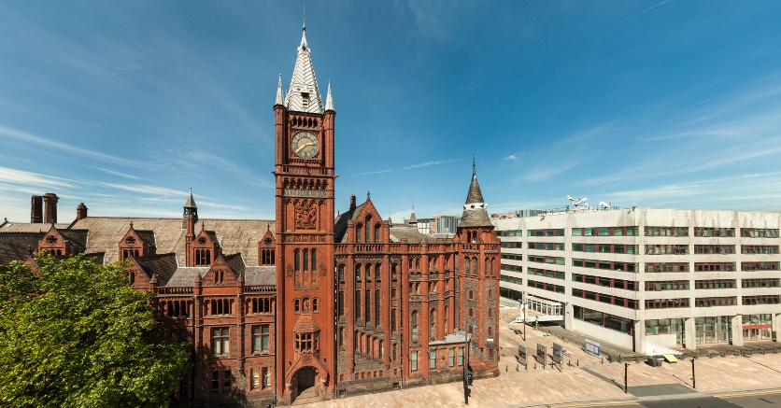
The Past in the Present
Postgraduate Research Conference
Tuesday 14th May 2019

Postgraduate researchers (PGRs) at the University of Liverpool warmly invite participants to the Department of History’s annual Postgraduate Research Conference. The theme of this year’s event will be The Past in the Present. At a time in which claims and narratives about the past are deployed to justify action (and inaction), relevance in the present, and often - quite simply - for self-promotion, the historian assumes a critically important, though sometimes contentious and questionable role. By focusing on innovative methodologies, and offering postgraduate students with any historical focus the opportunity to showcase their wide-ranging and interdisciplinary approaches to historical research, the conference will facilitate the sharing and development of ideas on the role of the past in the present.
Papers, organised into thematic, methodological or ‘issue-based’ panels, will be ten minutes in length, and will be followed by five minutes of feedback questions for each paper. There will also be a further ten minutes for questions and comments at the close of each panel.
Research poster submissions are also welcome in either digital or printed form and will be displayed in a dedicated space at the conference venue.
The Past in the Present will provide valuable experience for all speakers, and promote a space for the sharing of ideas and fostering of conversations. By providing a platform for participants to discuss their methodologies, and network with a broader PGR community in a supportive environment, the conference aims to build a greater sense of community among History PGRs in the North West.

Submission guidelines
Submissions for either a paper or poster are welcome from all PGR students across the North West, and further afield. Submissions should be submitted as a Word document stating the intended format of the presentation (ten minute paper, or poster), and including a 150 word abstract, title and short biography. Panel submissions of three speakers will similarly be considered and will require the above information for each paper within the panel as well as an overall title for the panel. Expressions of interest are also sought for chairing panel sessions.
Suggested topics for papers include, but are not limited to:
- Social, cultural, economic, political, and professional authority and the past
- Popular, spectacular and useful representations of the past
- Archives, evidence, and audiences
- Public History, memory, methods and engagement
- Using history of Race, Disability and Sexuality to educate the present
- Sites of Resistance in the past and present

All submissions and expressions of interest should be sent to livpostgradworkshop@outlook.com by 29th March 2019.
Funding opportunities
A contribution to travel expenses may be available for those travelling from further afield. Please get in touch with the conference organisers via the above email address for more information.

For updates and further information, please see: www.uolpostgraduateworkshop.wordpress.com.

