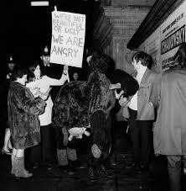The Protests Against Miss World, 1970

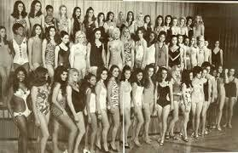

**FACT FILE: The Miss World Contest**

Miss World is the world’s oldest beauty pageant and was started in the UK in 1951. The pageants were aired on live television and during the 1960s and 1970s Miss World was amongst the most watched programmes on TV.

The BBC stopped airing Miss World in 1988.

This task will focus on historical sources we can use to look at the protest against The Miss World contest in 1970. You will:

* Learn about the historical context of the protests
* Think about what motivated these women to protest
* Examine different types of sources to see how they can be used to look at the past

Some of the key questions we might want to ask are:

* Why did the women protest against the Miss World contest?
* What did they do?
* What were the consequences of their actions?
* What is the historical significance of the protest?
* How can we use historical sources to examine these events?

Take a look at these photographs. What can they tell us about the event?

What are the limitations of these photographs, or what do they not tell us?

--------------------------------------------------------------------------------------

**FACT FILE: The Women’s Liberation Movement**

The Women’s Liberation Movement emerged in the early 1970s as women fought for equal rights. The demands of the UK movement were as follows:

1. – Equal pay now
2. – Equal education and job opportunities
3. – Free contraception and abortion on demand
4. – Free 24hr nurseries
5. – Financial and legal independence
6. – An end to all discrimination against

lesbians and a woman’s right to define her

own sexuality

1. – Freedom from intimidation by threat or use of violence or sexual coercion, regardless of marital status and an end to all laws, assumptions and institutions which

perpetuate male dominance and men’s

aggression towards women

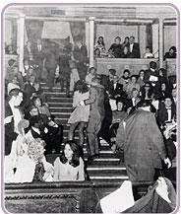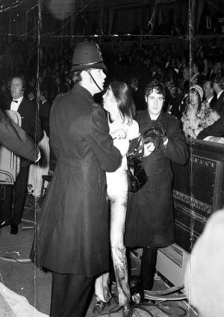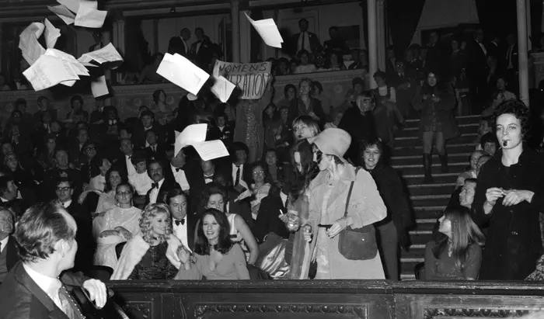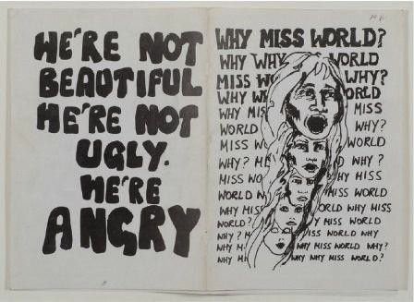

This is the cover of a pamphlet the women produced after the Miss World Protests. Using this and the other sources, what do you think they are angry about?

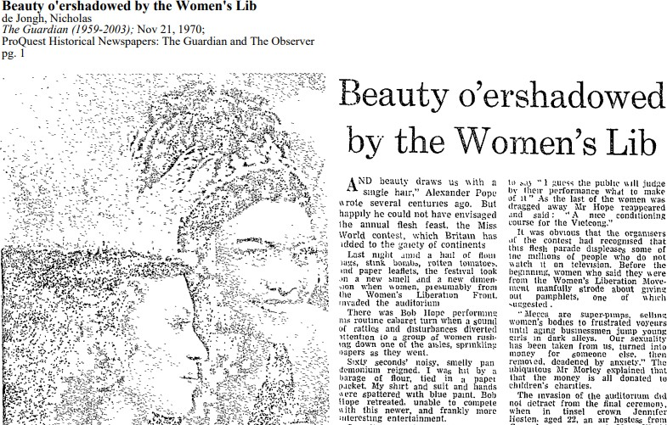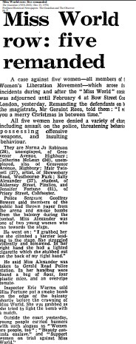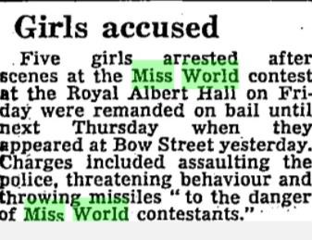

Newspaper Reports: The protests were covered extensively in the national press.

In what ways are newspaper articles useful to tell us what happened?

The Sunday Times, Sunday, Nov. 22, 1970

What are the limitations of newspaper reports?

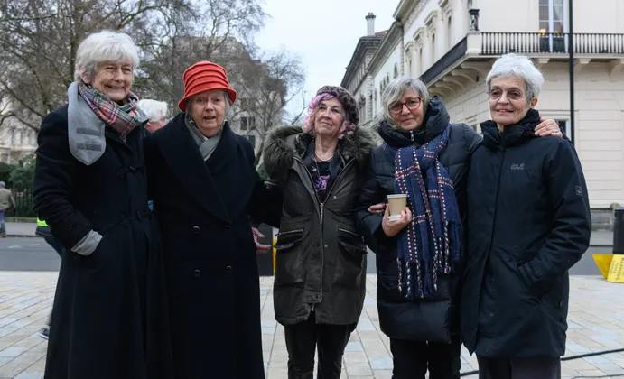

The women involved were arrested and imprisoned overnight. They represented themselves in court and were released soon after. All of the women continued to be active campaigning for women’s rights.

From left, protesters Sue Finch, Sarah Wilson, Jo Robinson, Jenny Fortune and Jane Grant Photograph: Parisa Taghizadeh

In what ways might these types of sources be problematic?------------------

---------------------------------------------

---------------------------------------------

---------------------------------------------

---------------------------------------------

---------------------------------------------

---------------------------------------------

**Jenny Fortune on the first Women’s**

**Liberation Conference:**

‘The confidence and shining exuberance of the speakers and all the women at the conference made me feel that I was entering a brave new world.’

**Angie Shrubsole-Brett on the protests:**

‘I’m proud to have played a small part in this creative, colourful, political demonstration. It was a genius idea and incredibly well planned. I believe the whole episode played a significant part in the history of the Women’s Liberation Movement – and for

that we can be rightly proud.’

How can first-hand accounts help us to understand the events?-----------------------

-------------------------------------------------

-------------------------------------------------

-------------------------------------------------

-------------------------------------------------

-------------------------------------------------

**The excerpts below are first-hand accounts from:** S. Finch, J. Fortune, J. Grant, J. Robinson, S Wilson, *Misbehaving: Stories of Protests Against the Miss World Contest and the Beauty Industry*, (Merlin Press Ltd: London 2020)

**FACT FILE: Timeline of the Women’s**

**Movement in 1970s UK**

1970 National WLM conference, Oxford Miss World Protest

1971 - Chiswick women's refuge opened 1973 - First UK Rape Crisis formed

Brixton Black Women's Group is formed

1975 - Sex Discrimination Act

National Abortion Campaign formed

1976 - Domestic Violence and Matrimonial Proceedings Act

1978 - Organisation of Women of Asian and African Descent (OWAAD) founded

1979 - Southall Black Sisters formed