Mary Williams: Exploring Race, Gender, Class and 19th Century Criminal Justice

Introduction

In this workshop, we will use the case of Mary Williams (1874) to explore race, gender and class prejudice and its impact on 19th century criminal justice. We will work through a range of sources before engaging in a final debate. First, watch the video presentation based on original sources located in Mary's Home Office case file (HO 144/368/251/81) and contemporary newspaper reports.

Task 1: Early reflections on the case

Immediately after watching the presentation about Mary Williams's case, write down three words to describe:
- Mary Williams
- The community/environment in which she lived
- The judgement against her

Representations of lrishness in 19 th century newspapers
The British newspaper industry boomed during the latter part of the nineteenth century. Newspapers were the primary source of public information, and therefore possessed great political, social and cultural power. Fierce competition between publications meant that many turned towards 'entertaining' journalistic styles as opposed to being purely informative. Material that had the ability to amuse, or provoke sensation, disgust and horror became increasingly popular in some quarters. Humorous and sensational reports of current affairs attracted the readership and engrained ideas about particular groups of people, such as criminals, immigrants (and racial others more generally), and the lower classes).
Irish people were a key target of the British press. Routinely dehumanised and portrayed as subnormal, ignorant, and savage, they were depicted as childlike, animalistic (often as apes (simian) or dogs), and/or inherently criminal. Physiognomical sketches and caricatures emphasised specific features believed to indicate 'low' traits. Irish people were not considered to be 'fully white': their portrayal is closely aligned to depictions of black and colonised peoples at the time.
Such images functioned to affirm the 'distance' between Irish people and the English, Anglo-Americans and other 'elite' white groups; it was believed that these groups were more advanced and belonged to a superior civilisation. These 'civilised' groups were constructed as the 'norm', the ideal to which all other groups were measured against,

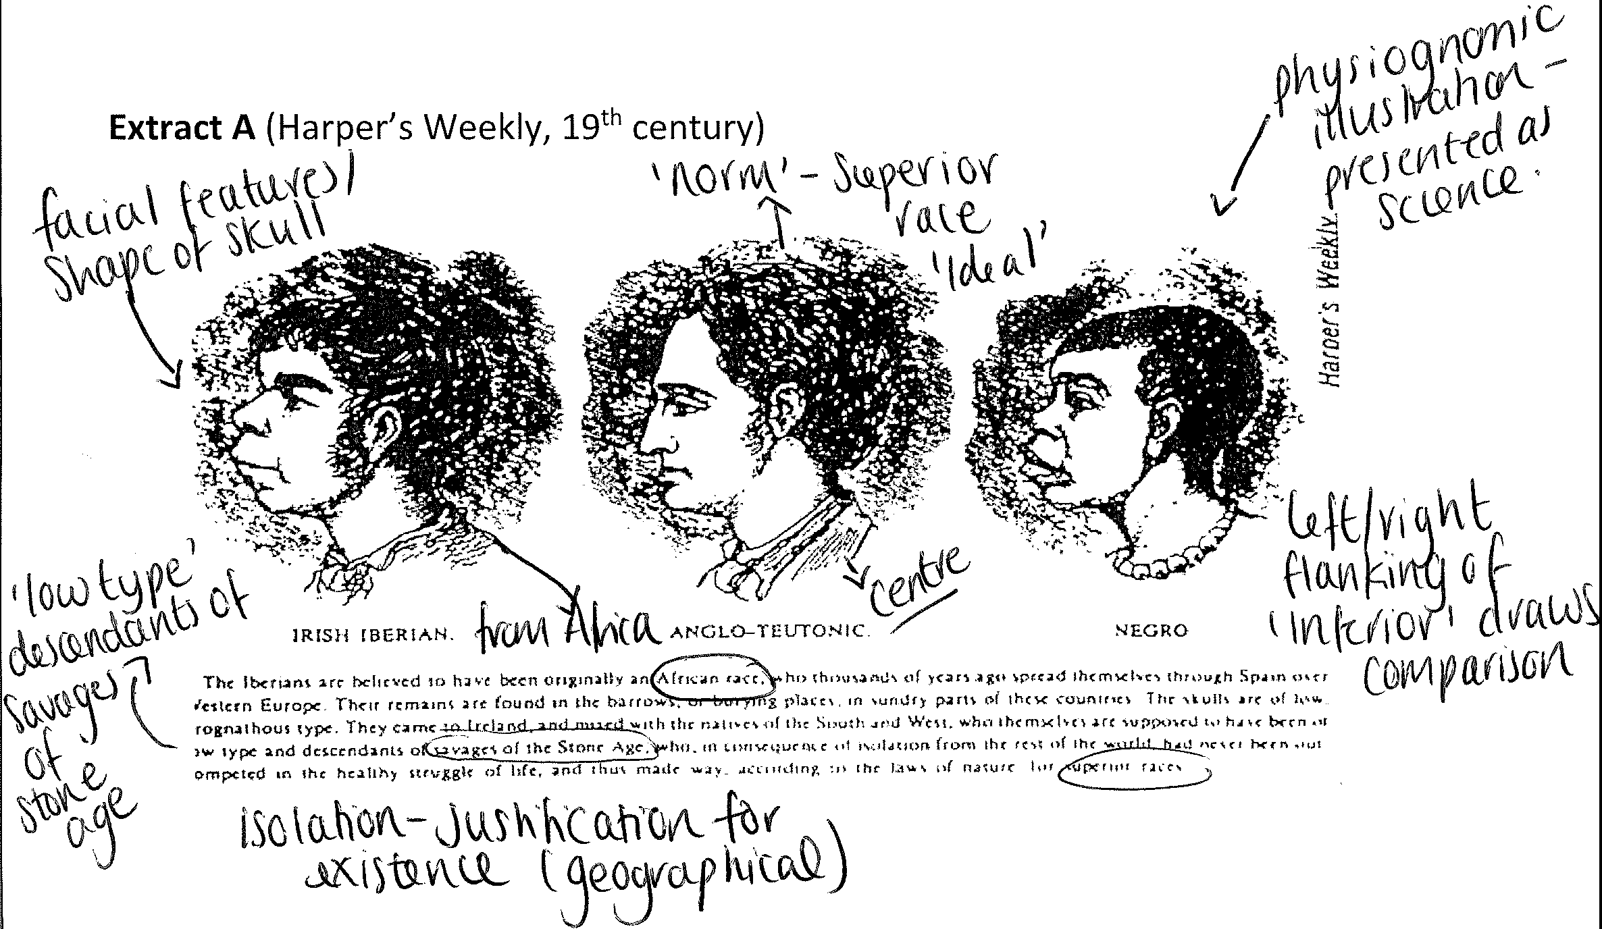whilst the Irish were designated as 'other': a subordinate and inferior people. This subordinated image sustained the idea that 'elite' groups were naturally superior.
Anti-Irish racism was fuelled by political, cultural, and sectarian differences. The British feared insurrection, and the image of the violent, gun toting Fenian pervaded the respectable imagination. By continuously reaffirming negative stereotypes, elites attempted to justify British rule in Ireland, just as they did in the colonies.
Task 2: Examining visual sources for context

  - Examine the images below taken from 19th century British and American newspapers and periodicals
  - Consider the representation of race, gender and class
  - Annotate each image
  - Feedback to your group/class

Extract B (New Physiognomy, New York, 1866}

CONTRASTED FACES.

"Look on this picture, and then on that"-Shakespeare

---------=============---···-··--
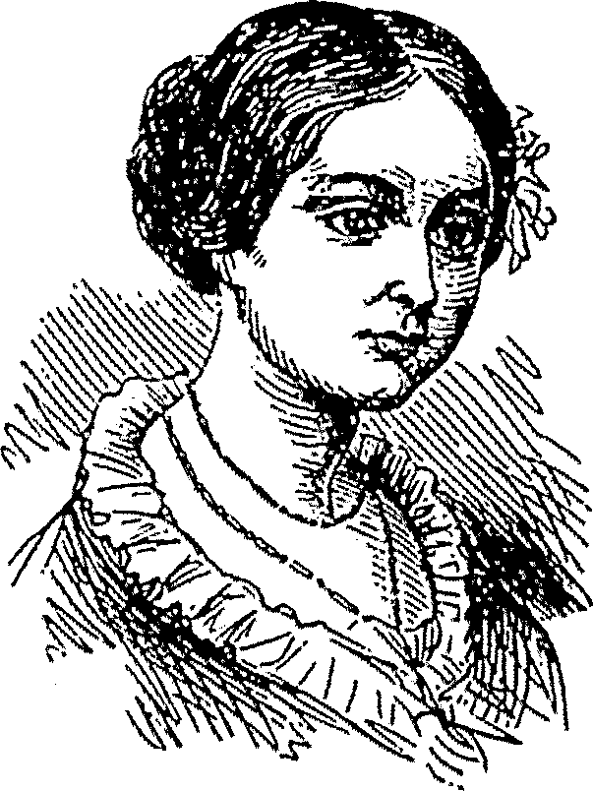
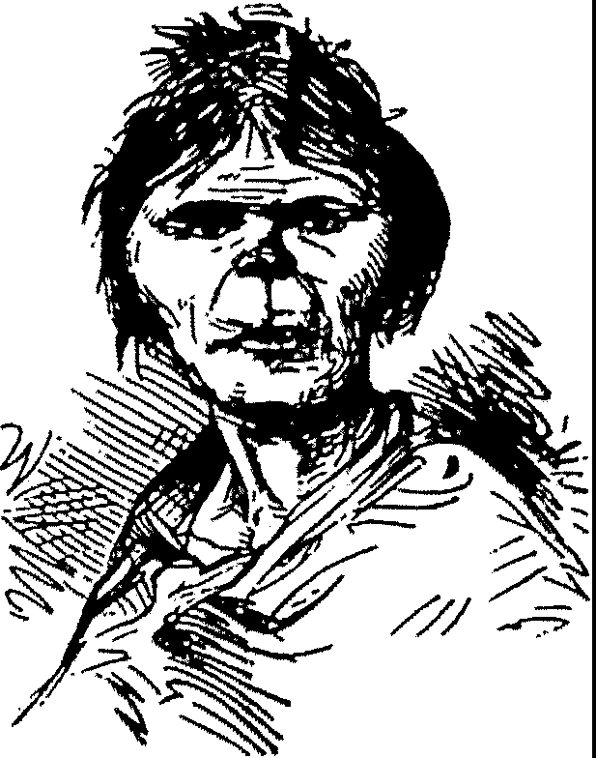
Fig. 747.- .FLORENCE NIOI1TllSGA.U:. :Fig. 748.-Bnmo.&T McBnu1sF.n.

Extract C (Puck, New York, 1883
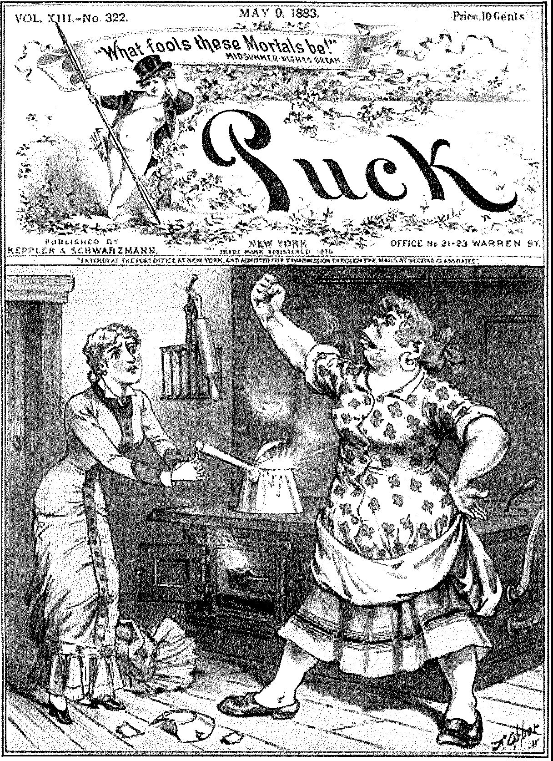
) 1HE !!l!SH DECLAllAHON Of INDEPttlOENC[ THAT WE ARE ALL fAMIUAR WITH.

Extract D (Punch, London, 1866}

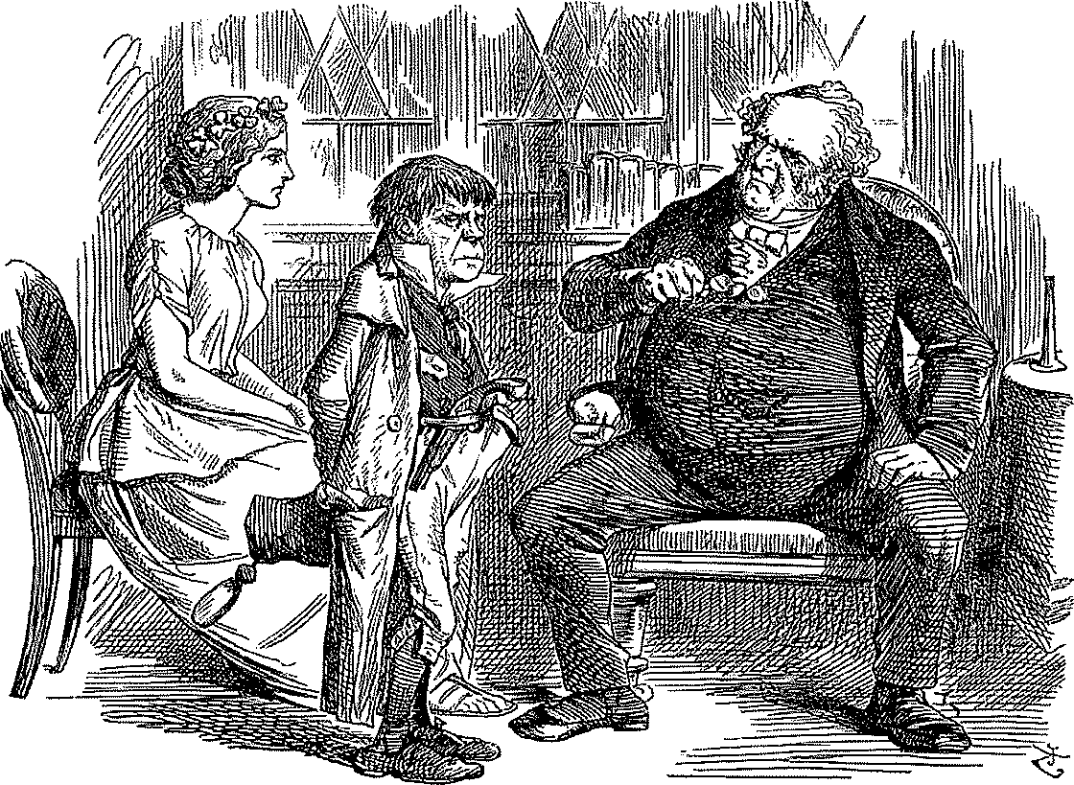
PHYSIC FOR FENIANS.
Ena.u l 'll AFRAID, DOCTIIOR DEAR, ms SY1U'TO:M5 ARB GETTING DANGEROUS."
D11., Duu... "ll!! I 51mt I TREATED A. SOMEWI!AT 61],IlLAlt CASD 'IO TIIIS Y}:R1'. SUCCESSFULLY IN lNDJA: LEA.YE HIM TO ME.."

Extract E
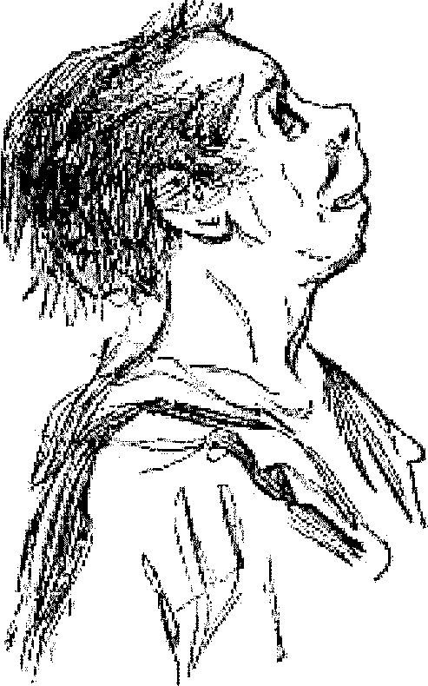
That subject is the resemblance between Irishman and the dog; and the elegance which we craved (without knowing exactly what we were waiting for) is “Irish eloquence”. This is so prominent a trait of Irish character that if the resemblance alluded to exist, it must be characteristic of the dog.
