Artefact Analysis Worksheet

- List organic materials and inorganic materials.

- What environments are needed for wood to survive in
the archaeological record?

- Fibers are derived from __________ and __________.

- Cotton is an example of what type of plant fiber?

- Picture question (see slide) – what type of plant fibers are shown on the slide? Bast or seed?

- What is the provenance?

- Petrology was first used by i)_________ and has since been borrowed by ii)__________.

- The two forms of optical/light microscopy are ___________ and _____________.

- What type of optical/light microscope would you use to examine metals?
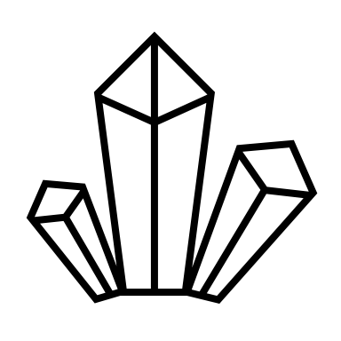

- What colour does quartz grains appear under polarised light?

- What does the scanning electron microscope use to create images? Photons or electrons?

- What are the two modes of operation for images for the SEM?

