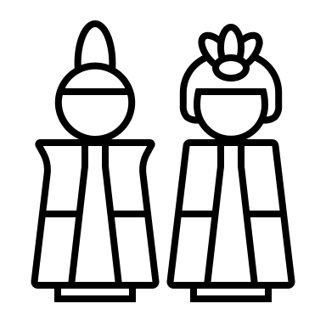
Worksheet

- How long has faience been made?
  - 500 years
  - 2000 years
  - 5000 years

- Faience was made to imitate__________ like ________ and _________.
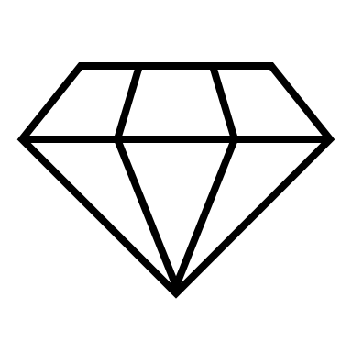
- What is faience made of?
  - Silica
  - Lime
  - Soda
  - All of the above
- The ancient craftsmen needed to have a good knowledge of ______ to make faience.

- What do you need to add to get yellow coloured faience?

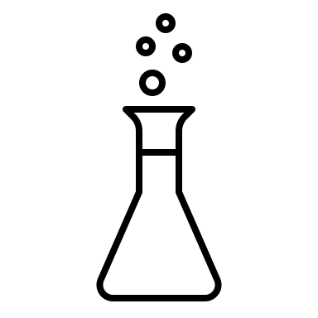
- What are the names of the different layers in a faience object?

- What have archaeologists done to work out the different production methods for faience?

- What are the names of the three glazing techniques of faience?

- What are the two types of examination that can be done on faience to work out the glazing method?

- What type of examination would you use to identify application glazing?

- What constitutes a technological choice by the ancient craftsmen?

