Introduction to Greek architecture: What did you learn about Greek architecture?
1) What did the Greeks build? Make a list of the buildings.
2) What was the purpose of Greek temples? Choose the correct
- a. A place of political reunion of Athenian citizens.
- b. A place of worship of Olympian gods.
- c. A marketplace
- d. A place of worship of Christian God
3) Observe the plan of a peripteral temple and match each part with the correct architectural terminology:
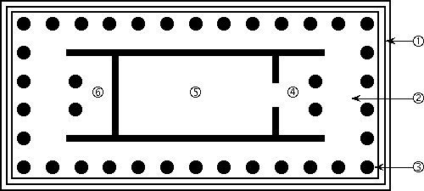
- a. Stylobate
- b. Peristyle
- c. Pronaos
- d. Stereobate
- e. Opisthodomos
- f. Cella or naos
Bonus: What is the definition of peripteral temple? Where was the god’s statue placed?
4) Match the pictures with the correct architectural order:
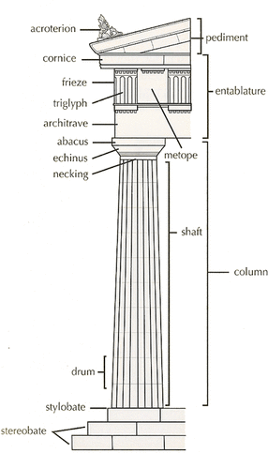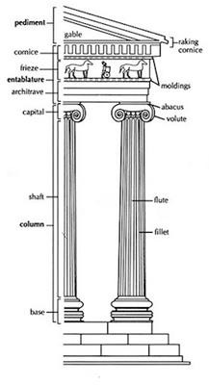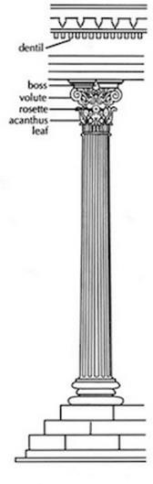

- a. Corinthian
- b. Doric
- c. Ionian
5) Which are the main features of Doric order? Choose the correct
- a. Strong simplicity
- b. Capital carved with acanthus leaves
- c. Squat column
- d. Frieze of metope and triglyphs
- e. Simple capital with abacus and echinus
6) Which are the main features of Ionian order? Choose the correct
- a. Capital carved with acanthus leaves
- b. Tall and elegant column with grooves
- c. Frieze of metope and triglyphs
- d. Continuous frieze with relief figures
- e. Capital decorated with volutes
7) Which Greek temple has a mix of Doric and Ionic features?
8) Do you remember the decoration of the Parthenon? Match the decorative themes (a-f) with the correct architectural part (1-6).

A. West pediment | 1. Gigantonomachy
B. East pediment | 2. Birth of Athena from Zeus’ head
C. Metope eastern side | 3. Amazonomachy
D. Metope western side | 4. Not preserved
E. Metope southern side | 5. Battle between Athena and Poseidon for  the possession of Attica
F. Metope northern side | 6. Battle of Lapiths vs Centaurs

9) The Greek temples were Which were the colours mainly used to decorate temples? How do we know that they bear colours?
10) Which architectural order the Romans used for their temples in Italy and over the empire?

