Answers
1) Temples, theatres, stadiums, public buildings, fortifications, tombs, houses
2) b
3)
a - Stereobate
b - StylobatePeristyle or colonnade
c - Pronaos
d - Cella or naos
e - Opisthodomos
Bonus: a peripteral temple is a temple with the colonnade on all the external sides. The god’s statue was placed inside the cella.

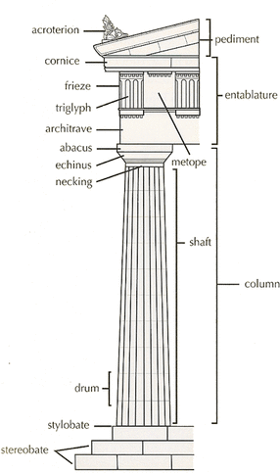4)

Doric

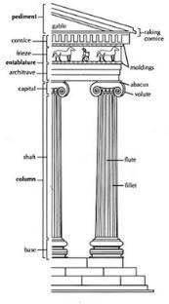

Ionian

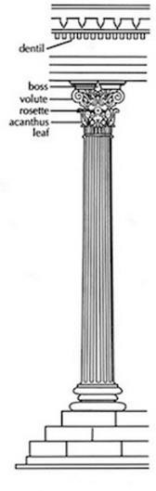

Corinthian

5) a, c, d, e
6) b, d, e
7) The Parthenon
8)
a - 5
b - 2
c - 1
d - 3
e - 6
f - 4
9) The main colours used to decorate the temples were black, white, blue, red and yellow. We know that the temples were coloured because archaeologists found traces of colours on temples and statues
10) The Corinthian order.

