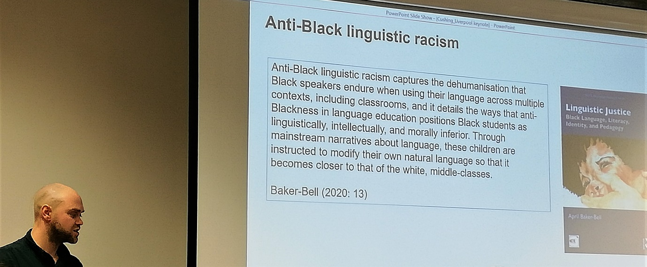
Image: Dr Ian Cushing

Global Voices: an exploration and celebration of language Conference 2023

8th March 2023

The close cooperation between CTELL, School Improvement Liverpool (SIL) and the Ethnic Minority and Traveler Achievement Service (EMTAS-MFL) resulted in a second, successful conference to celebrate languages in Liverpool and beyond, part of the CTELL events series ‘Variation and Change in Language Learning and Literacy Development – Celebrating diversity in the language classroom’.
Dr Natalie Finlayson (University of York) opened the conference with her keynote paper ‘Supporting Diversity, Inclusion, and Representation in the Modern Language Classroom’ [add link to ppt Finlayson Global Voices]. She demonstrated how an inclusive learning environment can be fostered and cultural barriers broken down through innovative learning resources.
Dr Ulrike Bavendiek (University of Liverpool) explored linguistic bias in the workshop ‘Linguistic stereotyping in education: what is it and how can we avoid it?’ [add link to ppt Bavendiek Global Voices]. Participants engaged in lively discussions, sharing their experiences of linguistic stereotyping in their own educational contexts. The summaries showed that linguistic discrimination really is a pertinent issue in most teachers’ everyday practice.
In their workshop ‘An introduction to the Global Citizenship and Multilingual Competences Project’, Dr Raúl Valdivia Murgueytio (University of Newcastle) and Dr Sandra Strigel (University of Liverpool) introduced the Erasmus+ funded project ‘Gobal Citizenship and Multilingual Competences’ [include link https://gcmc.global/ ]. The aim of this collaborative project, which includes research partners in Austria, the UK, the Netherlands, Italy, and Germany, is to provide online resources for secondary teachers of all subjects about how to integrate global citizenship goals and multilingual pedagogies into their practices. Teachers were pointed towards a free copy of the methodology OSDE [add link https://decolonialfutures.net/osde/ ] and other teaching materials [add link to https://www.globalcitizen.org/fr/content/this-photo-series-will-make-you-see-race-in-a-new/ ].
Dr Victorina González-Díaz (University of Liverpool) and Dr Elizabeth Parr (Liverpool Hope University) reported on their project on the gender-gap in writing in Liverpool primary schools. Their workshop ‘I” think I don’t like to do the gender division, but…”: addressing the gender-gap in primary school writing’ [add link to ppt Gonzalez-Diaz and Parr] provided a forum to reflect on ways in which research-based evidence can be used to raise awareness of and counteract stereotypes on gendered writing in the primary school context.

The conference ended with Dr Ian Cushing (Edge Hill University / Manchester Metropolitan University) talking about ‘Anti-Black linguistic racism in England’s schools: a raciolinguistic perspective’ [add link to ppt Cushing Global Voices]. He showed how, for a long time, whole communities have been categorized as linguistically deficient. Masking structural inequality, such deficit discourses in schools marginalize and disadvantage pupils, since they connect linguistic categories with intellectual capacity.

Teachers attending the conference were very positive about the event. They commented on the ‘good balance of information and workshops’ and found that the conference offered ‘a great choice of topics and presenters relevant to our educational settings’. Time flew by as teachers and researchers were engaged in animated conversation. Many participants shared the feeling that the conference was too short: ‘… a full day next time!’

