
ELC Admissions
Student Recruitment, Admissions and Widening Participation
University of Liverpool

Pre-sessional English courses elc-admissions@liverpool.ac.uk

A guide for applying to a Pre-sessional English for Academic Purposes Course at the University of Liverpool

Requirements:
- A valid English Language certificate dated within two years of your course start date. This must be a SELT for all our on-campus courses.
- If you are sponsored, your Financial Guarantee dated within one year of your course start date. If your sponsor fails to pay your tuition fees, the liability for payment will be transferred to you.
- If you are not sponsored, a payment of a £1000 deposit using our online payment page. Please read the payment policy.
- Any current or previous UK visas you may have held.
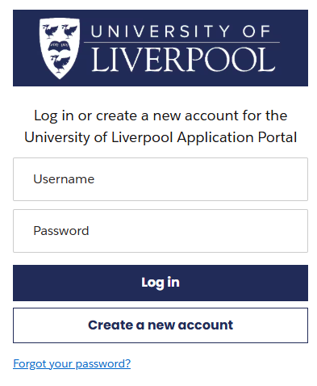

Go to the online application form and select
Create a new account or Log in
if you have previously applied to University of Liverpool.

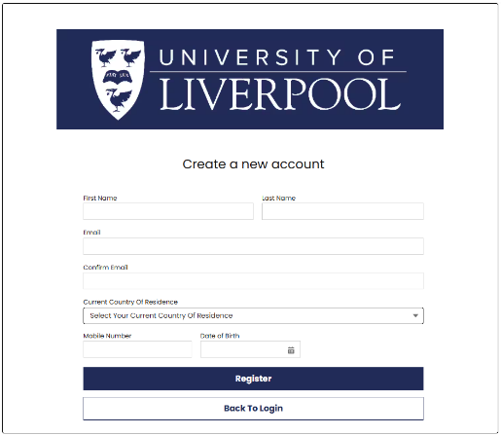
If this is your first application, then click on Create a new account.

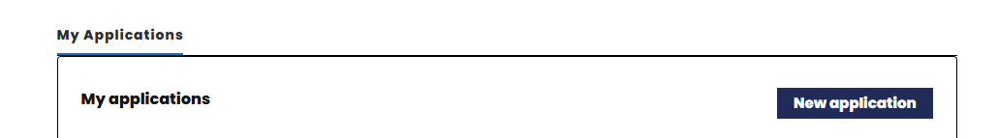

Click the New application button.

Find your course
Before selecting your course, you must check the entry requirements so that you apply for a course that you have the right English test result for.
Select Pre-sessional English from the Application Type drop-down picklist.
Click the Apply button on the row of the course you want to apply for.
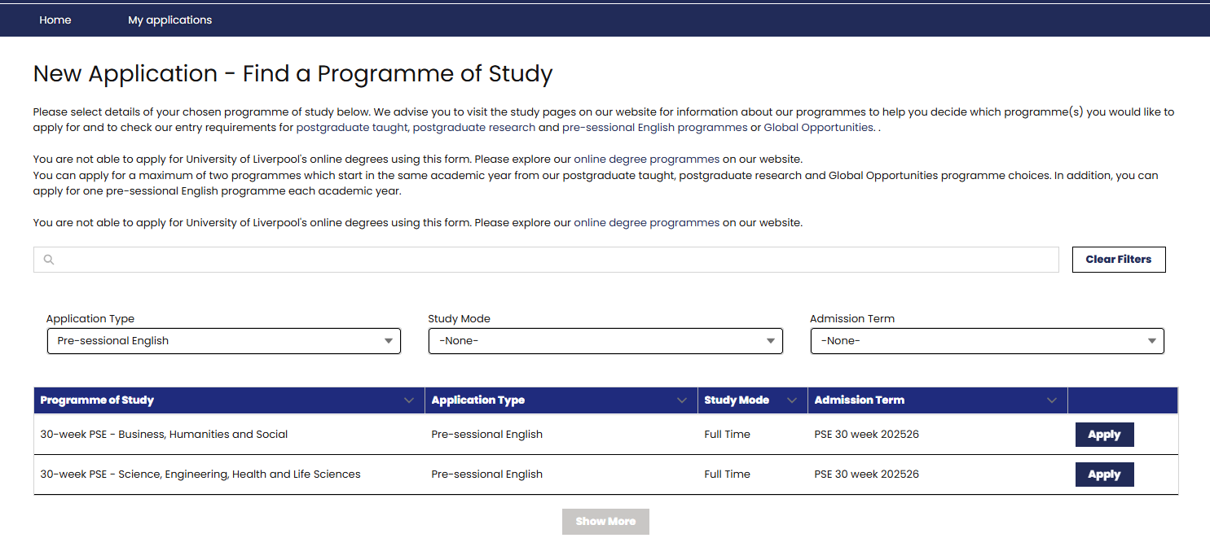
Read all the information on the next screen:
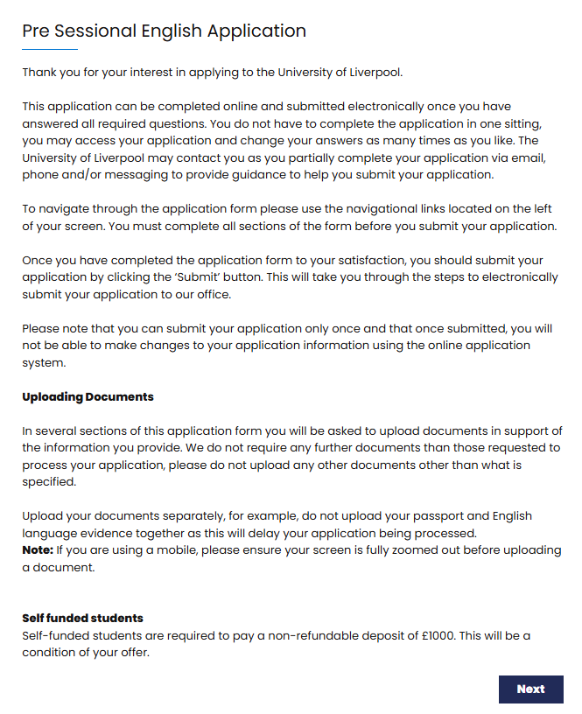

Completing the form

For courses lasting 20-weeks or less, you need to have made an application for academic study (Undergraduate, Postgraduate, or PhD). If your offer is not for the University of Liverpool, then you will need to also upload evidence of the offer.
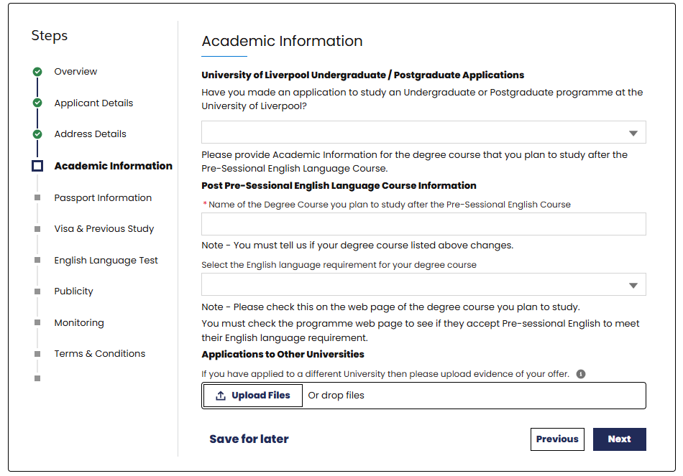

If you do not have a current valid passport, then you will need to get one and provide us with the details by email to elc-admissions@liverpool.ac.uk before we can issue you with a Confirmation of Acceptance of Study (CAS).
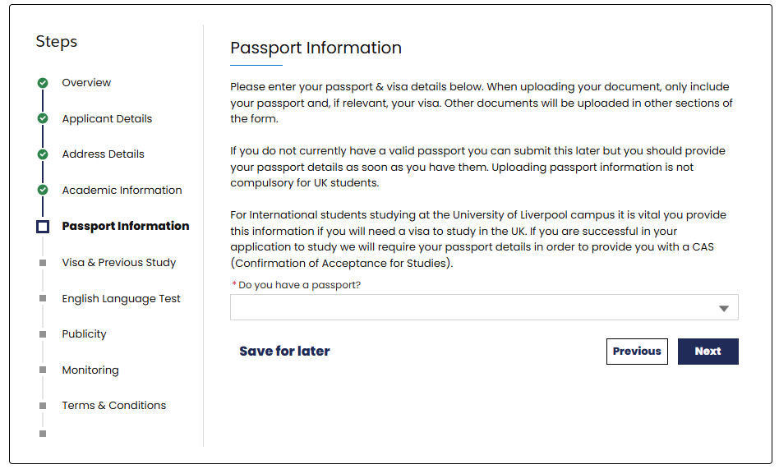

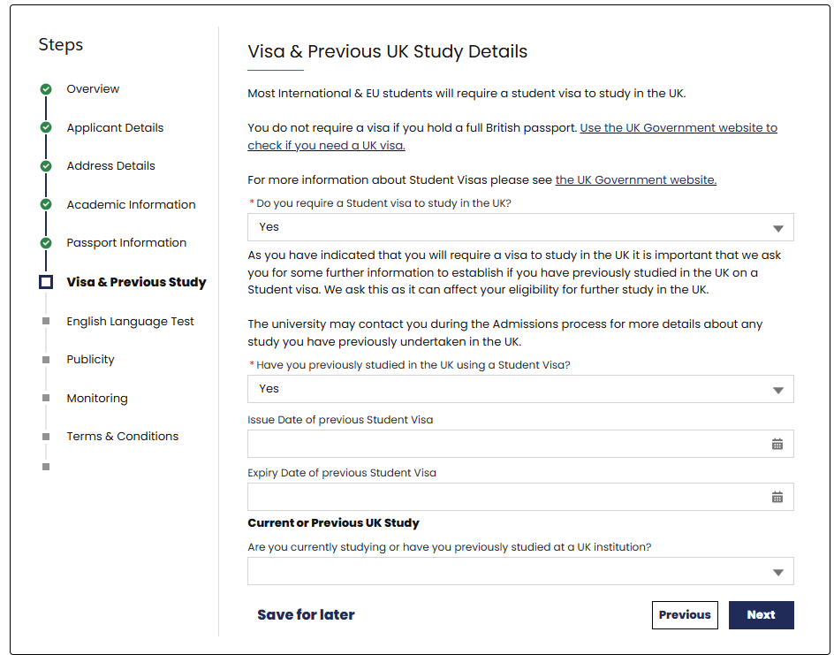

If you are currently studying in the UK or have previously studied in the UK, complete the further questions below. You will be emailed a form to complete, and we will not be able to make a decision on your application until this is returned.

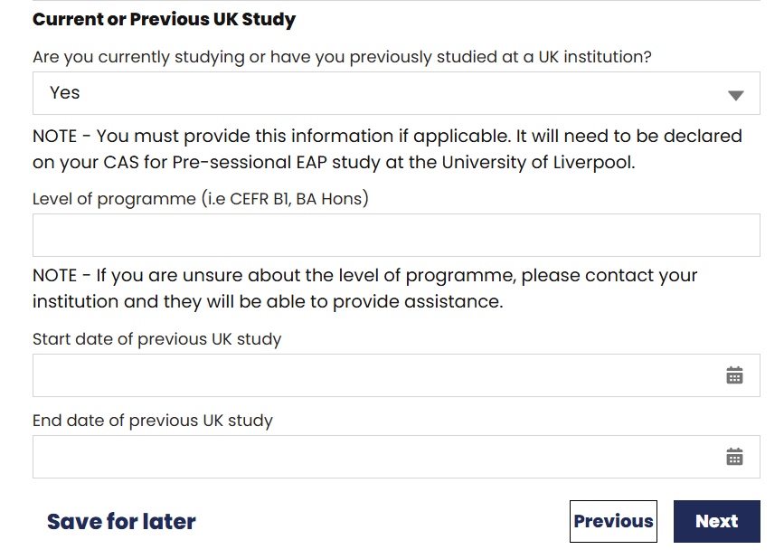

You will need a valid English Language certificate dated within two years of your course start date. This must be a SELT for all our on-campus courses.

Provide the date the test was taken as well as the overall score you achieved. Upload a copy of your SELT certificate using the Upload Files button. Your application will not be processed if you do not provide a valid SELT.

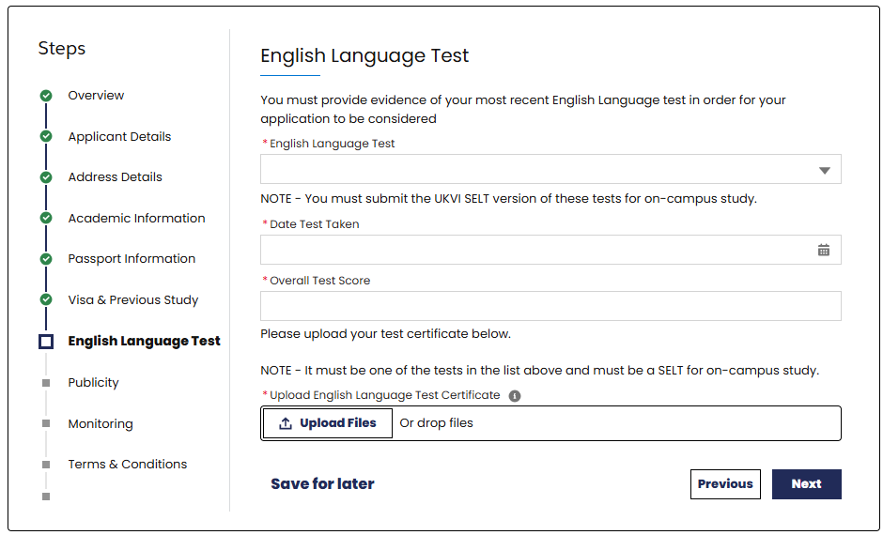

By submitting the application, you are acknowledging and agreeing to the terms and conditions of your course.

